**JSNA Needs Assessment – Alcohol Misuse**

**Introduction**

Alcohol misuse is a pattern of drinking that results in harm to a person’s health, interpersonal relationships or ability to work. Alcohol dependence, also known as alcohol addiction, is a chronic disease and is associated with experiencing withdrawal symptoms, loss of control, or alcohol tolerance.  As well as causing serious health problems, long-term alcohol misuse can lead to social problems for some people, such as unemployment, divorce, domestic abuse and homelessness.

The health harms associated with alcohol consumption in England are widespread, in the South West 30% of adults (Health Survey for England 2019, NHS Digital) are drinking at levels that pose some level of risk to their health; a further 3% of adults are higher risk drinkers.

**The current picture**

The following information is taken from the alcohol commissioning support packs 2021-22 key data provided to Commissioners by the Office for Health Improvement & Disparities.

**Hospital admissions due to alcohol**

Hospital admissions due to alcohol reflect the general impact of alcohol on population health. Alcohol-related hospital admissions can be due to regular alcohol use that is above low risk levels and are most likely to involve increasing risk drinkers, higher risk drinkers, dependent drinkers and binge drinkers. Health conditions in which alcohol plays a causative role can be classified as either 'alcohol-specific' or 'alcohol-related'.

‘Alcohol-specific’ conditions are where alcohol is causally implicated in all cases, e.g. alcohol poisoning or alcohol-related liver disease. ‘Alcohol-related conditions’ include all alcohol-specific conditions, plus those where alcohol is causally implicated in some but not all cases, for example high blood pressure, various cancers and falls.

The latest ‘alcohol specific’ hospital admissions data published by the Office for Health Improvement & Disparities (Local Alcohol Profiles for England) shows an England average of 644 admissions per 100,000 people (all ages) for alcohol related conditions. In the BCP Council area the figure is higher, at 862, while in the Dorset Council area it is lower, at 557. For young people the England average for hospital admissions for alcohol specific conditions is 31 per 100,000 young people. The figure is higher in BCP and Dorset, with 60 and 47 respectively.

The latest ‘alcohol related’ hospital admissions data shows an England average of 519 admissions per 100,000 adults for alcohol related conditions. In BCP the figure is higher, at 635, while in Dorset it is lower, at 416.

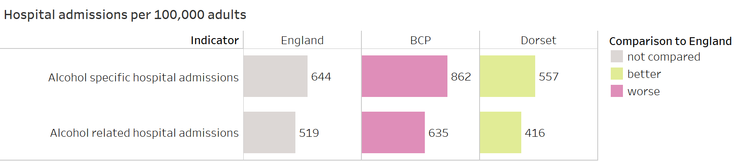

Alcohol has been identified as a factor in more than 60 medical conditions, many leading to hospital admission. The conditions below have been selected because national data shows that they are of particular concern for our local areas.

In the BCP area there is a high harm level for admissions for mental and behavioural disorders due to use of alcohol. The England rate per 100,000 people is 45.3 for females and 103.8 for males. In BCP it is 96.7 for females and 178.6 for males. This is also the case for admissions for alcoholic liver disease in the BCP area, the England rate is 89.3 for females and 191.8 for males, the BCP rate is 127.8 for females and 225.5 for males.

In the Dorset area there is a high harm level for admissions for intentional self-poisoning by and exposure to alcohol. The England rate per 100,000 people 52.8 for females and 39.7 for males, the Dorset rate is 74.7 for females and 50.1 for males.

In both areas the incidence rate of alcohol-related cancer is slightly higher than the England average for females. This is based on data from NCRAS (National Cancer Registration and Analysis Service).

**Mortality and years lost**

Mortality and years of life lost data reflects the level of chronic heavy drinking in the population and is most likely to be found in higher risk drinkers and dependent drinkers. Years of life lost indicate the contribution of alcohol misuse to premature death. Early death from chronic conditions is disproportionately prevalent in lower socio-economic groups and is likely to place demand on health and social care services prior to death. The death of people of working age will additionally impact on productivity.

The England rate for years of life lost due to alcohol-related conditions (per 100,000 people) is 926 years for males and 353 years for females. In the BCP it is higher at 1096 years for males and 379 years for females. In Dorset it is lower at 907 years for males and 276 years for females.

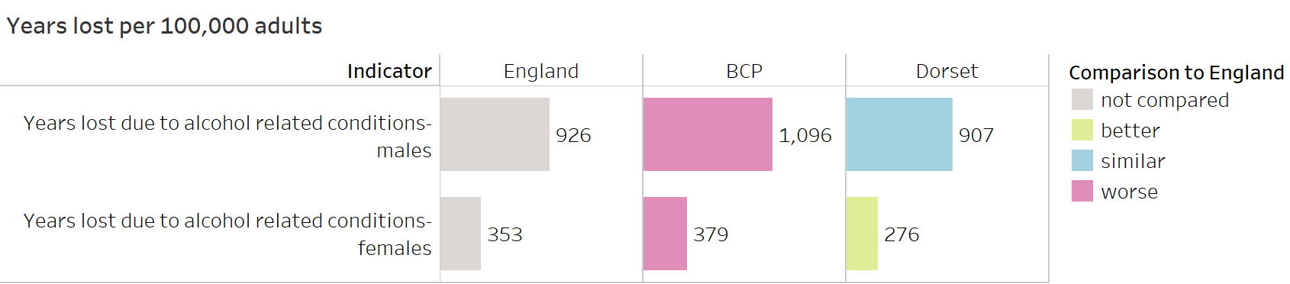

The England rate for alcohol specific mortality (per 100,000 people) is 10.9, in BCP it is 11.7 and in Dorset it is 7.9. The England rate for mortality from chronic liver disease (per 100,000 people) is 12, in BCP it is 12.3 and in Dorset it is 8.2.

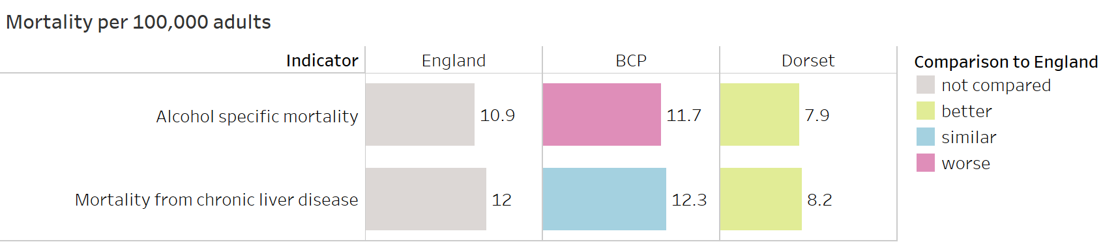

Higher rates of alcohol-specific mortality and mortality from chronic liver disease are likely to indicate a significant population who have been drinking heavily and persistently over the past 10 - 30 years (obesity is also a key factor for liver disease). Alcohol-related deaths made up around 4% of all deaths in 2019 in the UK (ONS, 2021). Of these, about a quarter are alcohol-specific deaths – e.g. from alcohol poisoning, alcoholic liver disease, alcoholic pancreatitis. The remaining alcohol-related deaths are from conditions partially related to alcohol, roughly two thirds of which are from chronic conditions – e.g. cardiovascular diseases and cancers, with the remainder caused by acute consequences such as road traffic accidents or intentional self-harm. The rate of chronic liver disease mortality in the most deprived quintile (17.6 per 100,000 of the population) is almost double the rate in the least deprived (9.1) (Source: LAPE, PHE).

**Patterns of alcohol consumption**

Alcohol-related harm is largely determined by the volume of alcohol consumed and the frequency of drinking occasions. As such, the risk of harm is directly related to levels and patterns of consumption. However, there can be a considerable lag between alcohol consumption and alcohol-related harms, particularly for chronic conditions where it can take many years. In January 2016 the Chief Medical Officer issued revised guidance on alcohol consumption, which advises that in order to keep to a low level of risk of alcohol-related harm, adults should not regularly drink more than 14 units of alcohol a week.

In England, 22% of the population are drinking at above low risk levels so may benefit from some level of intervention. However, harm can be short-term and instantaneous, due to intoxication, or long-term, from continued exposure to the toxic effect of alcohol or from developing dependence. The data presented here gives an indication of potential local need for some form of alcohol intervention and is a weighted estimate from the Health Survey for England (2015-2018 combined).

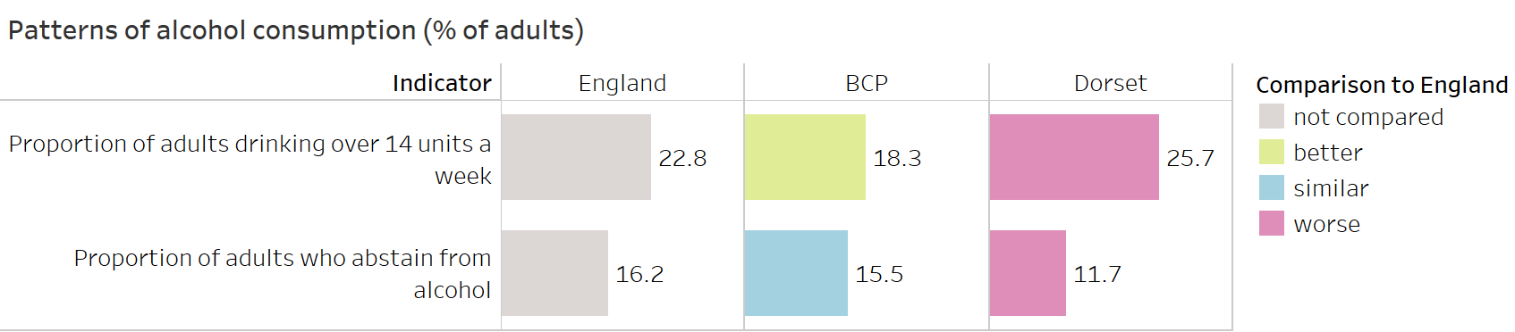

The data shows that the Dorset area has more people than the England average for the proportion of adults drinking above the low risk recommendations, and also less people who abstain from alcohol. The BCP area has more people who abstain from alcohol than the England average and has less people who are drinking at higher risk levels.

**Prevalence estimates and rates of unmet need for alcohol treatment**

Prevalence estimates give an indication of the number of adults in our local area that are in need of specialist alcohol treatment and the rate of unmet need gives the proportion of those not currently in treatment.

According to estimates of the number of adults in England with an alcohol dependency potentially in need of specialist treatment published by the Government for 2018-19, in BCP there are estimated to be approximately 4388 people with an alcohol dependency, this is 1.37% of the adult population (18+). In Dorset the estimate is 3284 people with an alcohol dependency, this is 1.06% of the adult population. (Note: this is the latest dependency estimate data available for our areas)

During 2020-21 there were 760 people with an alcohol dependency (alcohol only and alcohol/non-opiate) in structured alcohol treatment in BCP. This equates to an unmet need of 83% of those in the community who are alcohol dependent. In the same period, there were 874 people with an alcohol dependency in structured alcohol treatment in Dorset. This equates to an unmet need of 73%. The England average unmet need is 82%.

**People in alcohol treatment and drug use**

Although the information from the local treatment system from this point on focusses specifically on those individuals who are in treatment for alcohol misuse only, it is important to take into account the wider cohort of alcohol users who also have drug misuse problems. The needs of these clients are particularly complex and extra consideration needs to be given to what additional support they may require.

Of the 760 alcohol clients in the BCP treatment system in 2020-21, 541 were in treatment for alcohol misuse only, 219 were alcohol and non-opiate clients. There were an additional 280 opiate clients who also cited an alcohol problem.

In Dorset of 648 of the 874 clients were in treatment for alcohol misuse only. 226 were alcohol and non-opiate clients. There were an additional 152 opiate clients who also cited an alcohol problem.

**People in alcohol treatment who are parents / carers and their children**

Of the alcohol only clients who entered structured treatment in 2020-21 in BCP, 25% were living with children and a further 27% were parents not living with children. It is estimated that there were 180 children living with alcohol clients entering treatment. In Dorset 35% of alcohol clients who entered treatment were living with children and a further 29% were parents not living with children. It is estimated that there were 297 children living with clients entering treatment. The proportion for Dorset for those living with children is considerably higher than the England average which is 24% of new presentations.

**Co-occurring mental health and alcohol conditions**

Of the alcohol only clients who entered structured treatment in 2020-21 in BCP 243 (62%) identified a mental health treatment need. 215 of these were receiving mental health treatment. In Dorset 190 (45%) alcohol only clients entering structured treatment identified a mental health treatment need, 147 of these were receiving mental health treatment. The England average for alcohol only clients entering treatment with a mental health treatment need is 64%.

**Employment**

Self-reported employment status data for alcohol only clients at the start of their treatment in 2020-21 in BCP shows that 27% were in regular employment, 46% were unemployed, 22% were long-term sick or disabled. In Dorset 39% were in regular employment, 42% were unemployed, 14% were long-term sick or disabled.

**Housing and homelessness**

A safe, stable home environment enables people to sustain their recovery. Engaging with local housing and homelessness agencies can help ensure that the full spectrum of homelessness is understood and picked up: from statutory homeless, single homeless people, rough sleepers to those at risk of homelessness.

During 2020-21 in BCP 47 alcohol only clients entered treatment with a housing problem, and 3 entered treatment with an urgent housing problem (no fixed abode). This was 13% of the new presentations. In Dorset 35 alcohol only clients entered treatment with a housing problem, and 17 with an urgent housing problem (no fixed abode). This was 12% of the new presentations. Both areas are higher than the 9% of alcohol new presentations enter treatment with a housing problem, or an urgent housing problem nationally.

**The current picture – Local insights**

To develop a shared understanding of alcohol locally, workshops were held with alcohol treatment practitioners, health and care providers, police, service user representatives and other system partners. When asked what the local causes and effects of alcohol misuse were, key elements of discussion included:

* People using alcohol as self-medication in relation to mental health – it is socially acceptable to use alcohol to unwind. As alcohol is a mood depressant, using it to relieve stress, low mood or any poor mental health issue becomes a downward spiralling circle.
* The availability and low cost of alcohol - with 24 hour availability and the considerable cost difference between alcohol bought at a supermarket, and that bought in a pub or club, people are increasingly drinking at home, or “pre-loading” before going out.
* Readiness for change - to receive successful treatment it is vital that people first recognise they have an issue, then it is important that they are able to access the appropriate treatment.
* Older people with an alcohol dependence are experiencing particular problems - for them to live independently they need support at home, but it is difficult to provide the support as care workers are often reluctant to attend.
* Is the budget weighted appropriately between drug and alcohol services, compared to the needs of the population? Is there any evidence that separate drug and alcohol services would make a difference?

These local insights highlighted the following key challenges for tackling alcohol misuse in our area:

* There have been budget cuts for alcohol treatment at a time when alcohol related hospital admissions are rising.
* Differences in professional opinion in what works and a variation in expectations of what treatment is given is a blocker to collaborative working between partners which feeds into the system pressures. Clear and consistent pathways around detox, psycho-social interventions and aftercare are vital.
* How can we increase community knowledge and understanding of the harm that alcohol can do when it is so socially acceptable? What are the best messages around alcohol to have an impact on young people?
* How can we effectively influence the local level availability and cost of alcohol?
* How can we build resilience at younger ages, so that in times of stress alcohol is not the go-to coping strategy?
* How can we build service consistency and appropriate treatment for people with dual diagnosis (issues with both mental health and alcohol) and design the best pathway for people with co-existing mental health and alcohol issues.

**Future Vision**

Through the workshop process the following desired system changes were identified by the participants:

* Education to increase community knowledge and understanding of the harm alcohol can do
* Local level availability of alcohol
* Building resilience in young people, to reduce use of alcohol as a coping strategy.
* Building resilience and coping strategies for adults – reduce the use of alcohol as a coping strategy
* Service consistency and appropriate treatment for people with dual diagnosis (issues with both mental health and alcohol)
* Clear and consistent pathways around detox, psycho-social interventions and aftercare
* Reducing system pressures – reduce the cost of alcohol to health and social care system
* Workforce skills and competencies
* Management of recovery medicine

**Additional Resources**

[Statistics on Alcohol, England 2020 - NHS Digital](https://digital.nhs.uk/data-and-information/publications/statistical/statistics-on-alcohol/2020)

[NHS Alcohol Misuse](https://www.nhs.uk/conditions/alcohol-misuse/)

[Local Alcohol Profiles for England - Public Health England](https://fingertips.phe.org.uk/profile/local-alcohol-profiles)

[LAPE (Local Alcohol Profiles for England)](https://fingertips.phe.org.uk/profile/local-alcohol-profiles/data#page/9/gid/1938132984/pat/6/par/E12000001/ati/402/are/E06000047/iid/93763/age/1/sex/4/cat/-1/ctp/-1/yrr/1/cid/4/tbm/1) (Data downloads)

[Alcohol dependence prevalence in England - Estimates of the number of alcohol dependent adults in each local authority in England – Public Health England](https://www.gov.uk/government/publications/alcohol-dependence-prevalence-in-england)

[Alcohol and drug misuse and treatment statistics – GOV.UK](https://www.gov.uk/government/collections/alcohol-and-drug-misuse-and-treatment-statistics)

[Substance misuse treatment for young people: statistics 2018 to 2019](https://www.gov.uk/government/statistics/substance-misuse-treatment-for-young-people-statistics-2018-to-2019)

[Alcohol Statistics - Alcohol Change UK](https://alcoholchange.org.uk/alcohol-facts/fact-sheets/alcohol-statistics?gclid=EAIaIQobChMInPz8m-Kt5wIVR7DtCh33TQ6YEAAYAiAAEgKqL_D_BwE)