Version | Date | Changed by | Change made
1.0 | 01/10/22 |  | Sections 1, 3.2, 3.3, 3.6, 3.8, 3.9, 3.11, 4.3, 4.4, 5.9, 6.3, 6.4, 6.7, 7.8 and 7.9 amended following consultation

Public Health Dorset
Pharmaceutical Needs Assessment
October 2022
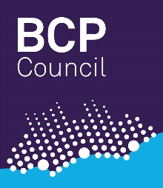
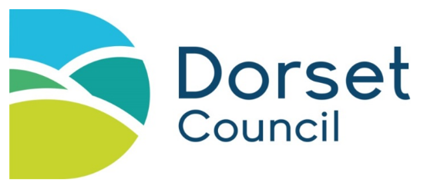
2022 – 2025

Produced by: Public Health Dorset
60- day consultation period: 21 July – 21 September
Contributors: Jane Horne – Consultant in Public Health, Public Health Dorset
Natasha Morris – Public Health Intelligence Team Leader, Public Health Dorset
Lee Robertson – Senior Analyst, Public Health Dorset
Anne Scott – Analyst, Public Health Dorset
Laura Brennan – Senior Intelligence Analyst, Quarter Analytics acting on behalf of Public Health Dorset

Contents
1 Executive summary 7
2 Introduction 8
2.1 Purpose of a pharmaceutical needs assessment (PNA) 8
2.2 HWB duties in respect of the PNA and pharmaceutical services 9
2.3 Contractors within the scope of the PNA 9
2.4 Services within the scope of the PNA 11
2.5 Pharmaceutical services provided by dispensing appliance contractors 16
2.6 Pharmaceutical services provided by dispensing doctors 17
2.7 Opening hours 18
2.8 Impact of the COVID-19 pandemic 19
2.9 National context 20
3 Development of the PNA 22
3.1 PNA steering group 22
3.2 PNA development timeline 22
3.3 PNA localities 23
3.4 Data collation and mapping 24
3.5 Data Limitations 25
3.6 Public and Pharmacy engagement 25
3.7 Other sources of information 26
3.8 Identifying gaps – criteria for necessary services etc. 26
3.9 Equality and safety impact assessment 27
3.10 Formal Consultation 27
3.11 Review and Supplementary statements 28
4 Local Context 29
4.1 Dorset Council and BCP Council 29
4.2 Public Health Dorset 29
4.3 NHS Dorset 30
4.4 Our Dorset 30
4.5 Local Demographics 32
4.6 Our Dorset Joint Strategic Needs Narrative 35
4.7 Housing Growth 37
4.8 Car or Van Ownership 38
4.9 Identified patient groups 38
5 Current services 41
5.1 Health needs that can be met by pharmaceutical services 41
5.2 Number of Pharmacies and Access 41
5.3 Dispensing GPs 42
5.4 Essential Services 43
5.5 Advanced Services 43
5.6 Enhanced services 44
5.7 Locally commissioned services 44
5.8 Access to pharmaceutical services on public and bank holidays 45
5.9 Other Services 46
6 Gap analysis 48
6.1 Access to Pharmaceutical Services in Dorset 48
6.2 Opening Hours 52
6.3 Housing Growth 53
6.4 Services 55
6.5 Choice of service provision 56
6.6 Meeting the needs of specific populations: 57
6.7 Community pharmacy workforce 57
7 Conclusion 59
7.1 BCP Council necessary services – current provision 59
7.2 BCP Council necessary services – future provision 59
7.3 BCP Council other relevant services - current provision 59
7.4 BCP Council improvements and better access – gaps in provision 60
7.5 Dorset Council necessary services – current provision 60
7.6 Dorset Council necessary services – future provision 60
7.7 Dorset Council other relevant services - current provision 60
7.8 Dorset Council improvements and better access – gaps in provision 61
7.9 Our Dorset – local recommendations 61
8 Appendix 1: Acronyms and definitions 62
9 Appendix 2: Legislation relating to PNAs 65
10 Appendix 3: Enhanced Service list 75
11 Appendix 4: Maps of Primary Care Network localities 76
11.1 Blandford PCN 76
11.2 Bournemouth East Collaborative Network PCN 76
11.3 Central Bournemouth PCN 77
11.4 Christchurch PCN 77
11.5 Crane Valley PCN 78
11.6 Jurassic Coast PCN 78
11.7 Mid Dorset PCN 79
11.8 North Bournemouth PCN 79
11.9 Poole Bay & Bournemouth PCN 80
11.10 Poole Central PCN 80
11.11 Poole North PCN 81
11.12 Purbeck PCN 81
11.13 Sherborne Area Network PCN 82
11.14 Shore Medical PCN 82
11.15 South Coastal Medical Group PCN 83
11.16 The Vale PCN 83
11.17 Weymouth & Portland PCN 84
11.18 Wimborne & Ferndown PCN 84
12 Appendix 5: Public Engagement Survey Summary 85
12.1 Why do you usually visit a Pharmacy? 85
12.2 How often do you use a pharmacy? 85
12.3 If you have a prescription, how do you usually collect your medication? 86
12.4 When is the most convenient time for you to use a pharmacy? 86
12.5 Use of multiple pharmacies 86
12.6 Use of the same pharmacy – why? 86
12.7 Use of multiple pharmacies - why​? 87
12.8 What influences your choice of pharmacy? 87
12.9 Is there a closer or more convenient pharmacy that you don’t use? 87
12.10 If you go to a pharmacy, how do you usually travel there? 88
12.11 How long does it usually take you to get to a pharmacy? 88
13 Appendix 6: Consultation report 89
14 Appendix 7: List of community pharmacies and opening times 97
15 Appendix 8: List of distance selling pharmacies and opening times 112
16 Appendix 9: List of dispensing appliance contractors and opening times 112

Executive summary
A Pharmaceutical Needs Assessment (PNA) is a statement of the need for pharmaceutical services of an area. PNAs are used by NHS England to aid in the consideration of applications to join the pharmaceutical list for the area under The National Health Service (Pharmaceutical and Local Pharmaceutical Services) Regulations 2013, as amended. The national legislations and regulations, and key concepts and definitions are outlined in Chapter 2 Introduction, along with the commissioning organisations involved in the development of this PNA. The localities developed for the PNA together with the process of creating the PNA are described in Chapter 3 Development of the PNA.
The population covered by this PNA is diverse (discussed in Chapter 4 Local Context), with an ageing population in the east contrasting with a younger population in the west. Although the majority of people live in less deprived areas, there are some small communities in more deprived areas. Both councils have low levels of ethnically diverse residents with 88.4% and 95.6% respectively identifying as white British. The highest proportion of BCP Councils and Dorset Councils ethnically diverse population are classified as 'White Other’.
Currently there are a total of 142 community pharmacies within the Dorset area (74 in BCP Council and 68 in Dorset Council), and 2 distance selling pharmacies (1 in each council area) all of which provide essential services, and some of which provide advanced and enhanced services, as defined in Chapter 5 Current services. Also detailed in this chapter are services from 3 dispensing appliance contractors (2 in BCP council and 1 in Dorset council) and locally commissioned services in the area and details on other services than could impact community pharmacy.
Chapter 6 Gap analysis uses the information on the current services to determine whether there is currently, or is likely to be in the lifetime of this PNA, a gap in the pharmaceutical service provisions for this area, or if there are areas where improvements could be made. This analysis considers accessibility in location and opening hours, choice of provider, and housing growth. Driving time has been chosen as the key measure of accessibility.
In Chapter 7 Conclusion, the PNA states that there is appropriate provision for the population that this PNA covers, with no current gaps and no future gaps identified over the three-year lifespan of this document. Future improvements and better access are best managed through working with existing contractors and improving integration with other services and within Primary Care Networks rather than through the opening of additional pharmacies. One geographical area is identified where access to essential service could be improved in the future. The use of medicines in Dorset could be improved by a focus on the pharmacy workforce challenge and a local campaign to encourage patients to only order the medicines they need.

Introduction
This chapter introduces the PNA and looks at national legislation and regulations, along with some key concepts and definitions that set out the scope for the PNA.
This document has been produced by Public Health Dorset for Bournemouth, Christchurch and Poole (BCP) Health and Wellbeing Board, and Dorset Health and Wellbeing Board. As such, when referring to both geographical areas as one whole, the name Dorset will be used. When discussing commissioning organisations that work within these areas, they will be called by their full title, for example, BCP Council, Dorset Council, Our Dorset, NHS Dorset, or Public Health Dorset. There is further discussion of these organisations in Chapter 0.

Purpose of a pharmaceutical needs assessment (PNA)
The purpose of the PNA is to assess and set out how the provision of pharmaceutical services can meet the health needs of the population of a Health and Wellbeing Board’s area for a period of up to three years, linking closely to the Joint Strategic Needs Assessment (JSNA). Whilst the JSNA focusses on the general health needs of the population of Our Dorset Integrated Care System, the PNA looks at how those health needs can be met by pharmaceutical services commissioned by NHS England.
If a person (a pharmacy or a dispensing appliance contractor (DAC)) wants to provide pharmaceutical services, they are required to apply to NHS England to be included in the pharmaceutical list for the HWB’s area in which they wish to have premises. In general, their application must offer to meet a need that is set out in the relevant PNA. There are however some exceptions to this, that is applications offering benefits that were not foreseen when the PNA was published (‘unforeseen benefits applications’).
As well as identifying if there is a need for additional premises, the PNA may also identify whether there is a need for an additional service or services, or whether improvements or better access to existing services are required. Identified needs, improvements or better access could either be current or will arise within the lifetime of the PNA.
Whilst the PNA is primarily a document for NHS England to use to make their decisions on pharmacies entering the market and other commissioning decisions, it may also be used by local authorities and Integrated Care Boards (the successor organisations to CCGs) to inform their commissioning. Changes as a result of the shift to statutory Integrated Care Systems, expected to become law in July 2022, may result in changes over time in responsibility for some community pharmacy commissioning arrangements.

HWB duties in respect of the PNA and pharmaceutical services
The legislation containing a HWB’s specific duties in relation to PNAs can be found in Appendix 2: Legislation relating to PNAs, however, in summary a HWB must:
- produce a PNA which complies with the regulatory requirements;
- publish their first PNA by 1 April 2015;
- publish subsequent PNAs on a three yearly basis or as directed in amended directions; in 2021 the need for an updated PNA was moved to October 2022 as a result of the COVID-19 pandemic;
- publish a subsequent PNA sooner when it identifies changes to the need for pharmaceutical services which are of a significant extent, unless to do so would be a disproportionate response to those changes; and
- produce supplementary statements in certain circumstances.
Given their role in developing the PNA the HWBs will also be consulted when pharmacies make applications to NHS England:
- to provide pharmaceutical services form a new provider premises
- to move the location of their existing provider premises
- to consolidate two or more pharmacies together on one site.

The HWB will be informed of other changes where pharmacies are only required to give notice:
- Closure of a pharmacy (this would then leave a gap, unless this is as part of a consolidation application)
- Change of ownership
Although Section 128A of the NHS Act 2006 requires that each HWB must publish a PNA, Section 198 of the Health and Social Care Act allows two or more HWBs to make joint arrangements in how they discharge their functions. The 2015 and 2018 PNAs were both developed and published as a single PNA to cover the Dorset ICS in accordance with the statutory provisions. The Dorset HWB and the BCP HWB agreed in September 2021 and October 2021 respectively that the 2022 PNA would again be a developed and published as a single PNA document to cover the Dorset Integrated Care System.

Contractors within the scope of the PNA
NHS England must keep lists of contractors who provide pharmaceutical services in the area of the HWB. The principal types of contractor are:

Pharmacy contractors
Individual pharmacists (sole traders), partnerships of pharmacists or companies who operate pharmacies. Who can be a pharmacy contractor is governed by The Medicines Act 1968. All pharmacists must be registered with the General Pharmaceutical Council, as must all pharmacy premises. Within this group there are:
Community pharmacies – These are pharmacies which provide services to patients in person from premises in, for example, high street shops, supermarkets or adjacent to doctors’ surgeries. As well as dispensing medicines, they can sell medicines which do not need to be prescribed but which must be sold under the supervision of a pharmacist. They may also, but do not have to, dispense appliances. Community pharmacies operate under national terms of service set out in schedule 4 of the 2013 regulations and also in the Pharmaceutical Services (Advanced and Enhanced Services) (England) Directions 2013 (the 2013 directions).

Local pharmaceutical services (LPS) contractors – A small number of community pharmacies operate under locally-agreed contracts. While these contracts will always include the dispensing of medicines, they have the flexibility to include a broader or narrower range of services (including services not traditionally associated with pharmacy) than is possible under the national terms of service, and so can be more tailored to the area they serve.

Distance-selling pharmacies (DSPs) – These pharmacies cannot provide most services on a face-to-face basis. They operate under the same terms of service as community pharmacies, so are required to provide the same essential services and to participate in the clinical governance system, but there is an additional requirement that they must provide these services remotely. For example, a patient may post their prescription to a distance selling pharmacy and the contractor will dispense the item and then deliver it to the patient’s address by post or using a courier. DSPs therefore interact with their customers via the telephone, email or a website and will deliver dispensed items to the customer’s preferred address. Such pharmacies are required to provide services to people who request them wherever they may live in England and cannot limit their services to particular groups of patients.

Dispensing appliance contractors (DACs)
DACs supply appliances such as stoma and incontinence aids, dressings, bandages etc. They cannot supply medicines. There are no restrictions on who can operate as a DAC. DACs operate under national terms of service set out in schedule 5 of the 2013 regulations and also in the 2013 directions.

Dispensing doctors
Medical practitioners authorised to provide drugs and appliances in designated rural areas known as “controlled localities”. Dispensing doctors can only dispense to their own patients. They operate under national terms of service set out in schedule 6 of the 2013 regulations.

Services within the scope of the PNA
The services that a PNA must include are defined within both the NHS Act 2006 and the 2013 regulations.
Unlike for GPs, dentists and optometrists, NHS England does not hold contracts with most pharmacy contractors (the exception being Local Pharmaceutical Services contractors). Instead, as noted above, they provide services under terms set out in legislation.
Pharmacy contractors provide three types of service that fall within the definition of pharmaceutical services and may choose to supply appliances (for appliance services see section 2.5).
For the purposes of this PNA we consider a ‘necessary’ service to be the essential services. All other advanced, enhanced and locally commissioned services are not considered necessary but secure improvements or better access to pharmaceutical services
The Community Pharmacy Contractual Framework for 2019/20 to 2023/24 is NHS England’s latest statement of what is expected of pharmacies providing NHS services. It has been designed to support delivery of the NHS Long Term Plan and as well as services sets out schemes to support quality and sustainability.

Essential services
All pharmacies must provide these services.
Dispensing of prescriptions – The supply of medicines and appliances ordered on NHS prescriptions (both electronic and non-electronic), together with information and advice, to enable safe and effective use by patients and carers. Maintenance of appropriate records and the urgent supply of a drug or appliance without a prescription at the request of a prescriber.

Dispensing of repeatable prescriptions – The management and dispensing of repeatable NHS prescriptions for medicines and appliances in partnership with the patient and the prescriber. Repeatable prescriptions allow, for a set period of time, further supplies of the medicine or appliance to be dispensed without additional authorisation from the prescriber, if the dispenser is satisfied that it is appropriate to do so. For example, an electronic repeatable prescription with a prescription interval of every 28 days that can be repeated six times would give a patient approximately six months’ supply of medication, dispensed every 28 days with the prescriber only needing to authorise them once.

Disposal of unwanted drugs – Acceptance by community pharmacies, of unwanted medicines which require safe disposal from households and individuals.

Promotion of healthy lifestyles – The provision of opportunistic healthy lifestyle and public health advice to patients receiving prescriptions who appear to have particular conditions, and pro-active participation in national/local campaigns, to promote public health messages to general pharmacy visitors during specific targeted campaign periods.

Signposting – The provision of information to people visiting the pharmacy, who require further support, advice or treatment which cannot be provided by the pharmacy but is available from other health and social care providers or support organisations who may be able to assist the person. Where appropriate, this may take the form of a referral.

Support for self-care – The provision of advice and support by pharmacy staff to enable people to derive maximum benefit from caring for themselves or their families, including advice on over-the-counter medicines or their lifestyle.

Discharge medicines service - Introduced in February 2021, the referral of patients to community pharmacy on discharge with information about medication changes made in hospital, as such community pharmacy can support patients to improve outcomes, prevent harm and reduce readmissions.

Meet Level 1 of the Healthy Living Pharmacies framework which looks at workforce development, local engagement and factors related to the pharmacy premises, to ensure that the pharmacy plays its part in pro-actively promoting health within its local community.
Note: where a pharmacy contractor chooses to supply appliances as well as medicines, the pharmacy contractor must also meet the requirements for dispensing appliance contractors, see section 2.5.
While not classed as separate services, pharmacies may also provide the following as enhancements to the provision of essential services:
Dispensing of electronic prescriptions received through the Electronic Prescription Service (EPS) – The ability for the pharmacy to receive prescriptions details from doctors’ surgeries electronically. EPS Release 1 involved paper prescriptions including a bar code which the pharmacy could scan to retrieve an electronic copy of the patient’s details and the medication prescribed. EPS Release 2 involves the prescription details being sent entirely electronically by the GP surgery to the pharmacy nominated by the patient.

Access to the NHS Summary Care Record – The pharmacy has access to an electronic summary of key clinical information about a patient, including medicines, allergies, and adverse reactions – and possibly additional information if the patient consents, sourced from the patient’s GP record to support care and treatment. This can, for example, be used to confirm that a patient requesting an emergency supply of a medicine has been prescribed that medicine before.

Advanced services
Advanced services are those services that pharmacies may choose to provide if they meet the required standards. Advanced services include:

The New Medicines Service (NMS), designed to provide early support to patients when they are prescribed a new medicine(s) for certain long-term conditions. This aims to reduce problems and side-effects as well as enabling the patient to make appropriate lifestyle changes and self-manage their condition.

The influenza vaccination service, commissioned annually, with provision of influenza vaccinations to patients in designated cohorts to provide more opportunities for access and maximise uptake. Eligible cohorts are usually people aged 65 years and over and adults in other at-risk groups.

The Hepatitis C testing service, focusing on point of care testing for hepatitis C antibodies in people who inject drugs who are not accepting treatment for their use of drugs. Pharmacies providing this service are often the same ones that provide locally commissioned needle exchange services. In the first instance this service ran until 31st March 2022, but in March 2022, NHS England and NHS Improvement, the Department of Health and Social Care and PSNC agreed that the service should continue to be commissioned until 31st March 2023.

The Community Pharmacist Consultation Service (CPCS), launched in October 2019. The service enables community pharmacies to supply repeat medications where the patient has run out of medication and provide health consultations for a set list of minor ailments. Patients may be referred into the service from NHS 111, who then direct patients to the most appropriate service for their need. Since November 2020 GPs have also been able to refer into the service relieving pressure on GP appointments.

The hypertension case-finding service started in October 2021. Working together with their local primary care network, community pharmacies will improve access to blood pressure checks, referring any patients newly identified with high blood pressure into general practice and supporting general practice, where requested, to undertake blood pressure monitoring.

Stoma appliance customisation service – The modification to the same specification of multiple identical parts for use with a stoma appliance, based on the patient’s measurements (and, if applicable, a template) to ensure proper use and comfortable fitting, and to improve the duration of usage.

Appliance use review service (AUR) – The improvement of patient knowledge, concordance and use of their appliances through one-to-one consultations to discuss use, experience, storage and disposal, and if necessary, making recommendations to prescribers.

Two services were put in place as part of the COVID-19 response that have now ended. The COVID-19 lateral flow device distribution service, which ran from March 2021 until 31 March 2022, and the Pandemic Delivery Service. This delivery service was initially to support delivery of prescriptions for shielded patients and then for people who were self-isolating. The delivery service ended on 5 March 2022.

From 10 March 2022, a smoking cessation service was introduced for patients who started their stop smoking journey in hospital. This will enable NHS trusts to undertake a transfer of care on patient discharge, referring patients (where they consent) to a community pharmacy of their choice to continue their smoking cessation treatment, including providing medication and support as required.

Between 30 September 2021 and 30 September 2022 selected community pharmacies are taking part in a pilot of Community Pharmacy Contraception Management. If successful, the service may be extended and offered out to all pharmacies. The pilot is currently looking at providing more access to ongoing oral contraceptives started in general practices or sexual health services, within community pharmacies.

Enhanced services
The 2013 directions contain a list of enhanced services which NHS England may commission, and broadly describes the underlying purpose of each one. (see Appendix 3: Enhanced Service list)
NHS England may choose to commission enhanced services from all or selected pharmacies to meet specific health needs, in which case it may develop an appropriate service specification. Some services on this list may be commissioned by NHS Dorset or the local authority instead of NHS England. In such cases these services do not fall under the definition of ‘pharmaceutical services’ within the legislation or for the purposes of the PNA. Such services are considered in section 5.7
NHS England currently commissions the following enhanced services in Dorset:
- Pharmacy Urgent Repeat Medication (PURM)

Clinical governance
Underpinning the provision of all these services is the requirement on each pharmacy to participate in a system of clinical governance. This system is set out within the 2013 regulations and comprises:
- a patient and public involvement programme, including production of a leaflet setting out the services provided and carrying out a patient questionnaire
- a clinical audit programme
- a risk management programme
- a clinical effectiveness programme
- a staffing and staff programme
- an information governance programme
- a premises standards programme.

The Pharmacy Quality Scheme is a voluntary scheme that supports delivery of the NHS Long Term Plan and rewards community pharmacy contractors that achieve quality criteria in the three domains of healthcare quality: clinical effectiveness, patient safety and patient experience.
Community pharmacies and DSPs are eligible but not Local Pharmaceutical Services. The scheme will run until at least 2023/24, although details may vary each year.
A revised Pharmacy Access Scheme started from January 2022. This scheme supports patient access to isolated, eligible pharmacies, with eligibility based on both the dispensing volume of the pharmacy, and distance from the next nearest pharmacy. Contractors do not need to apply to the scheme to be eligible.

Pharmaceutical services provided by dispensing appliance contractors
As with pharmacy contractors, NHS England does not hold contracts with DACs. Their terms of service are also set out in schedule 5 of the 2013 regulations and in the 2013 directions. Pharmacy contractors may also choose to supply appliances, in which case these services and relevant requirements will also apply to them.

Services provided by all DACs
DACs provide the following services that fall within the definition of pharmaceutical services:
Dispensing of prescriptions – The supply of appliances ordered on NHS prescriptions (both electronic and non-electronic). Together with information and advice and appropriate referral arrangements in the event of a supply being unable to be made, to enable safe and effective use by patients and carers. Also, the urgent supply without a prescription at the request of a prescriber.

Dispensing of repeatable prescriptions – The management and dispensing of repeatable NHS prescriptions for appliances in partnership with the patient and the prescriber.

Home delivery service – To preserve the dignity of patients, the delivery of certain appliances to the patient’s home in a way that does not indicate what is being delivered.

Supply of appropriate supplementary items – The provision of additional items such as disposable wipes and disposal bags in connection with certain appliances.

Provision of expert clinical advice regarding the appliances – To ensure that patients are able to seek appropriate advice on their appliance to increase their confidence in choosing an appliance that suits their needs as well as gaining confidence to adjust to the changes in their life and learning to manage an appliance.

Signposting – Where the contractor does not supply the appliance ordered on the prescription passing the prescription to another provider of appliances or giving the patient contact details for alternative providers.

DACs may also receive electronic prescriptions through the Electronic Prescription Service (EPS) where they have been nominated by a patient.

Advanced services
DACs or pharmacy contractors who choose to supply appliances may choose whether to provide the appliance advanced services or not. If they do choose to provide them then they must meet certain requirements and must be fully compliant with their terms of service and the clinical governance requirements.
Stoma appliance customisation service – The modification to the same specification of multiple identical parts for use with a stoma appliance, based on the patient’s measurements (and, if applicable, a template) to ensure proper use and comfortable fitting, and to improve the duration of usage.

Appliance use review service (AUR) – The improvement of patient knowledge, concordance and use of their appliances through one-to-one consultations to discuss use, experience, storage and disposal, and if necessary, making recommendations to prescribers.

Clinical governance
As with pharmacies, DACs are required to participate in a system of clinical governance as set out in the 2013 regulations. It is the same as the pharmacy contractor clinical governance framework except that there is no requirement for a premises standards programme.

Pharmaceutical services provided by dispensing doctors
The 2013 regulations allow doctors to dispense to eligible patients in rural areas where access to pharmacies can be difficult. Dispensing takes place in a dispensary which is not usually classed as a pharmacy and so is not registered with the General Pharmaceutical Council. Dispensing doctors do not generally employ pharmacists to work in their dispensaries, and dispensing will instead be carried out by the doctors themselves or by dispensing assistants who will generally be trained to NVQ2 or NVQ3 level.

Eligibility
The rules on eligibility are complex. In summary, and subject to some limited exceptions which may be allowed on an individual patient basis, a dispensing doctor can only dispense to a patient who:
- is registered as a patient with that dispensing doctor, and
- lives in a designated rural area (known as a ‘controlled locality’ – see below), and
- lives more than 1.6 kilometres (about 1 mile) in a straight line from a community pharmacy, and
- lives in the area for which the doctor has been granted permission to dispense, or is a patient for whom the doctor has historic dispensing rights.

Services
Dispensing doctors may supply medicines and appliances ordered on NHS prescriptions (whether issued by them or another prescriber such as a dentist) to eligible patients. Dispensing doctors are not permitted to sell medicines, so are unable to supply over-the-counter medicines except by prescribing and then dispensing them.
If a dispensing doctor participates in the Dispensary Services Quality Scheme (DSQS) then they will provide dispensing reviews of the use of medicines (DRUMs).

Clinical governance
Dispensing doctors can participate in the voluntary dispensary services quality scheme (DSQS) which includes requirements relating to:
- staff qualifications and training
- ensuring an appropriate level of dispensary staff hours
- standard operating procedures
- risk management
- clinical audit
- production of a leaflet
- providing DRUMs.

Opening hours
Arrangements for opening hours are different for the different types of contractors and may be separated into core hours and supplementary hours.

Pharmacy contractors
Community pharmacies are required to open for at least 40 hours per week, and these are referred to as core opening hours. Many pharmacies choose to open for longer than these core hours, referred to as supplementary opening hours.
Between April 2005 and August 2012, some contractors were able to open new premises based on being open for 100 core opening hours per week (referred to as 100-hour pharmacies). These pharmacies are required to be open for 100 hours per week, 52 weeks of the year (except for weeks which contain a bank or public holiday, or Easter Sunday). Although the exemption for new 100-hour pharmacies no longer applies, existing 100-hour pharmacies remain under an obligation to be open for 100 hours per week. As well as their core 100 hours, they may also have supplementary opening hours.

DACS
DACs are required to open at least 30 hours per week, and these are referred to as core opening hours. Similar to pharmacy contractors, they may choose to open for longer, as supplementary opening hours.

Dispensing doctors
GPs are able to determine what hours their dispensary should be open to patients. If they participate in the DSQS then they are required to notify NHS England of those opening hours as part of the DSQS assessment.
A pharmacy or DAC can apply to NHS England to change their core opening hours – applications normally need to be submitted 90 days in advance of the date on which the contractor wishes to implement the change. NHS England will assess the application against the needs of the population of the HWB area as set out in the PNA to determine whether to agree to the change in core hours or not.
If a pharmacy or DAC wishes to change their supplementary opening hours, they simply notify NHS England of the change, giving at least three months’ notice.
Dispensing doctors do not have to seek approval or give advance notice of any changes to their opening hours.

Impact of the COVID-19 pandemic
The current PNA has been undertaken following a period of two years impacted by the COVID-19 pandemic, which has had a considerable effect on the ability of pharmacies to deliver services in the conventional manner.
The multiple impacts of the pandemic on pharmacies have been summarised in a Debate Paper by Kulakiewicz and Macdonald for the House of Commons Library. The paper sets out that community pharmacies have remained open to customers throughout the periods of national lockdown and restrictions, employing preventive measures, such as mask-wearing, social distancing, use of hand gel and protective Perspex screens to do so. However, the challenges of the pandemic have meant that pharmacies have been less able to implement new initiatives. As commercial businesses, pharmacies have also experienced financial pressures, and there is concern that many will not be able to pay back the loans provided by the government to them as a means of temporary support. There have also been challenges to pharmacies in maintaining staff-levels due to illness, in keeping the physical environment secure, and in dealing with an increase in abusive behaviour from customers.
Pharmacies have been more involved in providing remote consultations (by telephone or sometimes video link) and in supplying repeat prescriptions when GP services have also been suffering pressures. All pharmacy contractors have been asked by NHS England to support the delivery of medicines to vulnerable patients shielding at home, but this has been considered a temporary measure.
Community pharmacies have also been involved, during the pandemic, in supporting victims of domestic abuse. The ‘Ask for ANI’ (Action Needed Immediately) scheme was launched in January 2021. By asking for ANI, a trained pharmacy worker can be alerted to offer a private space where they can understand if the victim needs to speak to the police or would like help to access support services such as national or local domestic abuse helplines. This scheme has been run in many Boots pharmacies as well as other providers.
Throughout 2021, all pharmacies that are NHS contractors were asked to supply rapid test (lateral flow) kits, as an advanced service under the Community Pharmacy Contractual Framework. Some community pharmacies were also contracted to give vaccinations against COVID-19 where a need was identified, through separate contractual arrangements with NHS England. As a profession, pharmacists have experienced increased pressures on their pharmacies during this time.

National context
In January 2019, NHS England published the NHS Long Term Plan setting out its priorities for healthcare for the coming ten years. For the year 2019 - 2020, every NHS Trust, NHS Foundation Trust and Clinical Commissioning Group was required to agree organisation-level operational plans which combined to form a coherent system-level operating plan. The five major practical advances in the NHS service model were described as follows:
- Boosting of hospital care to dissolve the divide between primary and community health services.
- Redesigning and so reducing pressure on emergency hospital services.
- More personalised care to help people gain greater control over their health when they need it.
- Digitally-enabled primary and outpatient care.
- Increasing focus on population health and local partnerships through Integrated Care Systems.
The rationale of an Integrated Care System (ICS) is to create a local health and care community in which all health and care services in an area are working together in an integrated and harmonious way. The advent of ICS will have far-reaching consequences for all aspects of health services including pharmaceutical services. Several implications for pharmaceutical services were highlighted in the NHS Long Term Plan. Progress is variable and includes development of the newer advanced services:
- The NHS 111 helpline should book GP appointments and also refer callers to community pharmacies for support with self-care.
- The creation of Pharmacy Connection Schemes for patients who do not need primary medical services.
- More support to all care home residents in line with the Enhanced Health in Care Homes model with pharmacist-led reviews.
- The funding for the new Primary Care Networks will be used to expand substantially the number of clinical pharmacists working in general practices and other environments, such as care homes.
- The NHS should work with government to make greater use of community pharmacists’ skills and their opportunities to engage patients.
- Up to 10% of hospital admissions in the elderly are medicines-related, so pharmacists should routinely work in general practice helping to relieve pressure on GPs and supporting care homes.
- About 50% of patients are not taking medicines as intended and pharmacists should support patients to achieve the best from medicines.

Development of the PNA
This chapter describes the process of developing this PNA, taking account of the National Health Service (Pharmaceutical and Local Pharmaceutical Services) Regulations 2013. We have also made use of guidance for HWBs. This has no statutory standing but is used to support local authorities interpret and implement their duty with regards to PNAs.

PNA steering group
Previous Dorset PNAs were published in 2015 and 2018, led by a PNA Steering Group on behalf of the two HWBs. The Steering Group was re-established in August 2021, with revised membership that included:
- Consultant in Public Health
- Chief Officer, Local Pharmaceutical Committee
- Head of Medicines Management, NHS Dorset CCG
- Primary Care Strategic Programme Lead, NHS Dorset CCG
- Dispensing Doctor representative
NHS England views were gathered through a Regional NHSE Reference Group.
The steering group has been responsible for overseeing the development of the PNA and ensuring that it meets statutory requirements before publication. This steering group approved the timetable, outline of the PNA, the draft for consultation and responses to the Consultation.

PNA development timeline

August 2021 | Steering Group established
September 2021 | PNA development process and delegated authority to DPH agreed with Dorset Council HWB
October 2021 | PNA development process and delegated authority to DPH agreed with Bournemouth, Christchurch and Poole HWB.
October 2021 to February 2022 | Initial data specification and collation
February 2022 | Steering Group via email
March 2022 | Initial patient and public engagement
March 2022 | Initial contractor engagement
March to April 2022 | Further data collation and visualisation
April 2022 | Steering Group virtual meeting
May to June 2022 | Updated narrative and preparation for consultation
July 2022 | Steering Group via email
July to September 2022 | Formal Consultation
September 2022 | Steering Group via email
October 2022 | Final PNA published

PNA localities
Previous PNAs have used 13 locality areas, closely aligned to the district councils in the West and based on groups of GPs working together informally across Dorset CCG, as the basic framework to discuss pharmaceutical services. However, since the publication of the PNA in 2018 the previous 6 district councils, 1 county council and 2 unitary authorities have been through local government reorganisation to become two unitary authorities, and within the NHS the previous informal groups of GP practices have been superseded by Primary Care Networks (PCNs) which are formal bodies. All General Practitioners in Dorset are therefore now working as part of one of 18 PCNs.
The Steering Group considered whether to continue with the 13 locality areas or shift to using the 18 Primary Care Network areas. Primary care network boundaries are based on where the patients live that are registered with the GP practices within that PCN. This does mean that there are overlaps between the geographical areas that different PCNs cover. However, Primary Care Networks are expected to develop over time to be more integrated and inclusive of specific community pharmacies in their area. These relationships are still in development, with different PCNs at different levels of maturity.
The Steering Group felt that the benefit of using PCNs, despite the issue of overlapping boundaries, outweighed the use of exclusive geographical boundaries that are no longer connected to how services work. PCN boundaries were also felt to be more reflective of how people experience and use services.
The PCN boundaries are mapped in Figure 1. Due to the overlapping catchment areas, information contained within the PCN profiles published with the PNA should not be aggregated or compared with other profiles as this could lead to misleading interpretations.

- Locality boundaries across BCP Council and Dorset Council based on existing PCNs
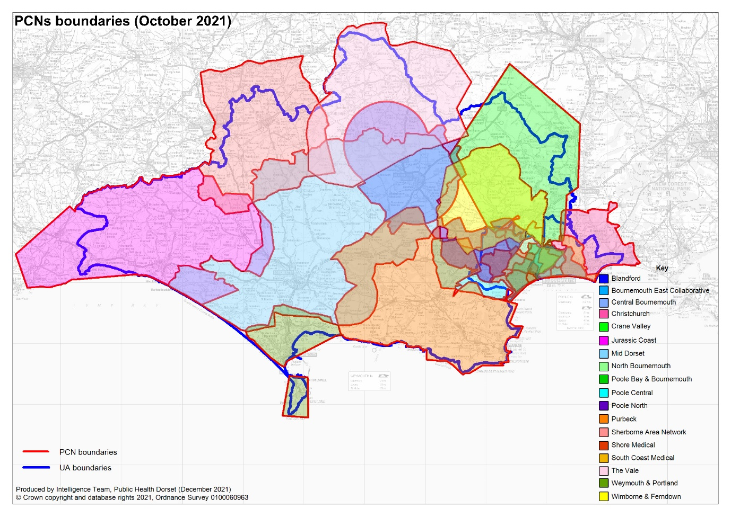

Data collation and mapping
Data from the Census, ONS population estimates, Dorset GP registers, and planning information on known housing developments within the lifetime of the PNA, were collated to help identify population size and characteristics (e.g. age, ethnicity).
The Joint Strategic Needs Assessment, Public Health Dorset Intelligence data, OHID public health data, ONS mortality data, and ONS mid-year estimate populations were used to identify health needs of the population of Dorset and the Primary Care Networks.
Information regarding current service provision, was obtained from OHID, NHSEI and NHS Business Services Authority (NHSBSA). In addition to this, data on locally commissioned services was provided by the commissioners at Public Health Dorset and NHS Dorset. This was then uploaded to the Strategic Health, Planning and Evaluation (SHAPE) tool from OHID and maps of pharmacies were created, to enable assessment for any gaps in the provision of services by location and opening times.

Data Limitations
Whilst every effort has been made to make the data included in this PNA accurate and timely, there are some limitations to the data that need to be considered:
- Data was collated during January – April 2022, an update was provided in June 2022. The data provides a snapshot in time only.
- Pharmacy service data may be inaccurate. For some services, provision of the service has been used as a proxy for a pharmacy being accredited for a service. This will not give an accurate picture of service availability. For example, a pharmacy who has undergone a change in ownership will not have service delivery activity although they may now be accredited to provide the service. Another example would be that the COVID-19 pandemic has meant that some pharmacy services were paused so activity has not been recorded, although the pharmacy is still accredited to provide the service.
- Pharmacy contracts that have undergone a change of ownership may provide a different set of services.
- Pharmacy services may not be openly commissioned. By this we mean that the commissioner may limit the number of pharmacies providing the service. Gaps in these services are created by the commissioner rather than gaps being created by lack of pharmacy provision.
- Surveys were not completed by all contractors. The responses may not be representative as only 23 out of 148 contractors that were open in March 2022 responded. One has subsequently closed.

Public and Pharmacy engagement
In addition to the population health information and relevant demographic data used to support this PNA process, a survey to members of the public was carried out. The survey, which asked about pharmaceutical service use, was made available online for members of the public to complete between 21st Feb 2022 - 20th March 2022. The survey was promoted via both Local Authorities consultation teams and on their public engagement websites and newsletters during that period, by the Public Health Communications team via the Public Health Dorset website, social media channels and relevant newsletters. The promotion was also picked up and promoted in local news outlet (Bournemouth / Dorset Echo). The survey was made available online with printed versions also available on request. A summary of the findings is available in appendix 5.
At the same time, a survey was emailed directly to pharmacies, asking about the services they provide and their willingness to provide future services. Unfortunately, there was a very low response to this survey, so the results are not included as they would not be representative of the pharmacy services available.

Other sources of information
Information was gathered from NHS England and NHS Improvement, the NHS Business Services Authority, Community Pharmacy Dorset, Public Health Dorset, BCP Council and Dorset Council regarding:
- Services provided to residents of Dorset HWB’s area and BCP HWB’s area, whether provided from within or outside of that area
- Known housing developments within the lifetime of the PNA and
- Any other developments which may affect the need for pharmaceutical services
Dorset JSNA documents and the public health intelligence team provided background information on the health needs of the population.

Identifying gaps – criteria for necessary services etc.
Although the 2013 regulations require the PNA to include a statement of those pharmaceutical services that are identified as being necessary to meet the need for pharmaceutical services, there is no definition of this term within the regulations. Therefore, in developing the PNA the Steering Group considered a range of criteria that it could use to assess whether pharmaceutical services met the health needs of the population, identifying desirable improvements and optimising access.
A key challenge for Dorset is our mix of rural and urban areas, therefore accessibility was a key consideration. Although there are online services that can be accessed, our initial engagement found that most people use local services, with most driving or walking to get there. Driving time to premises was therefore felt to be an appropriate proxy for this.
The Steering Group also considered the issue of opening hours and how this might impact on access at different times. Most prescriptions are issued in general practice. Although the GP contract specifies core hours of 8am to 6:30pm Monday to Friday there is no requirement for the practise to be open this whole time. GP practices working together as a PCN may now also choose to provide some extended opening hours between 6:30pm-8pm weekday evenings and 9am-5pm on Saturdays, expected to be in effect later in 2022/23. The Steering Group considered that a good match between GP opening hours and pharmacy opening hours would be beneficial. As information on GP enhanced access plans was not available at the time of writing, the use of 100-hour pharmacies was felt to be a helpful proxy, but without any clear criteria on driving time. The Steering Group did not feel there was a need for 24/7 access given the times when most prescriptions are issued.

The Steering Group therefore agreed that to support ‘the identification of gaps’, for the purposes of this PNA ‘necessary services’ are defined as:
- dispensing of medicines and appliances
- the other essential services in relation to both medicines and appliances
- is accessible to the Dorset population within a 20-minute drive time
Other criteria were viewed as aids in assessment, rather than as rigid tools, and interpreted in the context of the socio-demographic and health profile of the population and consultation responses, with other services, better opening hours, and accessibility of facilities, considered as potential improvements or better access.

Equality and safety impact assessment
BCP Council and Dorset Council use equality analysis as a tool to ensure that everyone can access its services and that no particular group is put at a disadvantage. Equality impact assessments (EIAs) are carried out when policies, strategies, procedures, functions, and services are developed and reviewed. The staff who develop the policy or service complete a template which gives them a series of prompts to consider how to promote equality and avoid unlawful discrimination. They consider the following nine protected characteristics as part of the assessment:
- Gender reassignment
- Race
- Disability
- Age
- Sex
- Sexual orientation
- Religion or belief
- Pregnancy and maternity
- Marriage and civil partnership
As part of the formal consultation the survey asked if there were any aspects of the recommendations that may need particular consideration to make sure services do not have adverse impacts on any specific groups of people, and comments were incorporated into a first stage Equality Impact Assessment (EQIA) for the PNA. As the PNA has not identified any gaps there is no need for a fuller EQIA.

Formal Consultation
Regulations require that a draft PNA is made available for consultation for a period of at least 60 days prior to publication of the final Assessment.
Consultation on this draft PNA commenced on 21 July and remained open until 21 September. Following the consultation period, a consultation report was drafted highlighting the themes from the consultation, and the response from the Steering Group. The report can be seen at appendix 6. The PNA was updated to reflect these responses prior to publication. The PNA is valid for three years from 1st October 2022 to 30th September 2025, when an updated PNA will be produced.

Review and Supplementary statements
After publication of the PNA it will be reviewed periodically. If there are any major initiatives, health requirements, or population changes which could have a significant impact on the assessment, the Steering Group will decide as to whether a revised PNA is required.
A Supplementary Statement explaining changes to the availability of pharmaceutical services may be issued, rather than a revised PNA, where:
- There has been a change to the availability of pharmaceutical services and this change is relevant to the granting of applications to open a new, or relocate a pharmacy; or to provide additional services; and
- the HWB is satisfied that the publication of a revised PNA would be a disproportionate response or is already in the process of producing an updated PNA but is satisfied that there is a need for a supplementary statement in order to prevent significant detriment to the provision of pharmaceutical services
These Supplementary Statements will be a statement of fact and will not make any assessment of the impact of the change on the need for pharmaceutical services within an area. Once issued a supplementary statement becomes part of the PNA.

Local Context
This chapter outlines the local NHS and public health organisations that have a role in community pharmacy in Dorset. It also outlines the demographics and the health needs of the local population that access these services.

Dorset Council and BCP Council
Dorset Council and Bournemouth, Christchurch and Poole (BCP) Council were created as two new unitary councils on 1 April 2019, replacing six borough and district councils, a county council and two previous unitary councils. As unitary councils they are responsible for a wide range of services including social care, housing and planning in their respective areas.
Dorset Council has around 4,500 employees serving a local population of 380,000 residents. The council works closely with local communities, across small rural villages, market towns, and popular coastal destinations to make Dorset a great place to live, work and visit. Over half of the area is designated as an Area of Outstanding Natural Beauty and is home to the only natural UNESCO World Heritage Site in England, the Jurassic Coast. The council has the largest proportion of people aged over 65 of any unitary or county council in the country.
BCP Council employ more than 5,000 people and provide services to around 400,000 residents in predominantly urban areas from Hamworthy in the west to Highcliffe in the east. The council is focused on vibrant communities with outstanding quality of life for the diverse population they serve. This includes a more ageing population in the east and a younger demographic in the west. There is a large Polish and Jewish community, and a variety of faith groups. Bournemouth is host to a university and a large language school, and as such has a significant student population. There is an established LGBT community and the area hosts Bourne Free, an annual festival to celebrate diversity.

Public Health Dorset
Public Health Dorset are a public health service supporting BCP Council and Dorset Council. It is a shared service across both councils that aims to help as many people as possible stay healthier for longer. This is achieved through commissioning and provision of public health services, as well as work with partners to influence the development and delivery of wider prevention work. Services commissioned or provided through Public Health Dorset include:
- Drug and Alcohol Treatment Services
- LiveWell Dorset
- NHS Health Checks
- Sexual Health Services
- Children’s public health nursing
- Community health improvement services such as weight management, smoking cessation and access to long-acting reversible contraception. Where these services are provided by community pharmacies this is covered in section 5.7.

NHS Dorset
NHS Dorset is the name of the NHS Dorset Integrated Care Board (ICB) that was established on 1 July 2022. NHS Dorset will undertake the statutory responsibilities of the clinical commissioning group (CCG) and will also be responsible for planning to meet the health care needs of people and communities in Dorset. NHS England delegated commissioning of primary medical care services (GP practices and PCNs) to the CCG, and this continues with the ICB. This has included work to increase the number of community pharmacists working within GP practices, taking on expanded roles around the management of medicines in primary care. NHS Dorset and NHS England are exploring the potential for further delegation of other primary care services, including Pharmaceutical Services. Delegated primary care functions will be governed through a Primary Care Commissioning Committee.
NHS Dorset also employ a Medicines Optimisation Team who work to bring together all those involved in the use of medicines in Dorset. The team works alongside partners in Dorset to ensure that prescribing, dispensing, and other issues relating to medicines are tackled in a joined-up way to ensure medicines use to meet people’s needs.
The establishment of NHS Dorset provides more opportunities for all local partners across the NHS, local authorities, to work together, building and developing the existing Dorset integrated care system, Our Dorset.

Our Dorset
The Dorset ICS, known as ‘Our Dorset’ is a partnership of Dorset Council and BCP Council, NHS services and the community and voluntary sector, all working together to address local health, wellbeing, quality and financial challenges across the county. Its vision is that everyone will start, live and age well and die with dignity, no matter where they live or what their circumstances are. Dorset became one of England’s first pilot ICSs in 2018, but with recent changes in legislation, this way of working is now being replicated across the country, and there are more opportunities locally for how we can work together. The focus of the ICS is on removing traditional barriers between services and ensuring that people can access the support and care that they need when they need it.
Each Integrated Care system now has two integral parts, an Integrated Care Board (NHS Dorset) and a Health and Care Partnership. NHS Dorset which is the integrated care board (ICB) was established on 1 July 2022 and along with the Dorset Health and Care partnership, the integrated health partnership (ICP), make up the two parts of Our Dorset.
The different partners are visualised in Error! Reference source not found..
- NHS Dorset Partners

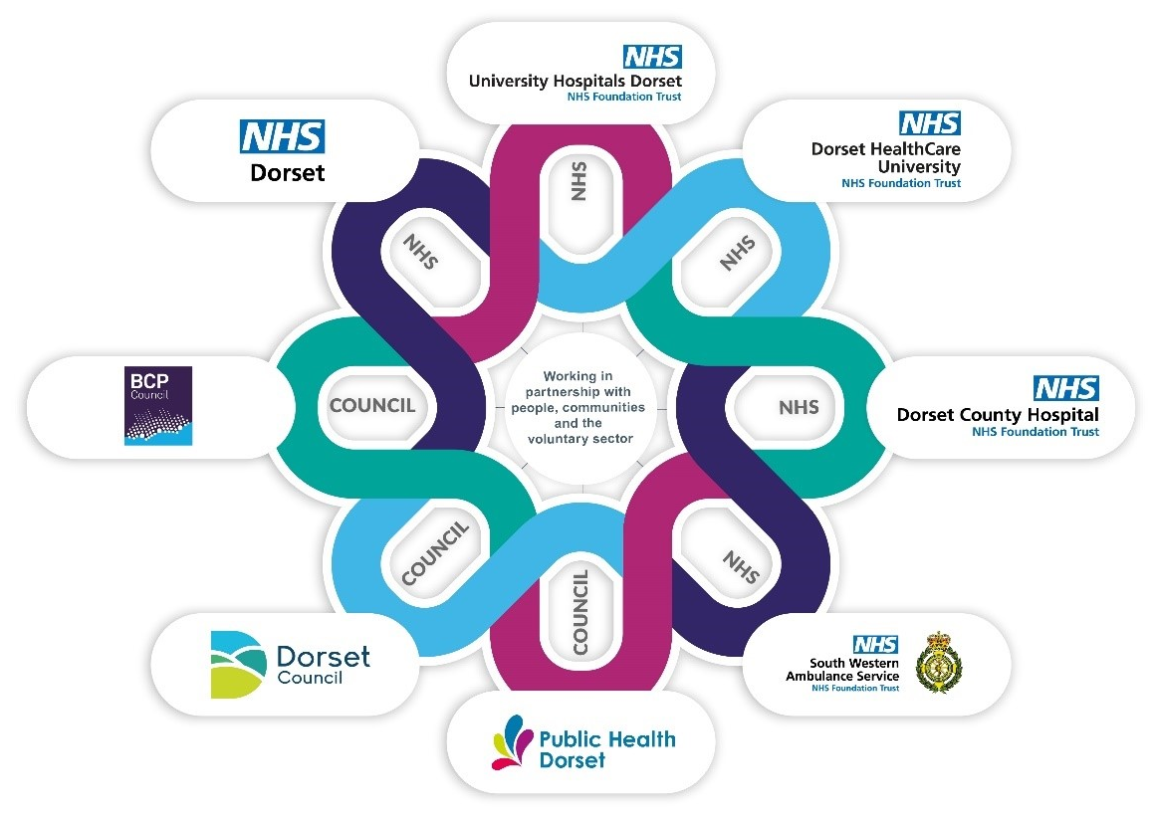The partnership is a statutory function supporting integrated working across the county. They will complement the ongoing activities of the existing Health and Wellbeing Boards by promoting integration from place level to system level. Responsibilities include:
- addressing inequalities in health and wellbeing outcomes and making sure there is better access to health services
- bringing together people and organisations involved with wider issues like employment, education, housing, and crime to support healthier communities
- improving the life chances and health outcomes of babies, children, and young people
- supporting communities to live more independent, healthier lives for longer
Community pharmacies are recognised as a vital part of local communities, offering a range of services to support people's health and well-being, but there is also a national and local drive to integrate pharmacy and clinical pharmaceutical skills into patient pathways through closer working between PCNs and community pharmacies, and expanded roles for community pharmacists working in different settings.

Local Demographics
According to the Census 2021 figures the population of BCP Council is 400,300, and the population of Dorset Council is 379,600. Both BCP Council and Dorset Council populations have a higher percentage of older persons (aged 70 plus), and a lower percentage of younger persons (aged under 20 years) than the England average. Dorset especially has a much higher older population making up 23% of the population compared to the England average of 14%. In Figure 3 the population by 10-year age bands is shown, with the children and younger persons bands shown in yellows and the older persons age bands shown in blues.
Changes in these population figures are shaped by both natural change (births and deaths) and by migration into and out of the area.
- Population breakdown by 10-year age bands for England, BCP Council, and Dorset Council. ONS Census 2021

The populations of both BCP Council and Dorset Council have increased since the previous Census in 2011, BCP Council by 5.7% and Dorset Council by 4.0%. According to Office for National Statistics (ONS) mid-year population estimates data this is expected to continue with a predicted 2% population increase for BCP Council and a predicted 4% population increase for Dorset Council between 2019-2029. For both populations, growth is driven primarily by those aged 65+.
According to the 2011 Census BCP Council and Dorset Council have low levels of ethnically diverse residents with 88.4% and 95.6% respectively identifying as White British, compared to 80.5% for England and Wales. . Figure 4 visualises the ethnic composition of BCP Council and Dorset Council in comparison to the England and Wales average.
- Ethnicity in BCP Council, Dorset Council, and England and Wales according to the 2011 census

The highest proportion of BCP Council’s and Dorset Council’s ethnically diverse population are classified as 'White Other’ (43.5% and 40.7% respectively). This classification includes people who identify as White but who do not have UK national identity (English, Welsh Scottish, Northern Irish and British). An example would be Polish or Irish. The 2021 Census data were not available at the time of writing but will provide insight into whether these figures reflect the current population of Dorset when published.
Deprivation is an important factor of health and well-being for communities and individuals. Where there are higher levels of deprivation, there are consistent associations with poorer health outcomes across a range of measures that represent a major cause of inequalities in health and well-being. Figure 5 and Figure 6 visualise the most and least deprived LSOAs in their respective areas. The Dorset Council areas of deprivation are largely located in the most urban areas, in particular Weymouth and Portland, but many of Dorset’s rural communities could also be considered deprived in terms of barriers to housing and essential services. BCP Council areas of deprivation are also largely located in the most urban areas, in particular areas around the town centres of Bournemouth and Poole.
- BCP Council and deprivation
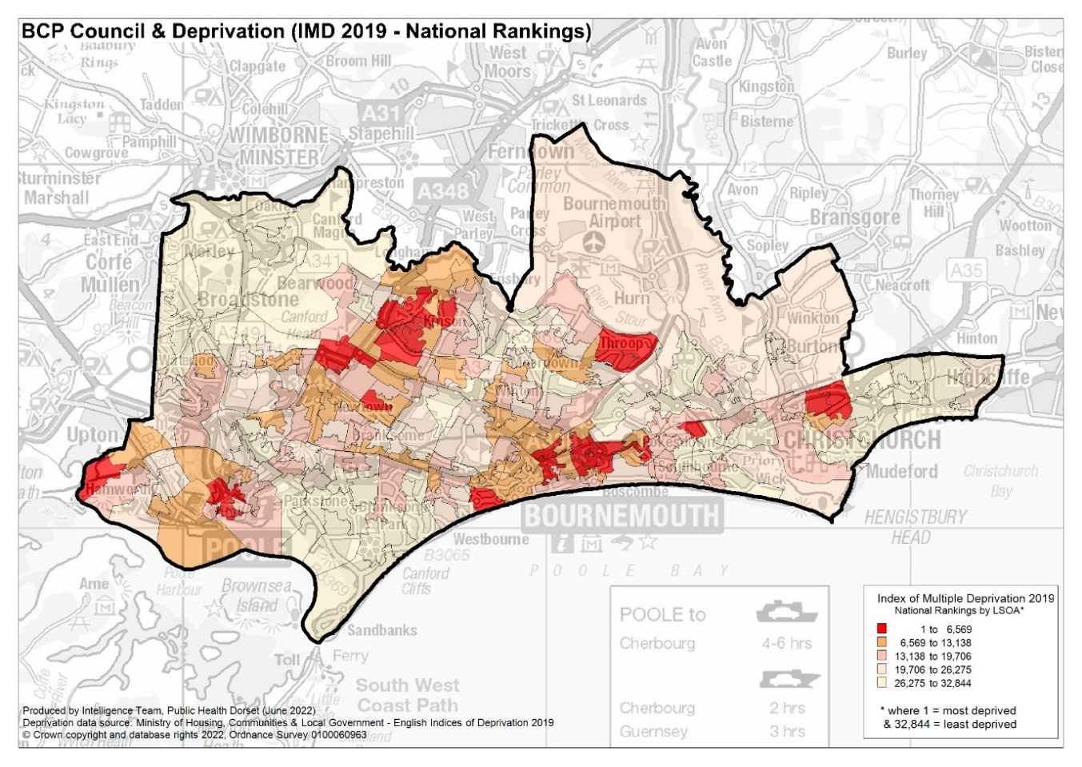
- Dorset Council and deprivation
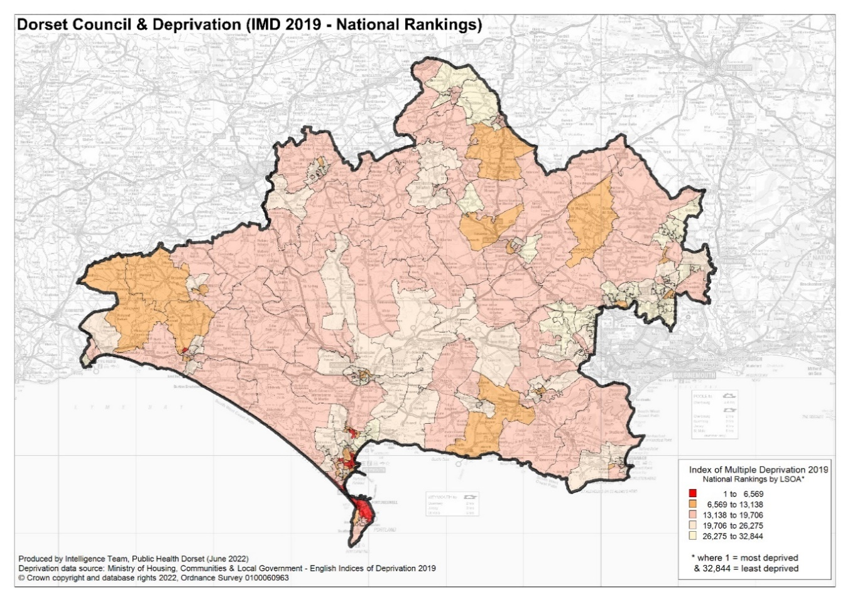

Our Dorset Joint Strategic Needs Narrative
Our Dorset Joint Strategic Needs Assessment (JSNA) is a process used to support Dorset Council and BCP Council Health and Wellbeing Boards to identify key issues and develop their Joint Health and Wellbeing Strategies in response to these.
Routine data underpins our JSNA as it does in many other local authorities. In Dorset our aim though is to go one step further, to better understand local needs through combining ‘stats with stories’. This includes using qualitative and workshop approached to understand topics in more detail than data indicators provide alone.
Overall both Dorset and BCP areas have a growing older population, with those aged 65+ projected to make up over a third of residents by 2029 in Dorset Council. Health in both areas is generally good compared to England, with healthy life expectancy similar to that for England; however, there has been some decline for males in Dorset Council and the latest data does not take account of any impact due to COVID.
Most children and young people in BCP and Dorset thrive and experience good health. However, there are some areas of concern:
- There are areas in both BCP and Dorset Council where there are higher levels of income deprivation affecting children.​
- Obesity – although our rates are lower than England, if each area had a population of 100 children 17 10-11 years olds would be obese in Dorset and 18 in BCP.
- Emotional Health and Wellbeing – it is estimated that 1 in 10 children and young people experience mental health issues​
- Special Educational Needs or Disability - 16% of pupils have a statutory plan of SEN or are receiving SEN support in BCP and 18.1% in Dorset (compared to 15.8% England 2020/21)
- Physical Health – several indicators related to hospital admissions are worse than England rates​ such as hospital admissions for unintentional and deliberate injuries.
For adults, again health and wellbeing in Dorset is generally good compared to England. Key areas of concern from local data are:
- Mental Health – 12.8% adults across Dorset experiencing Depression and/or Anxiety and this prevalence has been increasing. The suicide rate and admissions for self-harm are above the England average. Practitioners across many different services have a perception of rising presentations of low-level mental health issues. ​
- Excess Weight and Obesity – with 65.9% adults overweight or obese​ in Dorset Council and 60% in BCP.
- Physical Activity – 30.6% (100,000 people) of adults in BCP and 19.9% (63,300 people) of adults in Dorset Council area did less than 30 minutes activity per week.
- Food Insecurity - Local needs analysis suggests 5,800 people in BCP and 5,500 people in Dorset are experiencing food poverty, and a further 101,000 and 95,800 respectively are food insecure (can’t afford to meet recommended guidelines).

Recently there has been an apparent decrease in healthy life expectancy at birth for males in Dorset Council. Specific concerns that may play a part in this are:
- Diabetes - Approximately 7.4% of patients aged 17+ in Dorset have Diabetes.
- Dementia - In Dorset, the estimated dementia diagnosis rate (56.8%) is worse than that of England (67.4%).
- Hip fractures and frailty - The rate of hip fractures in the Dorset Council area is better or the same (dependent on age) as the England average, but worse in the BCP Council area. Local insights have also highlighted the challenge of inactivity and its role in falls and frailty.
As well as falling healthy life expectancy for males, we see inequalities in overall life expectancy across both BCP and Dorset area. For example there is just over 11 years difference in life expectancy for males between Colehill and Wimborne Minster East (84.9 years) and Melcombe Regis (73.4 years). One of the biggest contributors to inequalities in life expectancy is cardiovascular disease. Grouping data by general practice, who hold the best information to support our understanding but may still not have the full picture, variation can be seen at every point of the patient's journey:
- Smoking prevalence varies from 6.7% to 33.8%
- Recorded offer of support to stop varies from 50.4% to 100%
- Patients aged 45+ who have a record of their blood pressure varies from 75.9% to 97.2%
- Obesity varies from 3.8% to 16.2%
- Estimated proportion of patients with high blood pressure who have been identified compared to national modelled estimates of prevalence ranges between 40.4% and 84.2%
- Proportion of patients with recorded hypertension whose blood pressure has been managed to within target levels varies from 51.5% to 83.8%

Housing Growth
As discussed in section 4.5 the population of both BCP Council and Dorset Council is growing, with the majority of that growth expected to be within the over 65s age bracket which is likely to impact on future healthcare demand. As such the number of homes within the area is also growing accordingly.
Sites with full planning permission and those likely to proceed within, or those that are already under construction between 2022 and 2025 inclusive come to a total of around 7,682 new homes across BCP Council and 11,211 in Dorset Council. These new homes will be built across all localities, but the largest concentrations are as detailed in Table 1. Each locality profile goes into more depth about local developments and their potential effects on the pharmaceutical service need in the area.
- BCP Council and Dorset Council significant net growth developments
Area | Development | Net dwellings
Poundbury, Dorchester | North Quadrant | 477
Poole Town and Hamworthy | Sydenhams, Blandford Road  Quay West Marina | 374  291
Westcliff | Former Winter Gardens site | 351
Wimborne Minster | Cranborne Rd New Neighbourhood | 312
Chickerell | Urban Extension North  Urban Extension East | 292  280
Blandford | St Mary’s Hill, Blandford St Mary | 269

Car or Van Ownership
Census 2011 data shows that access to a car or van in the household was less likely in more deprived localities, which are for the most part located in more urban areas. The overall rate of no access to car or van for BCP Council was 22% and 15% for Dorset Council.

Identified patient groups
Not all inequality or disadvantage can be seen through a geographical lens. This is perhaps most pertinent when examining health inequalities across the population, and between different groups in society. While there may be concentration of health inequality in some of the region’s low-income communities, individual factors remain crucial. Patient groups who are particularly vulnerable, whom have specific needs that community pharmacy can help to address, or that impact demand on community pharmacy services are outlined in this section.

Asylum seekers and refugees
There are no accurate figures on the total number of refugees or asylum seekers living in the region. The latest figures from the Migration Observatory suggest that there are approximately 36 asylum seekers and refugees in BCP Council and 86 in Dorset Council, but this may be below the true size of this community in the region, with many not receiving support or accommodation from the Home Office. In particular, this figure is unlikely to include the full impact of the Afghan resettlement programme and recent migrants from Ukraine.
The health needs of refugees and asylum seekers are well-documented,, including untreated communicable diseases, poorly controlled chronic conditions, maternity care, and mental health and specialist support needs. In addition, a sizeable minority continue to experience physical injuries and trauma from mistreatment and torture.
Asylum seekers and refugees can face additional barriers to accessing or receiving suitable health care as a result of language barriers, poverty, the impact of existing trauma, or if they have no recourse to public funds in the UK.

Ethnic minorities
The 2011 Census data shows that both BCP Council and Dorset Council have a relatively low level of diversity, ethnically diverse people representing 11.6% of the population in BCP Council, and only 4.4% of the population in Dorset Council. There are well documented links between ethnic origin and health, where people from different ethnic communities have higher levels of illness for some diseases compared to the general population. In addition, differences in cultural background, first language and residence time in a new country may impact on the access and utilisation of health care services.

Disabilities
Defining the specific number of individuals with some form of physical disability is problematic, due to the range and type of conditions that may be considered a ‘physical disability’. According to the 2011 Census approximately 8.6% of the population of BCP Council and 8.4% of Dorset Council reported having a limiting long-term illness or disability that limited day to day activities a lot. 10.4% of the population of BCP Council and 11.4% of Dorset Council reported having a limiting long-term illness or disability that limited day to day activities a little.

People with learning disabilities
People with learning disabilities are one of the most vulnerable groups in society. They are known to experience inequalities in health and as a result suffer poorer health outcomes compared to the general population. In 2020/21, 0.6% of the Dorset GP registered populations were recorded as having a learning disability although this is likely to be an under representation as not everyone is registered.

Sex workers
While there are no accurate local figures, there is estimated to be more than 70,000 sex workers in the UK. Sex workers are at increased risk of ill-health, experiencing violence and substance misuse and can face additional barriers in accessing health care through fear or discrimination.

People who are homeless or sleeping rough
According to MHCLG in 2021 there were 549 households in BCP Council and 242 households in Dorset Council either homeless or at risk of being so. Homeless people, especially those alone, are more at risk of complex health needs including inter-related mental health, drug misuse and alcohol dependency challenges. They are also at increased risk of injury, pneumonia, tuberculosis, dental problems, and hypothermia.

Gypsies, Travellers, and Roma Groups
There are six local authority supported sites, a number of privately owned sites and further unauthorised encampments that support gypsies and travellers. The transient nature of some of these groups can mean they sometimes experience difficulty with registering with a GP practice; however, some groups are recognised to move around within the area as well as in and out of the local area.

Prisoners
People in prison are more likely to experience multiple, sometimes more complex physical and/ or mental health conditions compared with the overall population. These issues are often further complicated by wider health determinants such as homelessness, unemployment, financial problems or insecurity, social isolation, and poor access to health services appropriate to their needs.
Dorset has three prisons: Guys Marsh in Shaftesbury and the Verne and Portland Prison on Portland. Each has a dispensary for their prison population.

Students
BCP Council is home to Bournemouth University, Arts University Bournemouth (AUB) and AECC University College with around 18,000 students studying at Bournemouth University, around 4,000 at AUB and 750 at AECC each academic year. This significantly affects the population make-up of the surrounding wards.

Tourists
As a popular tourist destination Dorset sees a large number of UK and overseas visitors each year. The latest figures show there were approximately 4,162,000 trips to the area between 2017-2019. As such, some of these visitors are likely to utilise the local pharmaceutical services.

Military
Army camps each have their own dispensaries, using Ministry of Defence (MOD) prescriptions. There are two army camps in Dorset: Bovington camp and Blandford camp.

Current services

Health needs that can be met by pharmaceutical services
Community pharmacists and their teams are ideally placed to provide expertise in health advice and prevention, tackling health inequalities, supporting long-term conditions and the treatment of self-limiting common clinical conditions. As such they play an important role in meeting the health needs of the Dorset population.
The most obvious health need that can be met via pharmaceutical services is the need for appropriate drugs and appliances to be dispensed safely with expert advice available. Furthermore, the safe collection and disposal of unwanted or out of date dispensed drugs.
As well as supply medicines for the treatment of both mental and physical health problems, pharmacies can provide accessible and comprehensive information and advice to carers about what help and support is available to them. This is part of the signposting essential service.
The specific services that are offered at pharmacies within Dorset are detailed in section 5.4 to 5.7, between them they contribute to addressing health needs in long-term conditions, sexual health, teenage pregnancy, smoking, seasonal influenza, alcohol and drug usage, palliative care, and related conditions.
Although deprivation is not such a significant issue across all of Dorset there are areas of higher deprivation. Deprivation is a key component of health inequalities; as such, appropriate accessible services on the front line of primary care, such as those provided by community pharmacy, are key to ensuring that people across all communities are able to have their prescriptions dispensed and benefit from a range of associated services as part of the NHS.

Number of Pharmacies and Access
There are a total of 147 contractors providing pharmaceutical services within the Dorset area (77 in BCP Council and 70 in Dorset Council). Of these:
- 142 are community pharmacies (74 in BCP Council and 68 in Dorset Council)
- 2 are distance selling pharmacies (1 in BCP Council and 1 in Dorset Council)
- 3 are dispensing appliance contractors (2 in BCP Council and 1 in Dorset Council)
The majority of community pharmacies operate 40-hour contracts. However, there are 13 100-hour pharmacies within the Dorset area (8 in BCP Council and 5 in Dorset Council), shown with blue crosses in Figure 7. It should be noted that the 100-hour Day Lewis pharmacy (FWT74) at Shelley Manor Medical Centre ceased trading at close of business on 31st May 2022 and Rowlands Boscombe (FF445) (a 40-hour pharmacy) then moved into the premises previously operated by Day Lewis.
- 40 hour and 100 hour pharmacies across Dorset
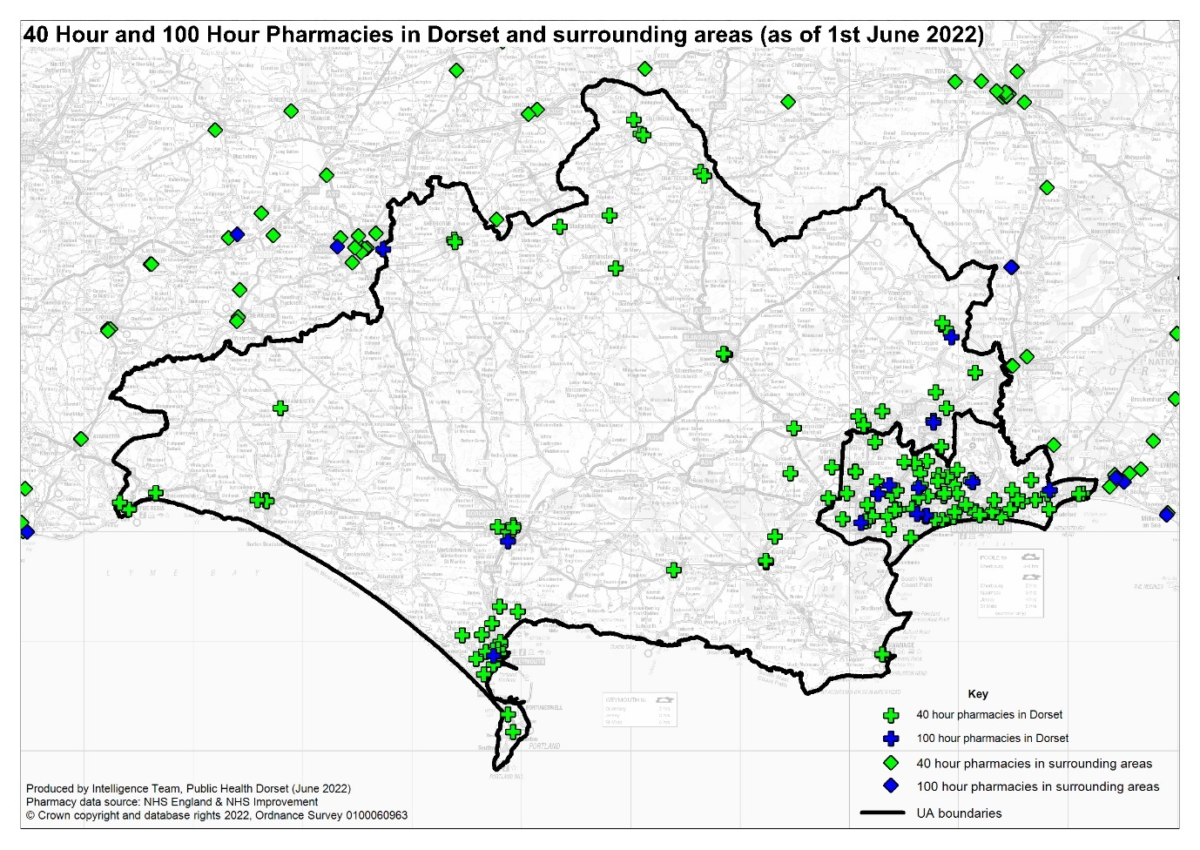

Dispensing GPs
Dispensing GP practices provide a dispensing service during their core hours from Monday to Friday excluding public and bank holidays. The service may also be provided during any extended opening hours provided by the practices.
As of June 2022, there were 16 dispensing practices across 18 sites in Dorset, all in the Dorset council area. Figure 8 displays their location on a map.

- Dorset pharmacies and dispensing practices
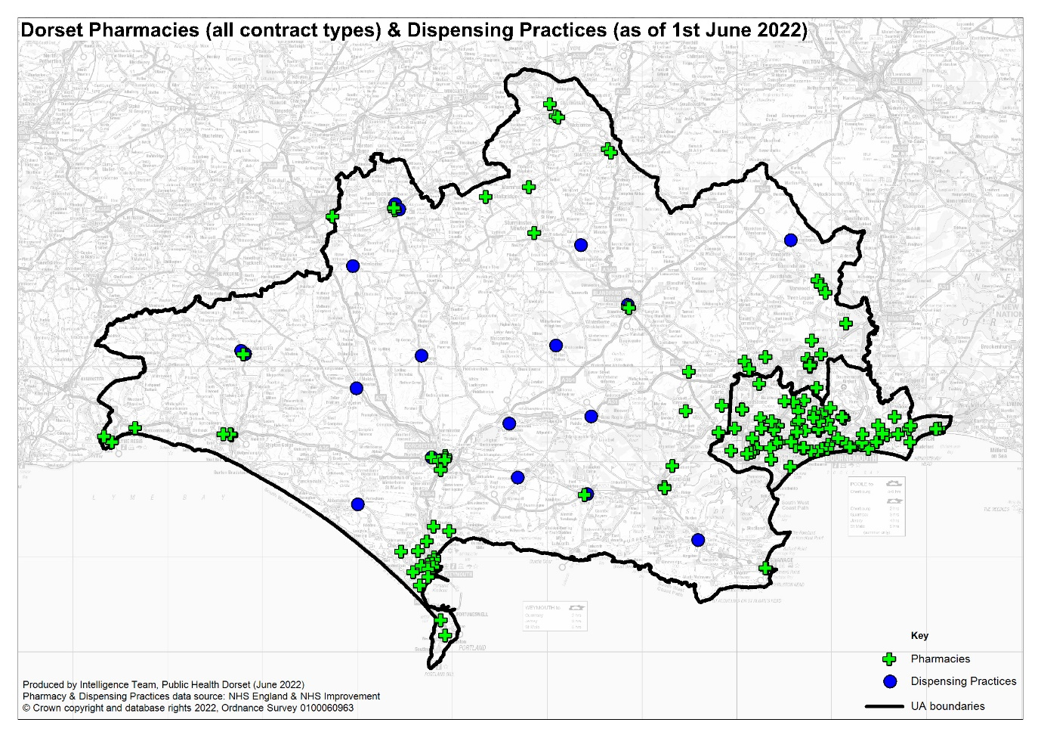

Essential Services
Essential services are provided by all community pharmacies across Dorset as detailed in 2.4.1.

Advanced Services
The advanced services provided by pharmacies across Dorset are detailed in 2.4.2. Table 2 details how many pharmacies in BCP Council and Dorset Council were signed up to deliver each of the advanced services as of April 2022. The hypertension case finding service and stop smoking service are both relatively new and pharmacies are continuing to sign up for these.
- Pharmacies signed up to deliver advanced services in Dorset
 | CPCS | New Medicines Service | Flu | Hypertension case-finding service | Stop Smoking Service
BCP Council | 72 | 66 | 67 | 34 | 9
Dorset Council | 66 | 65 | 64 | 47 | 21
Total | 138 | 131 | 131 | 81 | 30

 | Appliance Usage Review | Stoma Appliance Customisations | Hep C Testing Service | Lateral Flow service
BCP Council | 3 | 16 | 2 | 72
Dorset Council | 1 | 10 | 1 | 67
Total | 4 | 26 | 3 | 139

Enhanced services
The potential enhanced services that can be commissioned are detailed in Appendix 3: Enhanced Service list and section 2.4.3. NHS England currently commissions the following enhanced service in Dorset:
- Pharmacy Urgent Repeat Medication (PURM), of which 105 pharmacies are signed up to deliver.

Locally commissioned services
Locally commissioned services are commissioned by Public Health Dorset, Dorset Council, BCP Council, or NHS Dorset, these include:
- Emergency Hormonal Contraception (EHC) and Chlamydia
  - Describe the availability of emergency contraception, especially among young people.
  - Improve access to Emergency Hormonal Contraception (EHC) and sexual health advice for women who have had unprotected sex.
  - Effectively administer EHC with users and help contribute to a reduction in the number of unplanned pregnancies.
  - To signpost service users who may have been at risk of Chlamydia to access online Chlamydia testing services.
  - To provide free condoms to the service user as part of the consultation.
  - To increase awareness of and where appropriate refer to the integrated sexual health service for service users’ contraceptive or STI needs.
  - To reduce women’s repeated reliance on EHC through behaviour change interventions and effective referral for contraception.
- Needle Exchange
  - Provide sterile injecting equipment
  - Provide information and advice around changing lifestyles
  - Provide basic information on minimising the complications associated with drug misuse
  - To signpost support services for people who use alcohol or other drugs
- Supervised Consumption
  - Appropriately supervise the consumption of prescribed medicines, ensuring that the dose has been administered and consumed as required by the prescription, to the patient.
  - Provide direct input to promote harm reduction, including recognising people with physical health problems or severe mental health problems and signposting them to appropriate services.
  - Actively encourage Service Users to access hepatitis B immunisation and to complete the course.
  - Emphasise the risks of overdose, strategies to reduce those risks and to respond to overdose (including polydrug use and alcohol misuse).
  - Advise on safer sex, sexual health, HBV immunisation and HBV, HCV and HIV testing.
- NHS Health Checks
  - Identify people at risk of cardiovascular disease using a structured approach as part of the national NHS Health Check programme
  - Support clients to take action to reduce their risk as far as possible
- Smoking Cessation
  - Reduce smoking related illnesses and deaths by helping clients to give up smoking or reducing the harm caused by smoking tobacco.
  - Improve the health of the population by reducing exposure to second- hand smoke, promoting smokefree homes and cars (especially cars carrying children).
  - Reduce health inequalities by offering individual, flexible support through a range of delivery methods (including face to face and telephone), that is sensitive to the needs of high priority groups e.g. routine and manual workers, clients with mental health issues and/or long-term medical conditions.
  - Support clients to access additional behavioural and lifestyle support by promoting or signposting to Live Well Dorset.
- Palliative care service
  - to stock a list of specific medicines that may be required urgently in support of end-of-life care, supporting patients to remain at home if they wish. This is currently provided by a small number of community pharmacies in key locations, selected on the basis of their location and where possible for being able to provide easy access and extended opening hours. Some of the pharmacies providing this service are open for 100 hours a week.

Access to pharmaceutical services on public and bank holidays
NHS England and NHS Improvement has a duty to ensure that residents of the Health and Wellbeing Board’s area can access pharmaceutical services every day. Pharmacies and dispensing appliance contractors are not required to open on public and bank holidays, or Easter Sunday, although some choose to do so.
NHS England and NHS Improvement asks each contractor to confirm their intentions regarding these days and where necessary will direct a contractor or contractors to open all or part of these days to ensure adequate access.

Other Services
The following services affect the need for pharmaceutical services within its area:
- Hospital pharmacies – Hospitals will soon be able to use EPS (electronic transmission of prescriptions) and there may be an increased need for them to send out to community pharmacy. At present outpatient prescriptions are dispensed in-house by contracts awarded (outsourced) by Bournemouth & Poole (University Hospitals Dorset NHS Foundation Trust (UHD)) and in house by a wholly owned subsidiary in Dorset County Hospital Foundation Trust (DCH). UHD provides acute, elective, and specialist healthcare across two main hospital sites, Bournemouth Hospital and Poole Hospital, as well as some community-based services out of Christchurch Hospital. DCH provides acute, elective, and specialist healthcare. Dorset Health Care University Foundation Trust provides community and mental health services across over 300 sites, ranging from village halls and GP surgeries to mental health inpatient hospitals and community hospitals - as well as in people's homes.
- Weymouth Hospital Urgent Treatment Centre - services at this centre will affect the need for pharmaceutical services, in particular the dispensing of prescriptions across the opening hours.
- Prison pharmacies – Where prescriptions written in prisons are dispensed in prison pharmacies the demand for the dispensing essential service may be reduced; however, in some areas, local pharmacies are used.
- Hospices - there is one hospice in Poole, the Forest Holme hospice which is part of the United Hospitals Dorset NHS Trust. There is an independent hospice in Dorchester, Weldmar Hospice, care which also provides support to people at home in the west, south and north of Dorset. These generate a very small number of prescriptions that are dispensed by community pharmacies.
- Drugs and Alcohol services support those experiencing issues with substance misuse including alcohol to improve their health, wellbeing, and employability, and includes specialist prescribing of substitution therapies for those who need it, with close links to community pharmacies. In the Dorset Council area this is provided by Reach - a partnership between EDP Drug and Alcohol Services (EDP), and Avon and Wiltshire Mental Health Partnership Trust, and in the BCP council area by We Are With You.
- Additional roles in PCNs – Increasing numbers of clinical pharmacists and pharmacy technicians are now working in Primary Care Networks with and alongside the general practice teams, taking on expanded roles which may be patient-facing or based more on technical skills and audit.
- Extended GP access – each PCN is currently developing plans to ensure that more of their patients can access routine GP appointments in the early evenings and at weekends, providing more options for those who are working. Therefore, demand for prescriptions at extended opening times may be needed.
- South Western Ambulance Services Trust (SWAST) provide emergency response.

Gap analysis
The purpose of this analysis is to ascertain if there is a gap or potential future gap in the provision of community pharmacy in Dorset. Based on the necessary services definition (defined in section 3.8) the following criteria form the basis of the analysis:
- All parts of the population should have general access to a physical community pharmacy or be within range of a dispensing GP practice. Industrial and trading estates are not residential areas so will not form part of the gap analysis.
- Pharmacies located outside the borders of Dorset can qualify as providers of access if Dorset providers do not suffice in certain areas.
- In all areas the population should be within 20 minutes driving time of at least one of the above providers.
- All community pharmacies should dispense medicines and appliances and provide the other essential services in relation to both medicines and appliances.
The above criteria are considered both for the current population and the potential population as based on planned housing developments in Dorset.
Further factors that would not signify a gap in provision, but that are considered to contribute to improvements are:
- The majority of the population should be within 30 minutes driving time of a 100-hour pharmacy.
- Accessibility of the service for identified patient groups.
- A choice of service providers.

Access to Pharmaceutical Services in Dorset
Nationally, a common aim is for access to a pharmacy for 99% of the population (including those living in the most deprived areas) to be possible within 20 minutes by car.
Accordingly, the Steering Group has chosen 20 minutes by car to any community pharmacy or dispensing practice, or 30 minutes by car to a minimum 100-hour pharmacy as a reasonable time for residents to take to access a pharmacy. As can be seen in Figure 10, much of Dorset Council has a low population density due to how rural the area is. In Figure 9 it can be seen that although parts of BCP Council have a higher population density, the area is well supplied with pharmacies and, as the geographic footprint is small, much of the area can be covered within 30 minutes by public transport. According to the engagement survey (Appendix 5: Public Engagement Survey Summary) driving was also the most common way of travelling to a pharmacy with 52% of responses, followed by walking with 40% of responses, and 3% by public transport. In section 4.8 it is noted that 78% of BCP Council households and 85% of Dorset households have access to a car or van. As such, drive time was chosen as the most appropriate measure of access.
- BCP Council pharmacies by population density
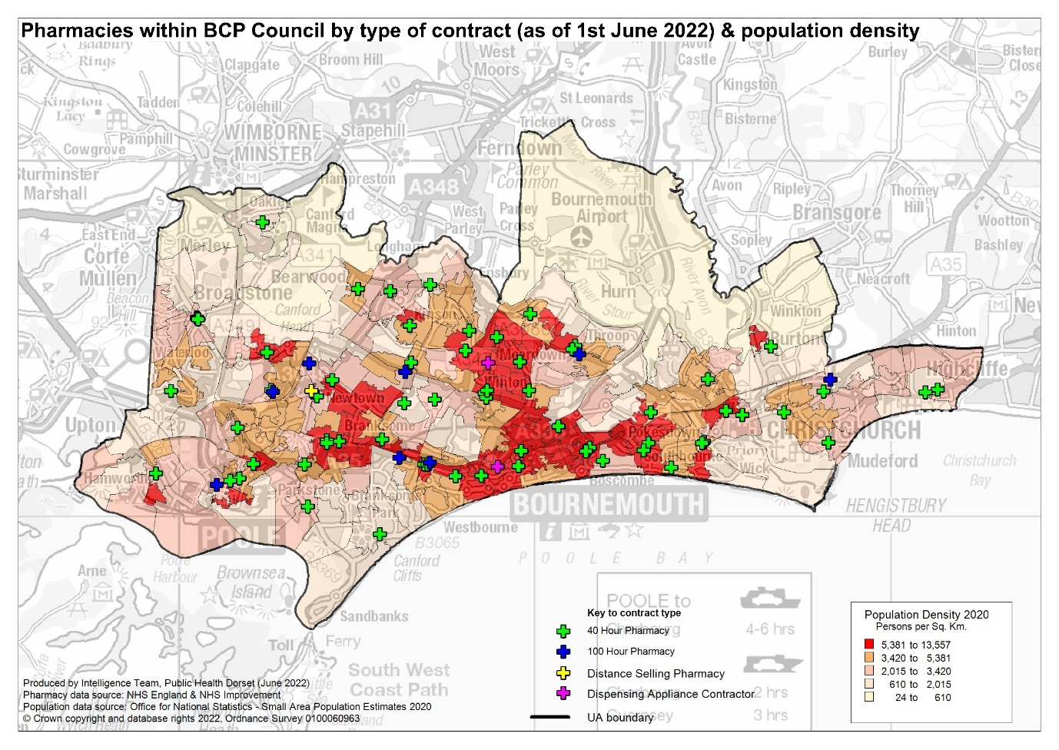
- Dorset Council pharmacies by population density
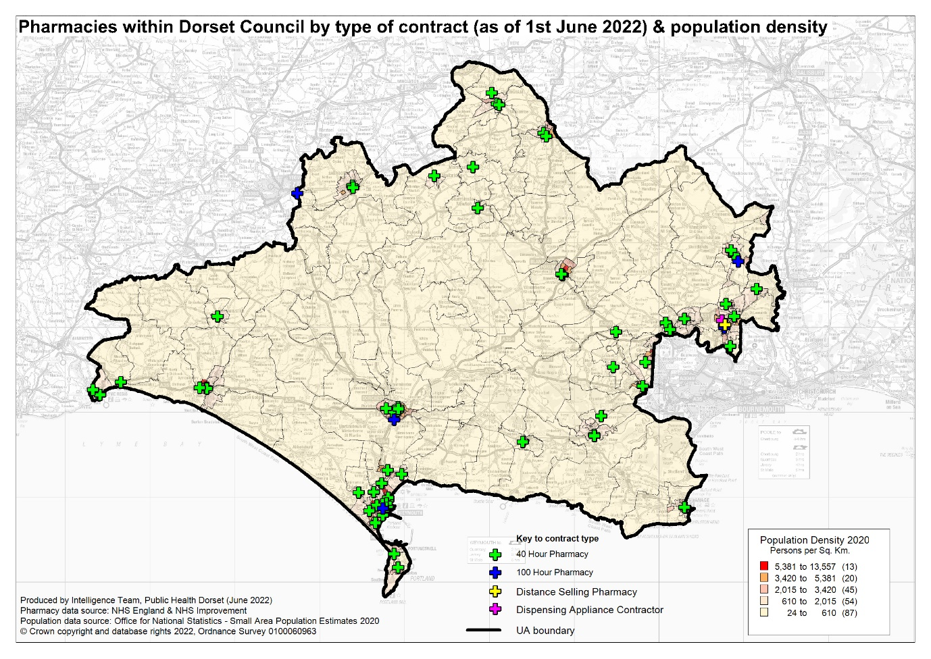
Figure 11 shows that the majority of residents within Dorset would be able to access a pharmacy within a 20-minute drive time. In particular localities where the most deprived areas are situated (Bournemouth East Collaborative Network PCN, Poole Bay & Bournemouth PCN, and Weymouth & Portland PCN), there is a very high proportion of residents living within a 20-minute drive of a pharmacy.

However, there is a rural area with a low population density in the centre of Dorset where residents would not be able to access a pharmacy within a 20-minute drive time. The GP practices in these areas are dispensing practices and all the patients in these very rural areas are eligible to access dispensing services from these practices; once these are included, all residents can access appropriate provision within a 20-minute drive time, and the majority within 15 minutes. This is mapped in Figure 12.

- Access to Dorset community pharmacies within a 20 min drive time
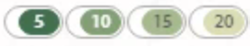
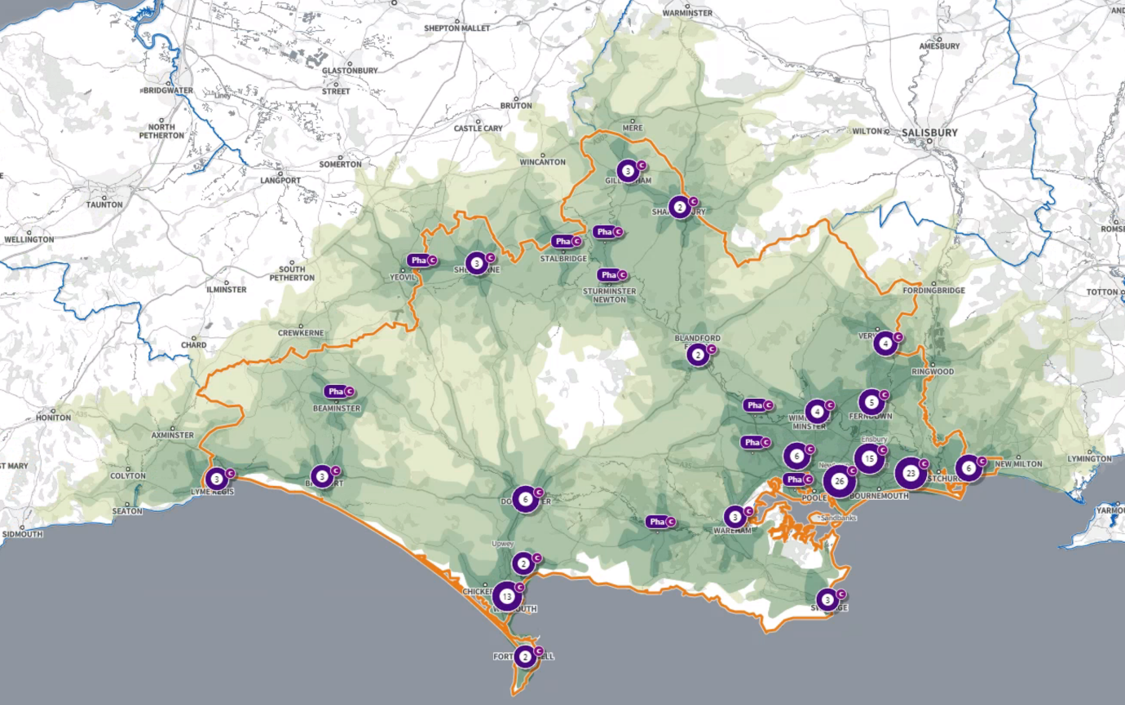
- Access to Dorset community pharmacies & dispensing practices
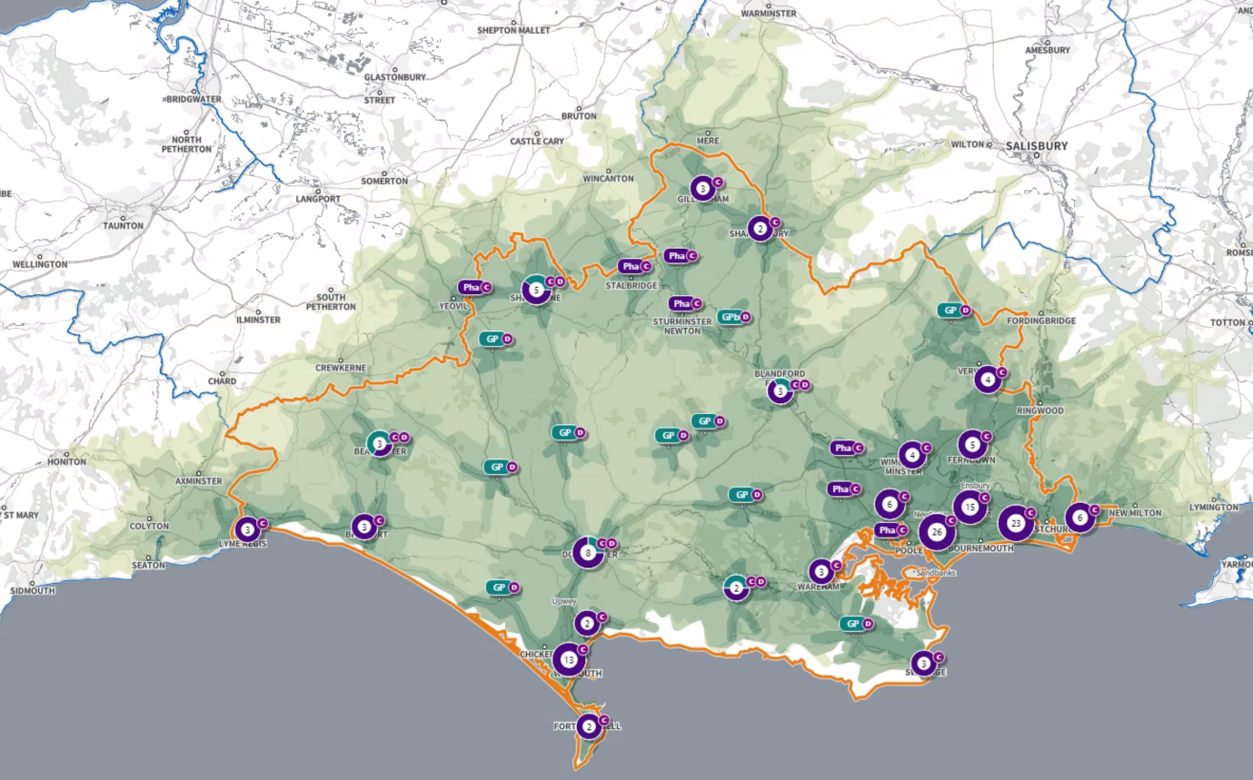
An additional consideration for the PNA was the accessibility of community pharmacy services outside of office hours. As such, a map of the 100-hour pharmacies in Dorset and the surrounding area (within a 10km buffer zone) was produced and it was concluded that the majority of Dorset would be able to access a 100-hour pharmacy within a 30-minute drive time. The high population density areas, and areas with higher levels of deprivation are particularly well supplied. There is an area in the north of Dorset that would not be able to access a 100-hour pharmacy within a 30-minute drive time, this area has a low population density and is served by dispensing GPs.
According to this analysis, the current population of Dorset is able to access a physical community pharmacy or is within range of a dispensing GP practice as set out in the criteria at the start of this chapter, as such no gaps have been identified.
- Access to Dorset 100-hour pharmacies (with 100 hr pharmacies in surrounding 10km buffer) within a 30 min drive time
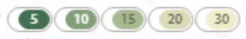
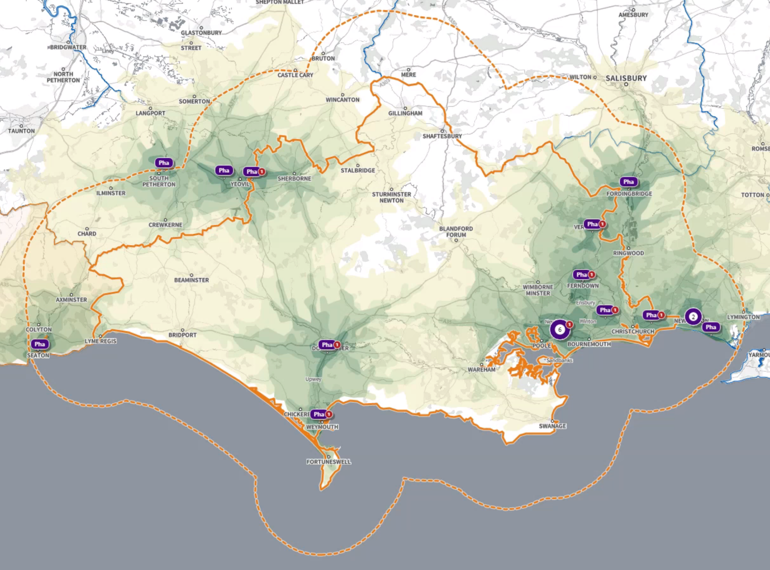

Opening Hours

Detailed opening times of all pharmacy contractors in Dorset are shown in Appendix 7: List of community pharmacies and opening times. Earliest opening times and latest closing times are visualised for each PCN in the locality profiles.
In summary there are 129 40-hour community pharmacies and 13 100-hour community pharmacies in Dorset. There are 3 DACs and 2 distance-selling pharmacies that also operate a minimum of 40 hours.
There is at least one pharmacy open until at least 6:30 p.m. every day, and at least one open on a Saturday in every locality. Most localities also have at least one pharmacy open on a Sunday.
Pharmaceutical services in the out-of-hours period are principally supported by 100-hour pharmacies. Together, the current 100-hour contract pharmacies offer the local population good access to pharmaceutical services during evenings, weekends and bank holidays. Drive times shown in Figure 13 may be optimistic in periods of heavy traffic but are realistic late at night and on Sundays when the services would be required.
In regard to opening hours across Dorset, all localities have good provision during office hours, and at least provision until 6:30 p.m. on an evening and during Saturday daytimes. There is the potential that any further reduction in 100-hour contracts could be detrimental to access and should trigger further review and development of a supplementary statement. As it stands, no gaps in provision have been identified.

Housing Growth
To understand any increases in demand for services based on planned housing developments, planning applications with consent to build to 2025 in BCP Council and 2026 in Dorset Council were analysed. Postcodes (or the nearest existing postcode to the development site) have been matched to LSOAs and then PCN networks to give a realistic picture of housing growth within the PCN. As such, each locality profile details the specifics of the planned housing developments in the area. The Consultation draft summarised that new build plans suggest that all new housing areas in Dorset in the period up to March 2025 would meet the appropriate criteria set out at the start of this chapter, and that no gaps had therefore been identified.
During the consultation a minority of responses disagreed, with some specific comments highlighting specific locations where people felt there might be a gap. For each of these locations the Steering Group reviewed the relevant comments alongside the information available for the relevant PCN as well as more local information where relevant and provided a more detailed rationale of their decision, as set out below.

Roeshot Hill development, Christchurch, BCP council area
One person commented on housing development in the Christchurch area, particular the Roeshot Hill development, suggesting that additional facilities may be required.
The Steering Group reviewed the information for this area and concluded that the additional planned housing and impact on services from developments in Christchurch Town Centre (204) particularly in the Priory area, and Mudeford, Stanpit and West Highclife (248) were considered within the Christchurch PCN profile when the consultation PNA was drafted. There are a good range of pharmacies within Christchurch, and they are pretty well spread out, plus there are pharmacies on the borders in Tucton, Southbourne and Castle Lane. The PCN has a much higher number of pharmacies per 100,000 than either the Southwest or England, along with much higher items dispensed per patient. The Steering Group therefore confirmed that there was no future gap identified in this area.

Shaftesbury and Gillingham, The Vale PCN, Dorset council area
A range of comments were made about service levels and waiting times, with staffing and closures mentioned, but increased demand from planned housing expansion was also raised as a concern.
The Steering Group reviewed the information for this area and concluded that the additional planned housing and impact on services from developments in Gillingham (404) particularly Bourton and Gillingham Town areas, and Shaftesbury Town (336) were considered within The Vale PCN profile when the consultation PNA was drafted. Whilst there are additional developments planned in these towns, there are 3 pharmacies in Gillingham and 2 in Shaftesbury, which is relatively good for towns of this size. Looking at data for the Vale PCN, it has higher items dispensed by patient than figures for the Southwest or England, but also a higher number of pharmacies per 100,000 than the Southwest or England. The Steering Group therefore confirmed that there was no future gap identified in this area.

Portland, Weymouth and Portland PCN, Dorset council area
Comments included issues around local demand on pharmacy services and waiting times and expressed concern due to the impact of population and housing increases.
The Steering Group reviewed the information for this area and concluded that the additional planned housing and impact on services from developments in Chickerell (694), Rodwell & Wyke (484) particularly around Rodwell and the Nothe, Westham (471) particularly west, and Littlemoor and Preston (362) were considered within the Weymouth and Portland profile when the consultation PNA was drafted. Historically Weymouth and Portland have had more pharmacies per head of population than average, and this continues to be the case, although they do also have higher items dispensed per patient than the Southwest or England average. There are existing pharmacies in all the areas identified for further housing development, including 2 on Portland. Some of the issues identified in the comments relate to current staffing and workforce issues, covered in section 6.7, rather than the planned housing developments. The Steering Group therefore confirmed that there was no future gap identified in this area.

Poundbury, Mid Dorset PCN, Dorset council area
The planned housing developments as well as existing pharmacy demand were raised as a concern.
The Steering Group reviewed the information for this area and concluded that the additional planned housing and impact on services from developments in Poundbury North (647) and West Dorchester (400) particularly Brewery Square were considered within the Mid-Dorset PCN profile when the consultation PNA was drafted. There has also been discussion about the impact on health services of these developments as building plans were being drafted. There are 5 pharmacies within Dorchester, sufficient for the additional demand, although 3 of these are relatively close together in Dorchester town centre. Looking at data for mid-Dorset PCN, it has higher items dispensed by patient than figures for the Southwest or England, and the number of pharmacies per 100,000 falls between the Southwest and England figures. The Steering Group therefore confirmed that there was no future gap identified in this area. The Steering Group considered that relocation of one of the existing pharmacies in Dorchester to provide a better spread across Dorchester and Poundbury including the new areas of development could lead to improved access in the future.

Purbeck PCN, Dorset council area
The growing elderly population in the Purbeck area generally was also commented on as a potential consideration point for need.
Although this was a more general comment about population growth, particularly in older age groups, the Steering Group felt it was helpful to review the housing development information for this area to understand where such growth might occur. The overall planned development for Purbeck PCN area is around 1568 dwellings, mostly dispersed across the area. The more concentrated areas of development in Wool, Lytchett Matravers and Upton (293), Corfe Mullen (154) are in areas that already have pharmacies, and Crossways (207) is covered by a dispensing practise from mid-Dorset PCN. A key consideration in developing the Purbeck Local Plan submission was to help deal with the local gap between average income and average house prices by providing affordable homes for local people, helping young people who want to stay in the area, and providing homes for people who provide care and support to older residents. This means that housing developments could enable a younger demographic group into the area. Overall, data for Purbeck PCN does show higher items dispensed per patient than the Southwest and England figures, not unexpected given the higher proportion of people aged 65 & over. The PCN also has a higher number of pharmacies per 100,000 people than the Southwest and England. The Steering Group therefore confirmed that there was no future gap identified in this area.

Services
All community pharmacies provide the necessary services as defined in section 3.8 and highlighted at the start of this chapter.
Advanced services are also provided, details of provision are included in the locality profiles. As such the services provided meet the appropriate criteria and no gaps have been identified.
During the consultation some respondents described examples of dispensing inefficiency or issues with the amount of medication ordered. The Steering Group considered the responses and confirmed that no gap was identified but did recommend that these examples were shared with commissioners and the medicines team at NHS Dorset to support potential service improvement in the future. The Steering Group recommended that at least one health campaign over the next three years should focus on encouraging patients to only order the medicines they need.

Choice of service provision
Patients can choose where they access pharmaceutical services; this may be close to their GP practice, their home, their place of work or where they go for shopping, recreational or other reasons. As a result, some of the prescriptions written for Dorset registered patients are dispensed outside the area.
Generally, the demand for pharmaceutical services by the population registered to GP practices within Dorset is met by pharmacies from within the two HWB areas, with pharmacies outside of the Dorset area providing a small amount of dispensing, likely due to ease of access. These include pharmacies in the neighbouring local authorities Somerset, Wiltshire, Hampshire and Devon.
According to the engagement survey 73% of responders collect their medication from a pharmacy in person, for 13%, someone else collects it for them, 7% use an online delivery service, and 5% collect it from a dispensary in their GP surgery. Of the respondents to the survey, 83% use the same pharmacy each time, and 17% use multiple pharmacies. Reasons for using the same pharmacy included being near or attached to the GP surgery, being the nominated pharmacy for prescriptions, the convenience of the location and/or ease of access, and good customer service. Reasons for using multiple pharmacies included convenience of location or opening times, use of different pharmacies for different products or services, and the unavailability stock.
Distance-selling pharmacies make up around 6.2% of dispenses. There are two distance selling pharmacies within Dorset, and a further 370 nationally, any one of which residents can choose to use.
DACs are specialist services for the dispensing of medical appliances of which there are three in Dorset, and many others operating nationally that Dorset residents can access.
In summary the choice of pharmaceutical services in Dorset is reasonable. The population of Dorset access pharmacies in different ways. Typically, in the rural areas, people will access a range of services through their local GP and pharmacies in their local market town. In addition, supermarket or out-of-town retail areas offer other ways of accessing pharmaceutical services. In the urban areas of Bournemouth and Poole, the population have a greater choice of pharmacies. Changing technology also offers access to internet pharmacy services, which may be based anywhere in the UK. Therefore, the level of choice available in Dorset meets the appropriate criteria and no gaps have been identified.

Meeting the needs of specific populations:
Section 4.9 identifies vulnerable groups and communities that may have specific health needs that should be recognised by community pharmacy in Dorset. As well as an awareness of these populations and their health needs, there are services and facilities that can be put in place to ensure their needs are met.
First and foremost, all pharmacies are required to be compliant with the Equalities Act. This legislates against direct discrimination against any person for the supply of goods or services. Pharmacy contractors are required to make reasonable adjustments to accommodate any person with a disability both on their premises and in terms of service, for example, wheelchair access and ramps. Wherever possible, provision of disabled-friendly services (wheelchair accessible consulting rooms, provision for those with visual or hearing difficulties, etc.) should be considered an important aspect of good service provision.
Considering the number of residents who are from an ethnic minority (section 4.5), the number of those unable to speak English are likely to be small; however, where this occurs it creates a barrier to access. Community pharmacies in Dorset must be able to signpost people to language access services. All pharmacies in Dorset can utilize the NHS interpretation and translation services, although in the past not all pharmacies were aware of how or where to access help with translation in such situations. NHSE have clarified that services can access help through the NHS England local office when required, however this can take time to arrange and may not be immediately available. Working with language interpreters and translators helps provide optimal patient care as it can reduce communication barriers between practitioner and patient. It has been shown to improve safety with respect to diagnosis and prescription.
Homeless people can register with a General Practice and then access community pharmacies for dispensing medication. In addition, anybody who is homeless can also access advice and support from a community pharmacy without GP registration or the need to provide an address.

Community pharmacy workforce
The community pharmacy workforce was not one of the criteria considered by the gap analysis. We know that there have been difficulties in community pharmacy recruitment in Dorset for some years, which has been highlighted further with the development of additional and expanded roles for pharmacists and technicians. The issue also came through very strongly in the community engagement survey and in the formal consultation.
Pharmacy leaders in Dorset have identified the workforce challenges in relation to registered Pharmacists and Pharmacy technicians. Various initiatives have been underway since 2019 to address some of the challenges, but none of them are likely to have rapid results. We have already increased the numbers of trainee pharmacists and trainee pharmacy technician places in the county and the development and retention of staff is the priority of a pharmacy faculty that is meeting and supporting joint working between organisations. The local teams work closely with workforce leads, the Dorset People Committee and Health Education England to maximise any opportunities for funding and development of the local workforce.
The Steering Group recommended that the pharmacy workforce challenge was highlighted as a high priority for Our Dorset.

Conclusion
Throughout this PNA the provision of pharmaceutical services across Dorset has been considered in conjunction with the demography and health needs of the population. Analysis has been conducted as to whether the current provision meets the needs of the population, both as a whole and at a locality level (see individual locality profiles), and whether there are any potential gaps in pharmaceutical service provision either now or within the lifetime of the document.
Taking into account the range of information considered within this needs assessment, including current provision of services across the area, the results of the public survey, and the formal consultation it can be concluded that there is appropriate provision of pharmaceutical services in Dorset.
The anticipated increase in housing developments in each locality area over the next three-year period until 2025 will not have a significant impact on the overall provision of pharmaceutical services and at present it is not anticipated that additional pharmacy facilities will be required.
The consultation raised one issue for the Dorset Council area, where the PNA now indicates that future improvements to access could be made.

BCP Council necessary services – current provision
For this PNA, the Steering Group has agreed that necessary services are:
- dispensing of medicines and appliances
- the other essential services in relation to both medicines and appliances
- is accessible to the Dorset population within a 20-minute drive time
Based on the information available at the time of developing this PNA no current gaps in the provision of necessary services have been identified in any of the localities across BCP Council.

BCP Council necessary services – future provision
Based on the information available at the time of developing this PNA no gaps in the need for the necessary services in specified future circumstances have been identified in any of the localities across BCP Council.

BCP Council other relevant services - current provision
For the purposes of this pharmaceutical needs assessment, the Steering Group has agreed that other relevant services are the locally commissioned advanced and enhanced services.
Based on the information available at the time of developing this PNA no gaps in the current provision of other relevant services or in specified future circumstances have been identified in any of the localities across BCP Council.

BCP Council improvements and better access – gaps in provision
Based on the information available at the time of developing this PNA no gaps have been identified in essential services, advanced services, or enhanced services that if provided either now or in the future would secure improvements, or better access, to essential services in any of the localities. Future improvements and better access are best managed through working with existing contractors and improving integration with other services and within Primary Care Networks rather than through the opening of additional pharmacies.

Dorset Council necessary services – current provision
For this PNA, the Steering Group has agreed that necessary services are:
- dispensing of medicines and appliances
- the other essential services in relation to both medicines and appliances
- is accessible to the Dorset population within a 20-minute drive time
Based on the information available at the time of developing this PNA no current gaps in the provision of necessary services have been identified in any of the localities across Dorset Council.

Dorset Council necessary services – future provision
Based on the information available at the time of developing this PNA no gaps in the need for the necessary services in specified future circumstances have been identified in any of the localities across Dorset Council.

Dorset Council other relevant services - current provision
For the purposes of this pharmaceutical needs assessment, the Steering Group has agreed that other relevant services are the locally commissioned advanced and enhanced services.
Based on the information available at the time of developing this PNA no gaps in the current provision of other relevant services or in specified future circumstances have been identified in any of the localities across Dorset Council.

Dorset Council improvements and better access – gaps in provision
Based on the information available at the time of developing this PNA, future improvements and better access are best managed through working with existing contractors and improving integration with other services and within Primary Care Networks rather than through the opening of additional pharmacies.
The PNA identifies that access to essential service could be improved in the future through relocation of one of the existing pharmacies in Dorchester to provide a better spread across Dorchester and Poundbury including the new areas of housing development.
No other gaps have been identified in essential services, advanced services, or enhanced services that if provided either now or in the future would secure improvements, or better access, to essential services in any of the localities.

Our Dorset – local recommendations
Based on the consultation on the draft PNA, the Steering Group made two additional recommendations that will support improved use of medicines for the Dorset Integrated Care System:
- that the pharmacy workforce challenge is a high priority for Our Dorset, and
- that at least one health campaign over the next three years should focus on encouraging patients to only order the medicines they need.

Appendix 1: Acronyms and definitions

AandE accident and emergency
AUR appliance use review
BAME black and Asian minority ethnic
BCP Bournemouth, Christchurch and Poole
CCG clinical commissioning group
CHD coronary heart disease
COPD chronic obstructive pulmonary disease
DAC dispensing appliance contractor
DH Department of Health
DRUM dispensing review of the use of medicines
DSP distance-selling pharmacy
DSQS dispensary services quality scheme
EHC emergency hormonal contraception
EIA equality impact assessment
EPS electronic prescription service
GIRES Gender identity research and education society
GUM genito–urinary medicine
HIV human immunodeficiency virus
HSCIC Health and Social Care Information Centre
HSV herpes simplex virus
HWB health and wellbeing board
ICB Integrated Care Board
ICS Integrated Care System
IHS integrated household survey
IMD index of multiple deprivation
JSNA joint strategic needs assessment
LAPE local alcohol profiles for England
LARC long–acting reversible contraception
LGBT lesbian, gay, bisexual and transgender
LPS local pharmaceutical services
LSOA lower layer super output area
LTC long term condition
MSM men who have sex with men
MSOA medium layer super output area
MUR medicines use review
NCMP national child measure programme
NCSP national chlamydia screening programme
NMS new medicine service
NHSCB NHS Commissioning Board (NHS England)
NUMSAS NHS urgent medicine supply advanced service
OCU opiate or crack cocaine user
ONS Office for national statistics
PCT primary care trust
PGD patient group direction
PHO public health observatories
PhAS pharmacy access scheme
PNA pharmaceutical needs assessment
POPPI projecting older people population information
QOF quality and outcomes framework
SADL simple aid to daily living
SMR standardised mortality rate
STI sexually transmitted infections
TB tuberculosis
UK United Kingdom

Appendix 2: Legislation relating to PNAs

Section 128A of the NHS Act 2006, as amended by the Health and Social Care Act 2012, sets out the requirements for HWBs to develop and update PNAs and gives the Department of Health powers to make regulations.
Section 128A Pharmaceutical needs assessments
(1) Each Health and Well-being Board must in accordance with regulations--
(a) assess needs for pharmaceutical services in its area, and
(b) publish a statement of its first assessment and of any revised assessment.

(2) The regulations must make provision--
(a) as to information which must be contained in a statement;
(b) as to the extent to which an assessment must take account of likely future needs;
(c) specifying the date by which a Health and Well-being Board must publish the statement of its first assessment;
(d) as to the circumstances in which a Health and Well-being Board must make a new assessment.

(3) The regulations may in particular make provision--
(a) as to the pharmaceutical services to which an assessment must relate;
(b) requiring a Health and Well-being Board to consult specified persons about specified matters when making an assessment;
(c) as to the manner in which an assessment is to be made;
(d) as to matters to which a Health and Well-being Board must have regard when making an assessment.

The regulations referred to are the NHS (Pharmaceutical and Local Pharmaceutical Services) Regulations 2013, as amended, in particular Part 2 and Schedule 1.
Part 2: Pharmaceutical needs assessments
3. Pharmaceutical needs assessments

(1) The statement of the needs for pharmaceutical services which each HWB is required to publish by virtue of section 128A of the 2006 Act(1) (pharmaceutical needs assessments), whether it is the statement of its first assessment or of any revised assessment, is referred to in these Regulations as a “pharmaceutical needs assessment”.

(2) The pharmaceutical services to which each pharmaceutical needs assessment must relate are all the pharmaceutical services that may be provided under arrangements made by the NHSCB for—
(a) the provision of pharmaceutical services (including directed services) by a person on a pharmaceutical list;
(b) the provision of local pharmaceutical services under an LPS scheme (but not LP services which are not local pharmaceutical services); or
(c) the dispensing of drugs and appliances by a person on a dispensing doctors list (but not other NHS services that may be provided under arrangements made by the NHSCB with a dispensing doctor).

4. Information to be contained in pharmaceutical needs assessments

(1) Each pharmaceutical needs assessment must contain the information set out in Schedule 1.

(2) Each HWB must, in so far as is practicable, keep up to date the map which it includes in its pharmaceutical needs assessment pursuant to paragraph 7 of Schedule 1 (without needing to republish the whole of the assessment or publish a supplementary statement).

5. Date by which the first HWB pharmaceutical needs assessments are to be published
Each HWB must publish its first pharmaceutical needs assessment by 1st April 2015.
6. Subsequent assessments
(1) After it has published its first pharmaceutical needs assessment, each HWB must publish a statement of its revised assessment within 3 years of its previous publication of a pharmaceutical needs assessment.
(2) A HWB must make a revised assessment as soon as is reasonably practicable after identifying changes since the previous assessment, which are of a significant extent, to the need for pharmaceutical services in its area, having regard in particular to changes to—
(a) the number of people in its area who require pharmaceutical services;
(b) the demography of its area; and
(c) the risks to the health or well-being of people in its area,
unless it is satisfied that making a revised assessment would be a disproportionate response to those changes.

(3) Pending the publication of a statement of a revised assessment, a HWB may publish a supplementary statement explaining changes to the availability of pharmaceutical services since the publication of its or a Primary Care Trust’s pharmaceutical needs assessment (and any such supplementary statement becomes part of that assessment), where—
(a) the changes are relevant to the granting of applications referred to in section 129(2)(c)(i) or (ii) of the 2006 Act; and
(b) the HWB—
(i) is satisfied that making its first or a revised assessment would be a disproportionate response to those changes, or
(ii) is in the course of making its first or a revised assessment and is satisfied that immediate modification of its pharmaceutical needs assessment is essential in order to prevent significant detriment to the provision of pharmaceutical services in its area.

(4) Where chemist premises are removed from a pharmaceutical list as a consequence of the grant of a consolidation application, if in the opinion of the relevant HWB the removal does not create a gap in pharmaceutical services provision that could be met by a routine application—
(a) to meet a current or future need for pharmaceutical services; or
(b) to secure improvements, or better access, to pharmaceutical services,
the relevant HWB must publish a supplementary statement explaining that, in its view, the removal does not create such a gap, and any such statement becomes part of its pharmaceutical needs assessment

7. Temporary extension of Primary Care Trust pharmaceutical needs assessments and access by the NHSCB and HWBs to pharmaceutical needs assessments

(1) Before the publication by an HWB of the first pharmaceutical needs assessment that it prepares for its area, the pharmaceutical needs assessment that relates to any locality within that area is the pharmaceutical needs assessment that relates to that locality of the Primary Care Trust for that locality immediately before the appointed day, read with—
(a) any supplementary statement relating to that assessment published by a Primary Care Trust under the 2005 Regulations or the 2012 Regulations; or
(b) any supplementary statement relating to that assessment published by the HWB under regulation 6(3).

(2) Each HWB must ensure that the NHSCB has access to—
(a) the HWB’s pharmaceutical needs assessment (including any supplementary statement that it publishes, in accordance with regulation 6(3), that becomes part of that assessment);
(b) any supplementary statement that the HWB publishes, in accordance with regulation 6(3), in relation to a Primary Care Trust’s pharmaceutical needs assessment; and
(c) any pharmaceutical needs assessment of a Primary Care Trust that it holds,
which is sufficient to enable the NHSCB to carry out its functions under these Regulations.

(3) Each HWB must ensure that, as necessary, other HWBs have access to any pharmaceutical needs assessment of a Primary Care Trust that it holds, which is sufficient to enable the other HWBs to carry out their functions under these Regulations.

8. Consultation on pharmaceutical needs assessments
(1) When making an assessment for the purposes of publishing a pharmaceutical needs assessment, each HWB (HWB1) must consult the following about the contents of the assessment it is making—
(a) any Local Pharmaceutical Committee for its area (including any Local Pharmaceutical Committee for part of its area or for its area and that of all or part of the area of one or more other HWBs);
(b) any Local Medical Committee for its area (including any Local Medical Committee for part of its area or for its area and that of all or part of the area of one or more other HWBs);
(c) any persons on the pharmaceutical lists and any dispensing doctors list for its area;
(d) any LPS chemist in its area with whom the NHSCB has made arrangements for the provision of any local pharmaceutical services;
(e) any Local Healthwatch organisation for its area, and any other patient, consumer or community group in its area which in the opinion of HWB1 has an interest in the provision of pharmaceutical services in its area; and
(f) any NHS trust or NHS foundation trust in its area;
(g) the NHSCB; and
(h) any neighbouring HWB.

(2) The persons mentioned in paragraph (1) must together be consulted at least once during the process of making the assessment on a draft of the proposed pharmaceutical needs assessment.

(3) Where a HWB is consulted on a draft under paragraph (2), if there is a Local Pharmaceutical Committee or Local Medical Committee for its area or part of its area that is different to a Local Pharmaceutical Committee or Local Medical Committee consulted under paragraph (1)(a) or (b), that HWB—
(a) must consult that Committee before making its response to the consultation; and
(b) must have regard to any representations received from the Committee when making its response to the consultation.

(4) The persons consulted on the draft under paragraph (2) must be given a minimum period of 60 days for making their response to the consultation, beginning with the day by which all those persons have been served with the draft.

(5) For the purposes of paragraph (4), a person is to be treated as served with a draft if that person is notified by HWB1 of the address of a website on which the draft is available and is to remain available (except due to accident or unforeseen circumstances) throughout the period for making responses to the consultation.

(6) If a person consulted on a draft under paragraph (2)—
(a) is treated as served with the draft by virtue of paragraph (5); or
(b) has been served with copy of the draft in an electronic form,
but requests a copy of the draft in hard copy form, HWB1 must as soon as is practicable and in any event within 14 days supply a hard copy of the draft to that person (free of charge).

9. Matters for consideration when making assessments

(1) When making an assessment for the purposes of publishing a pharmaceutical needs assessment, each HWB must have regard, in so far as it is practicable to do so, to the following matters—
(a) the demography of its area;
(b) whether in its area there is sufficient choice with regard to obtaining pharmaceutical services;
(c) any different needs of different localities within its area;
(d) the pharmaceutical services provided in the area of any neighbouring HWB which affect—
(i) the need for pharmaceutical services in its area, or
(ii) whether further provision of pharmaceutical services in its area would secure improvements, or better access, to pharmaceutical services, or pharmaceutical services of a specified type, in its area; and
(e) any other NHS services provided in or outside its area (which are not covered by sub-paragraph (d)) which affect—
(i) the need for pharmaceutical services in its area, or
(ii) whether further provision of pharmaceutical services in its area would secure improvements, or better access, to pharmaceutical services, or pharmaceutical services of a specified type, in its area.

(2) When making an assessment for the purposes of publishing a pharmaceutical needs assessment, each HWB must take account of likely future needs—
(a) to the extent necessary to make a proper assessment of the matters mentioned in paragraphs 2 and 4 of Schedule 1; and
(b) having regard to likely changes to—
(i) the number of people in its area who require pharmaceutical services,
(ii) the demography of its area, and
(iii) the risks to the health or well-being of people in its area.

Schedule 1: Information to be contained in pharmaceutical needs assessments
1. Necessary services: current provision
A statement of the pharmaceutical services that the HWB has identified as services that are provided—
(a) in the area of the HWB and which are necessary to meet the need for pharmaceutical services in its area; and
(b) outside the area of the HWB but which nevertheless contribute towards meeting the need for pharmaceutical services in its area (if the HWB has identified such services).

2. Necessary services: gaps in provision
A statement of the pharmaceutical services that the HWB has identified (if it has) as services that are not provided in the area of the HWB but which the HWB is satisfied—
(a) need to be provided (whether or not they are located in the area of the HWB) in order to meet a current need for pharmaceutical services, or pharmaceutical services of a specified type, in its area;
(b) will, in specified future circumstances, need to be provided (whether or not they are located in the area of the HWB) in order to meet a future need for pharmaceutical services, or pharmaceutical services of a specified type, in its area.

3. Other relevant services: current provision
A statement of the pharmaceutical services that the HWB has identified (if it has) as services that are provided—
(a) in the area of the HWB and which, although they are not necessary to meet the need for pharmaceutical services in its area, nevertheless have secured improvements, or better access, to pharmaceutical services in its area;
(b) outside the area of the HWB and which, although they do not contribute towards meeting the need for pharmaceutical services in its area, nevertheless have secured improvements, or better access, to pharmaceutical services in its area;
(c) in or outside the area of the HWB and, whilst not being services of the types described in sub-paragraph (a) or (b), or paragraph 1, they nevertheless affect the assessment by the HWB of the need for pharmaceutical services in its area.

4. Improvements and better access: gaps in provision
A statement of the pharmaceutical services that the HWB has identified (if it has) as services that are not provided in the area of the HWB but which the HWB is satisfied—
(a) would, if they were provided (whether or not they were located in the area of the HWB), secure improvements, or better access, to pharmaceutical services, or pharmaceutical services of a specified type, in its area,
(b) would, if in specified future circumstances they were provided (whether or not they were located in the area of the HWB), secure future improvements, or better access, to pharmaceutical services, or pharmaceutical services of a specified type, in its area.

5. Other NHS services
A statement of any NHS services provided or arranged by a local authority, the NHSCB, a CCG, an NHS trust or an NHS foundation trust to which the HWB has had regard in its assessment, which affect—
(a) the need for pharmaceutical services, or pharmaceutical services of a specified type, in its area; or
(b) whether further provision of pharmaceutical services in its area would secure improvements, or better access, to pharmaceutical services, or pharmaceutical services of a specified type, in its area.

6. How the assessment was carried out
An explanation of how the assessment has been carried out, and in particular—
(a) how it has determined what are the localities in its area;
(b) how it has taken into account (where applicable)—
(i) the different needs of different localities in its area, and
(ii) the different needs of people in its area who share a protected characteristic; and
(c) a report on the consultation that it has undertaken.

7. Map of provision
A map that identifies the premises at which pharmaceutical services are provided in the area of the HWB.

Finally, specifically in relation to controlled localities, regulation 39 provides:
39. Process of determining controlled localities: formulation of the NHSCB’s decision
…
(2) Once it has determined whether or not an area is or is part of a controlled locality, the NHSCB must—
(a) if it determines that the area is to become or become part of a controlled locality, or is to cease to be part of a controlled locality—
(i) delineate precisely the boundary of the resulting controlled locality on a map,
(ii) publish that map, and
(iii) make that map available as soon as is practicable to any HWB that has all or part of that controlled locality in its area;
…
(4) A HWB to which a map is made available under paragraph (2)(a)(iii) must—
(a) publish that map alongside its pharmaceutical needs assessment map (once it has one); or
(b) include the boundary of the controlled locality (in so far as it is in, or part of the boundary of, the HWB’s area) in its pharmaceutical needs assessment map (once it has one).

Appendix 3: Enhanced Service list

- Antiviral collection service
- Anticoagulation monitoring
- Care home service
- Disease specific medicines management service
- Emergency supply service
- Gluten free food supply service
- Home delivery service
- Independent prescribing service
- Language access service
- Medication review service
- Medicines assessment and compliance support service
- Minor ailment scheme
- Needle and syringe exchange
- Patient group direction service
- Prescriber support service
- Schools service
- Screening service
- Stop smoking service
- Supervised administration service
- Supplementary prescribing service

Appendix 4: Maps of Primary Care Network localities

Blandford PCN
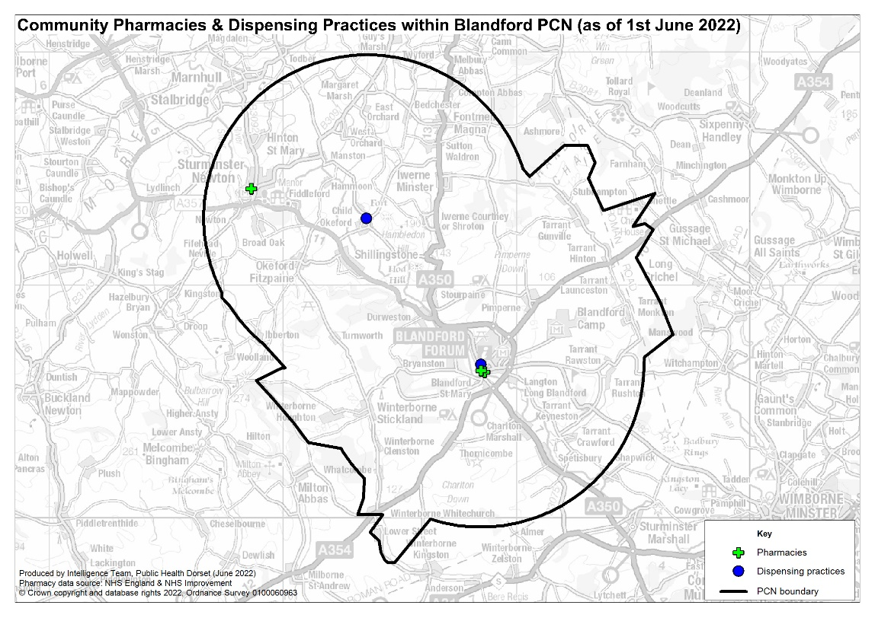

Bournemouth East Collaborative Network PCN
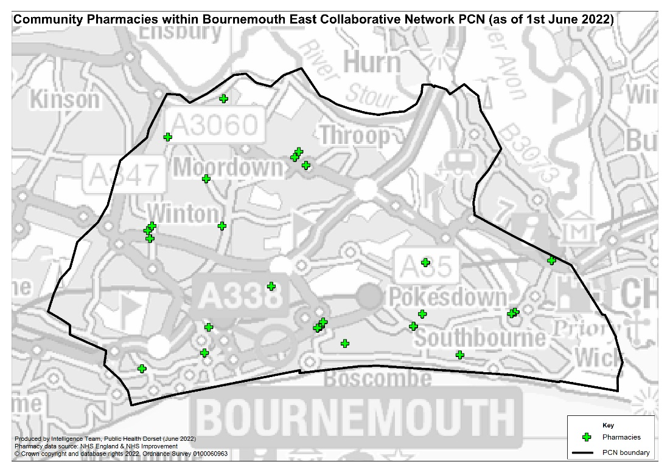

Central Bournemouth PCN
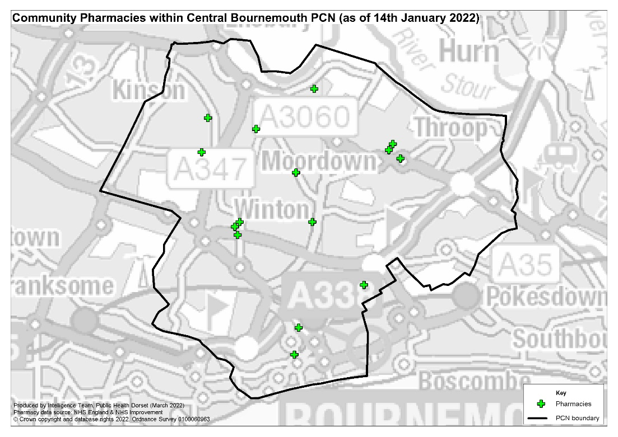

Christchurch PCN
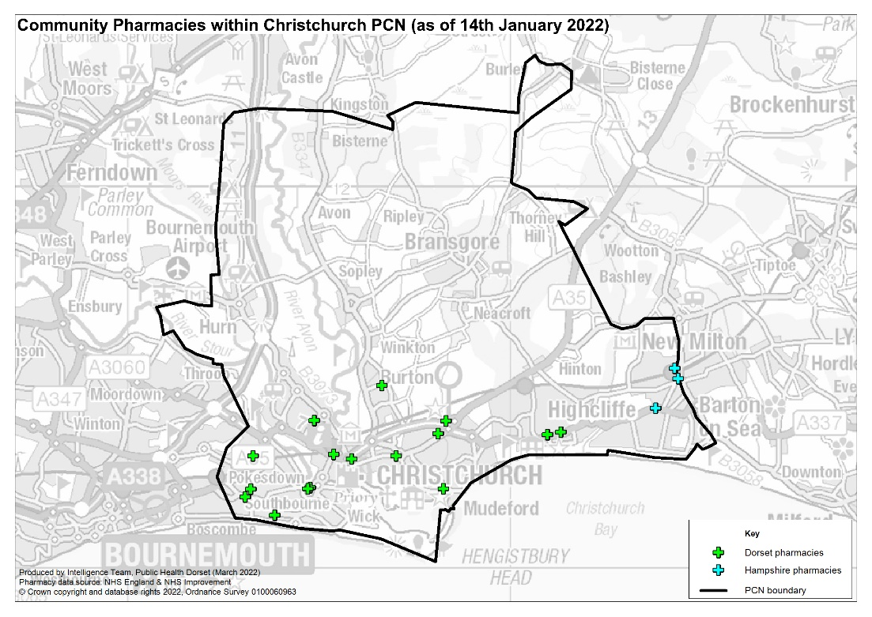

Crane Valley PCN
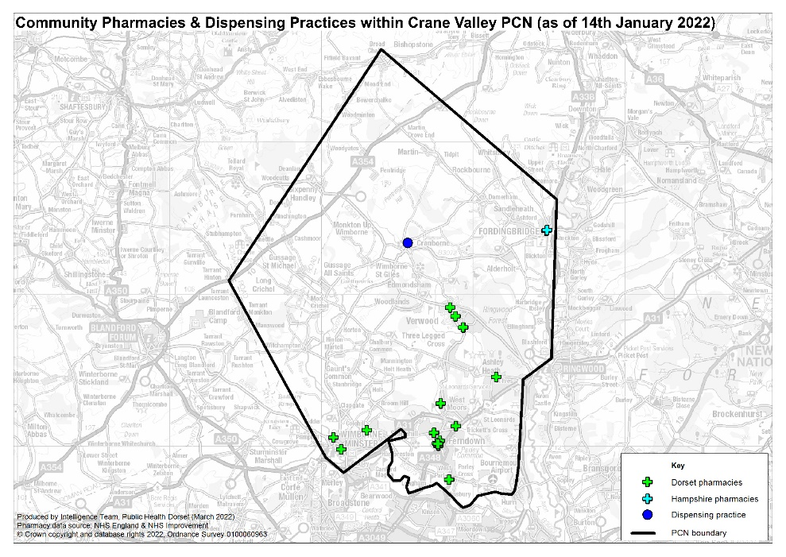

Jurassic Coast PCN
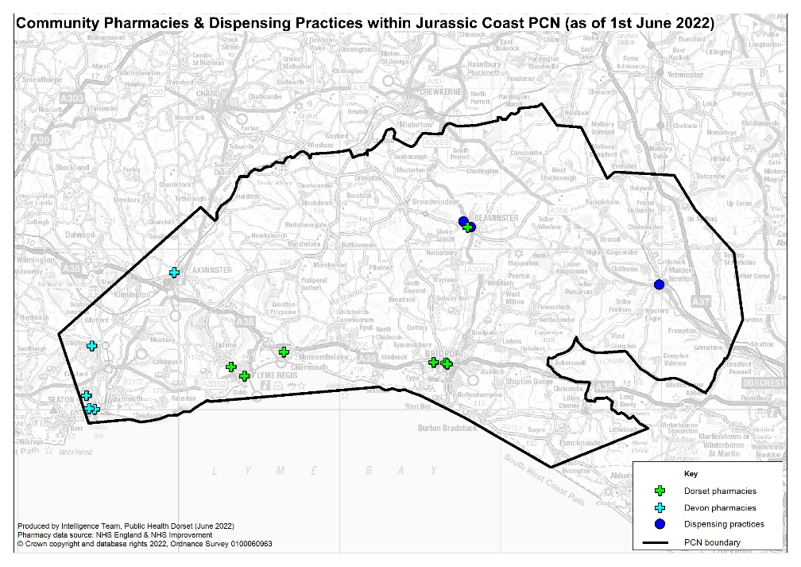

Mid Dorset PCN
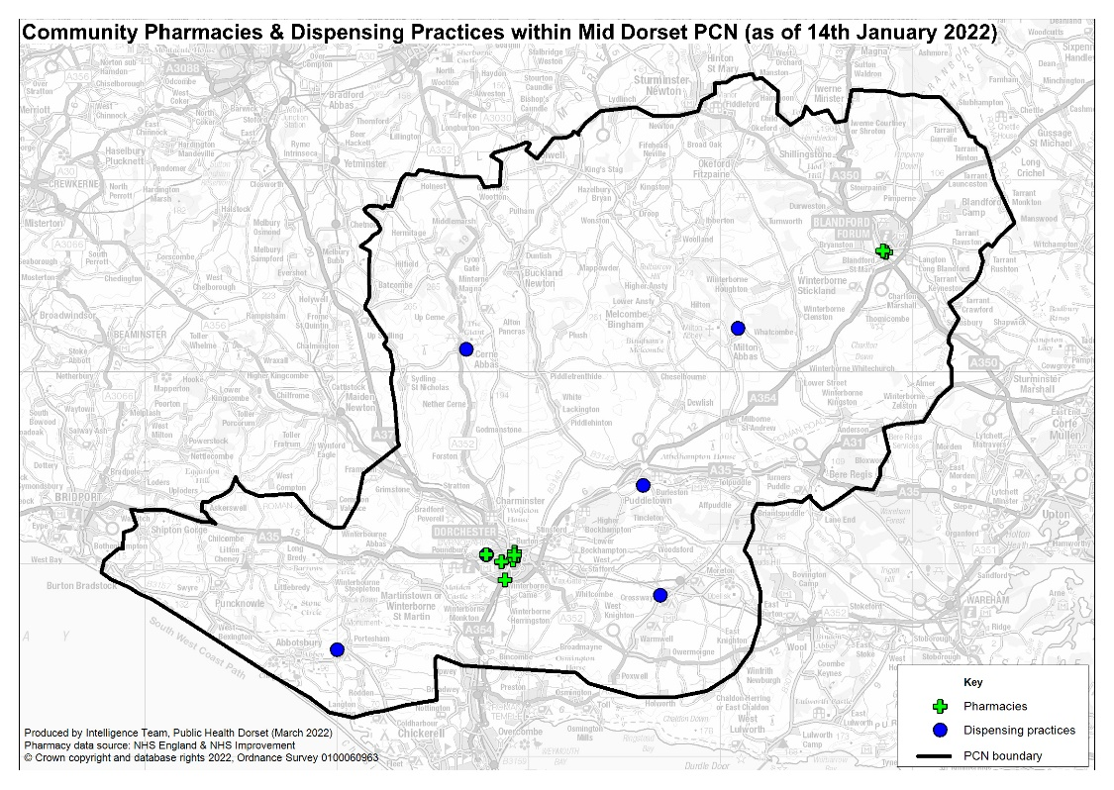

North Bournemouth PCN
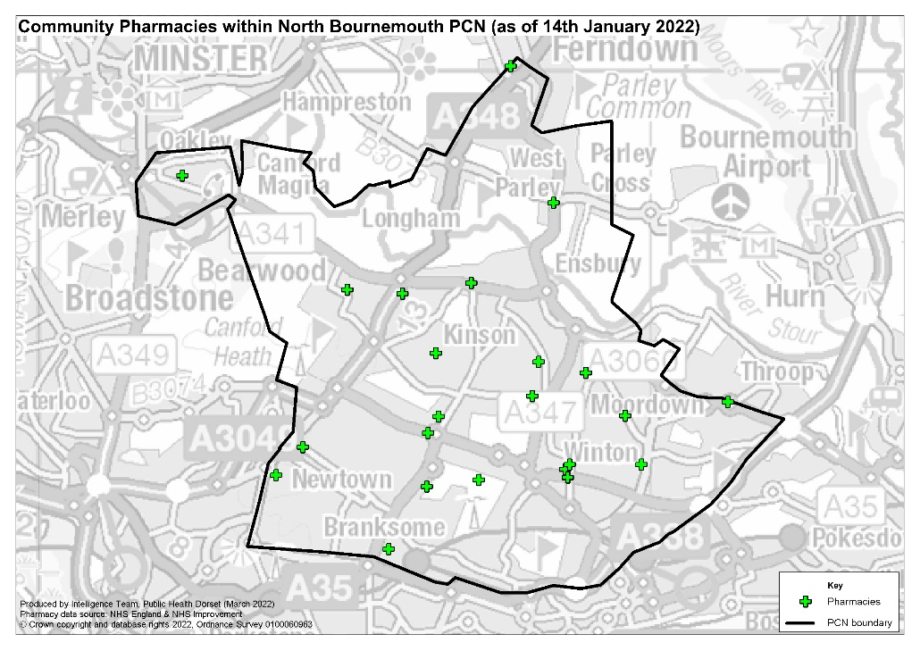

Poole Bay & Bournemouth PCN
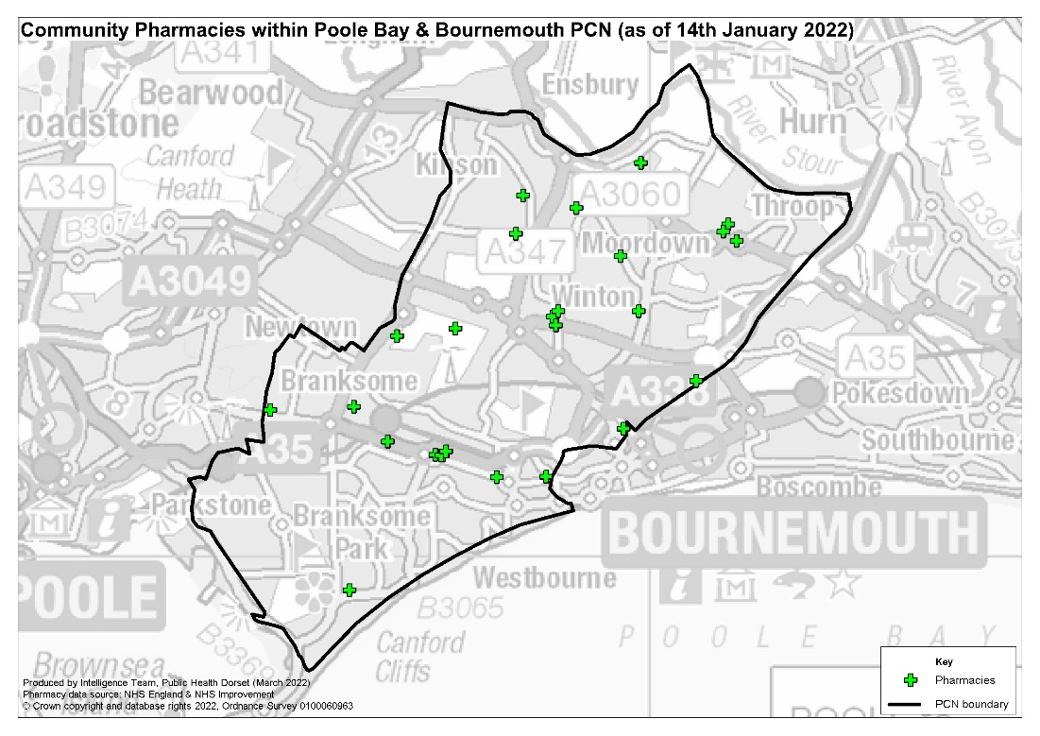

Poole Central PCN
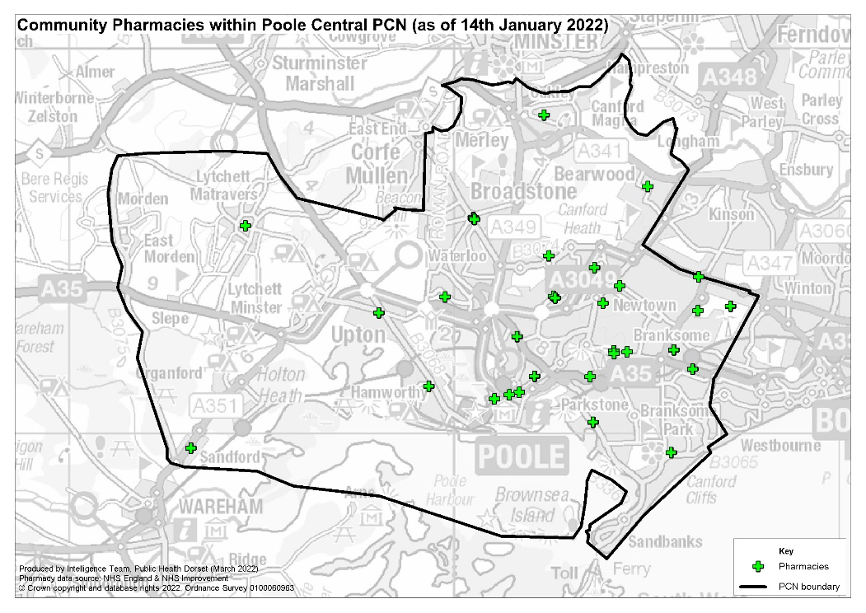

Poole North PCN
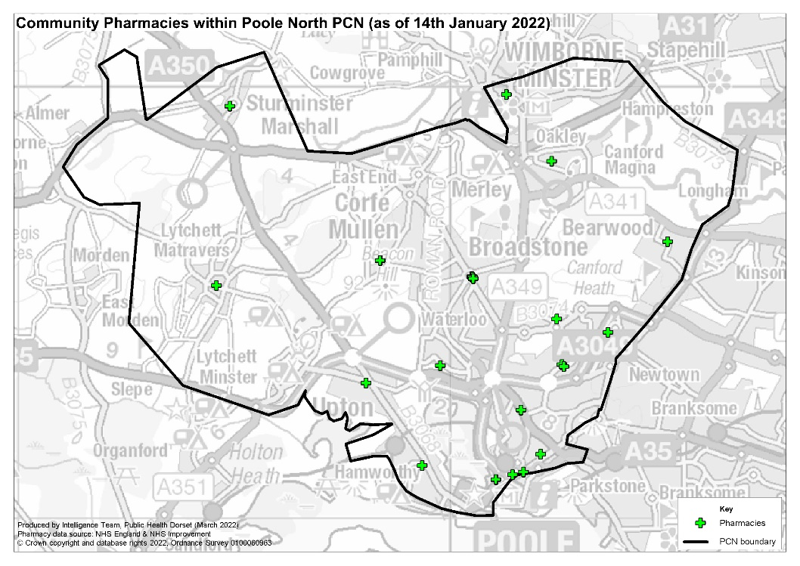

Purbeck PCN
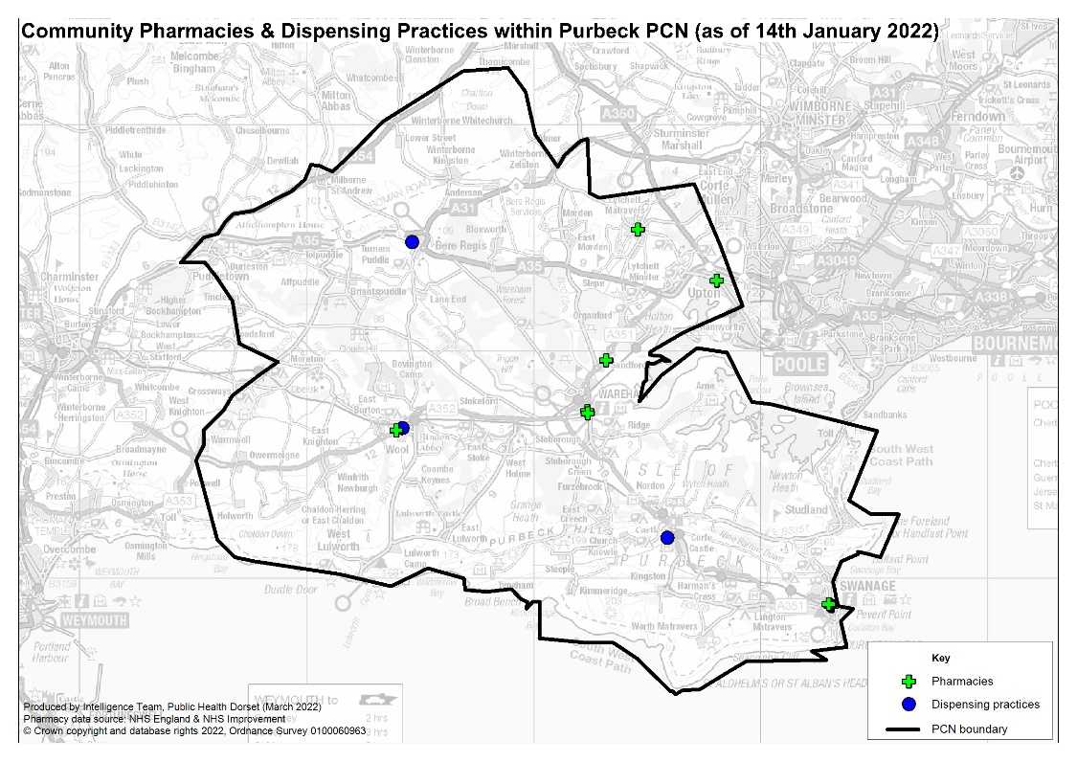

Sherborne Area Network PCN
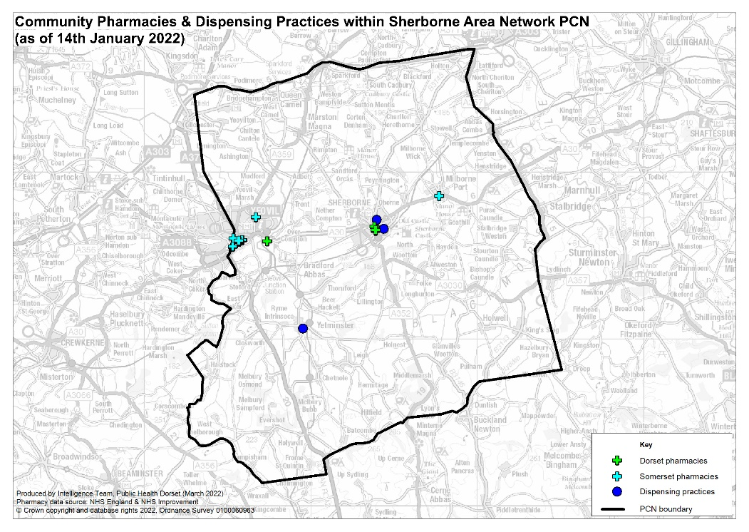

Shore Medical PCN
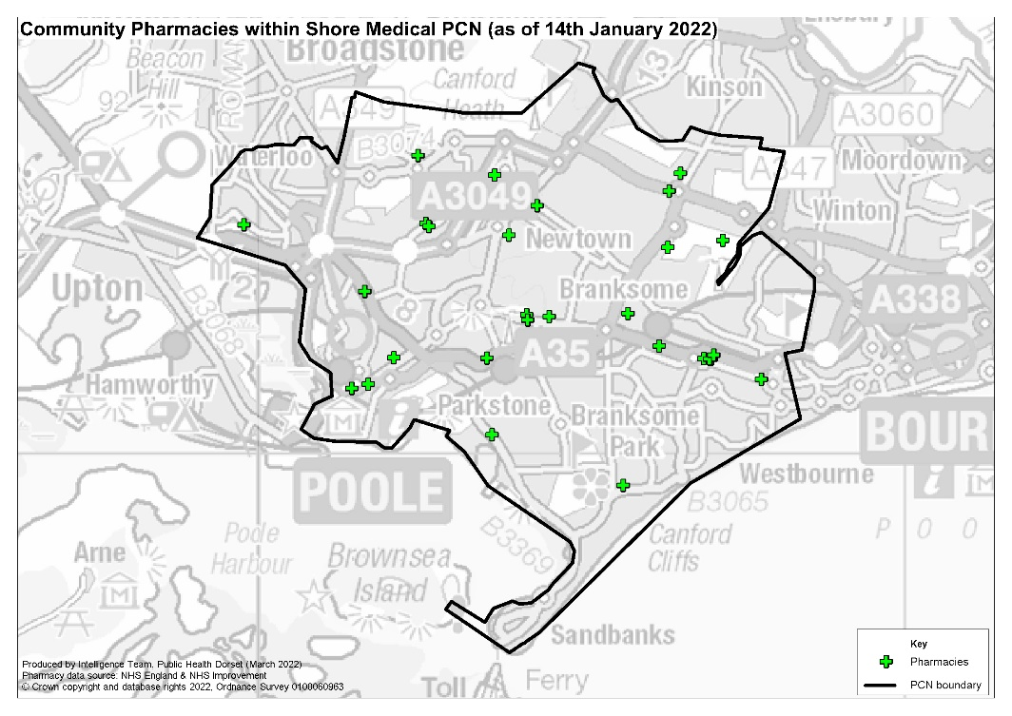

South Coastal Medical Group PCN
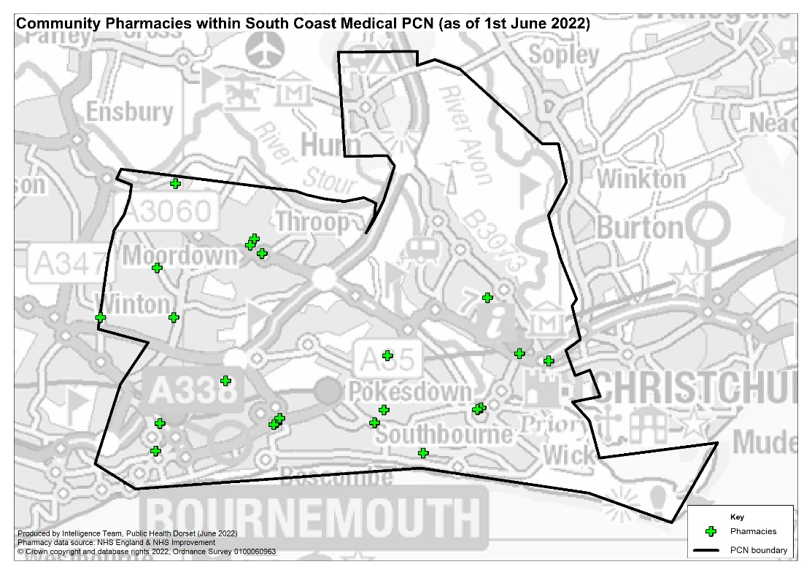

The Vale PCN
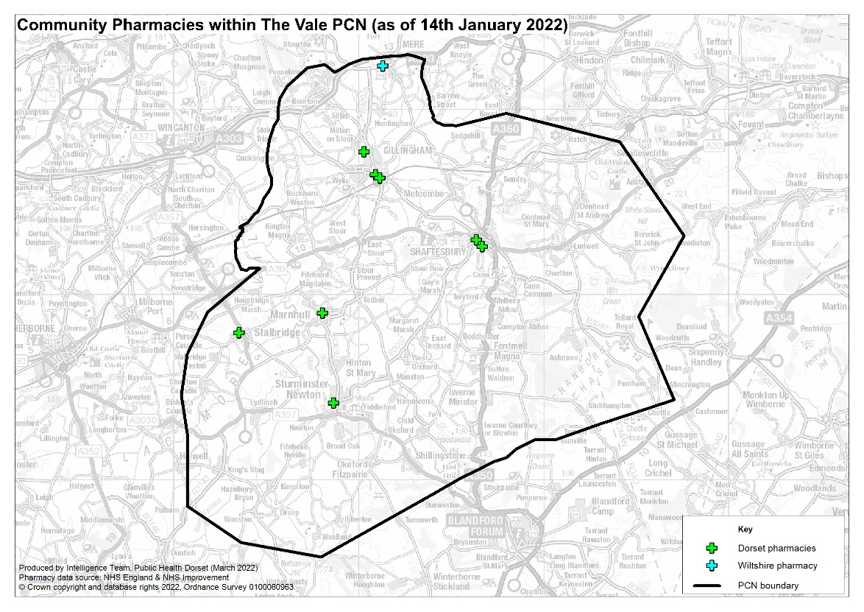

Weymouth & Portland PCN
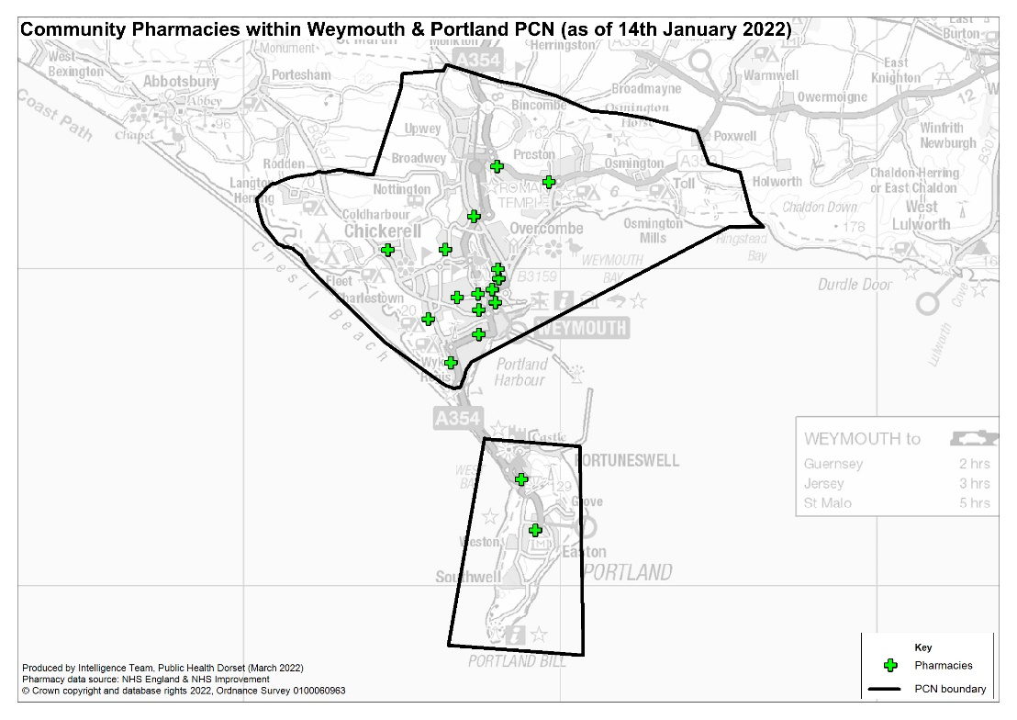

Wimborne & Ferndown PCN
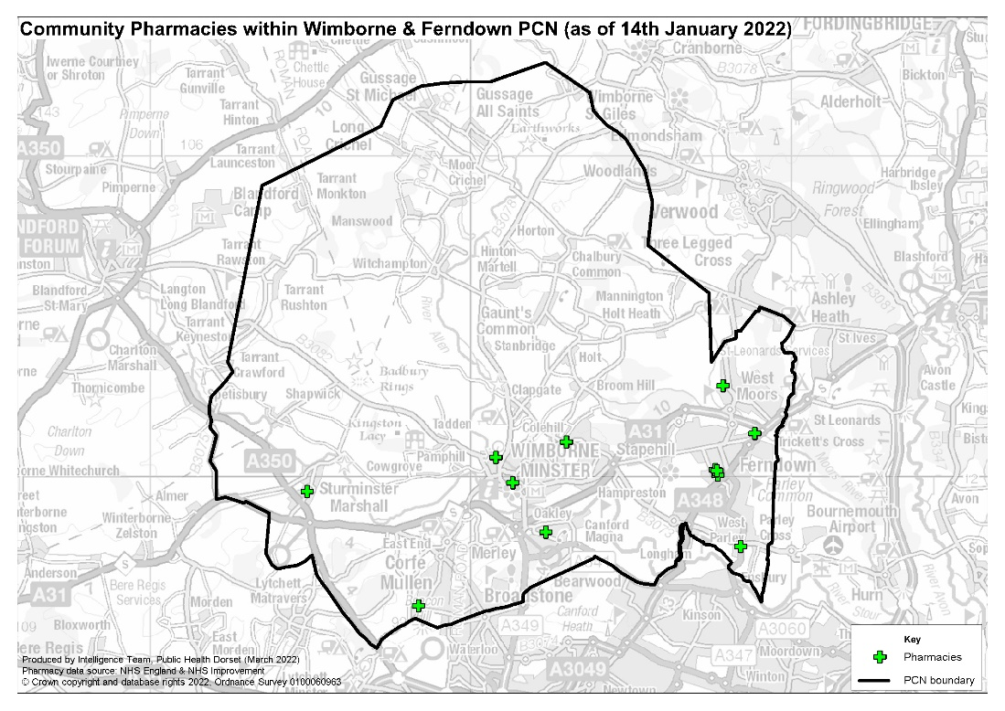

Appendix 5: Public Engagement Survey Summary
- 1121 responses received in total​
- ​80% were aged 60 or above, 12% 50-59 and 8% under 50​
- 70% of respondents were female, 30% male​
- 66% said they had a long-term physical or mental health condition​
- 96% were from white British backgrounds, 0.5% from ethnic minority backgrounds​
- 99% said English was their main language​
- 92% receive prescription medication, with the majority receiving 1-6 items​

Why do you usually visit a Pharmacy?
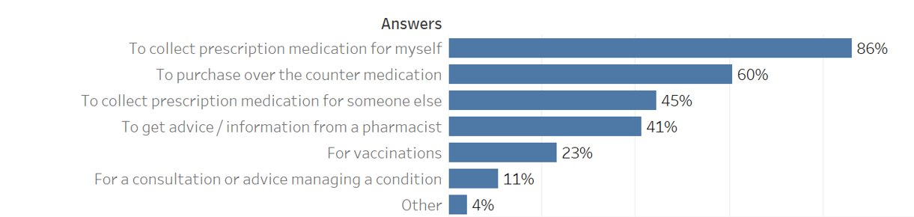
Other reasons for visiting pharmacies included:​
​
- To buy other items e.g. toiletries, personal care (24)​
- To collect Lateral Flow Tests (3)​
- Work related reasons (2)​
- To order prescriptions (1)​

8 said they don’t use them or have items delivered

How often do you use a pharmacy?
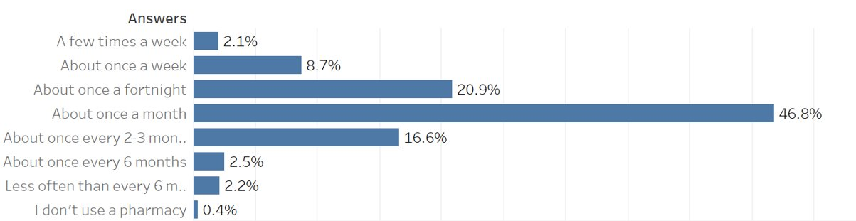
- About once a month was the most common response across all demographic groups.​
- Those that don’t use a pharmacy were aged 60+​
- Older age groups were slightly more likely to visit more regularly -- 22% of 50-59 and 60+ visited once a fortnight compared to around 5-8% of younger age groups

If you have a prescription, how do you usually collect your medication?
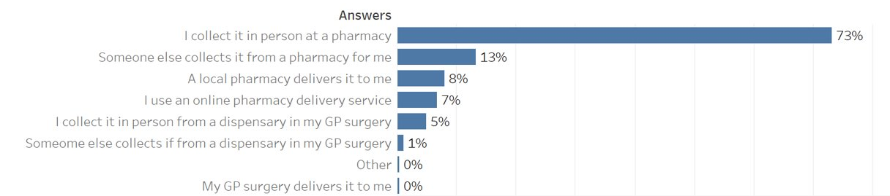

When is the most convenient time for you to use a pharmacy?
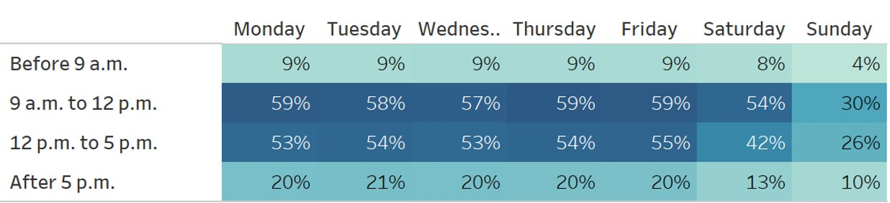
Age groups under 60 were much more likely to answer that after 5 pm weekdays or weekend mornings were more convenient than people aged 60+

Use of multiple pharmacies
- 83% used the same pharmacy each time, 17% use multiple pharmacies​
- Using the same pharmacy was highest for people aged 60+, with 24-32% of younger age groups using multiple pharmacies.​
- People with a LTLI more likely to use the same pharmacy each time​
- People with prescription items are more likely to use the same pharmacy than people with no prescription items

Use of the same pharmacy – why?
- Reasons for using the same pharmacy included being near or attached to the GP surgery, or being the nominated pharmacy for prescriptions.​
- Convenience of location and/or ease of access was another key reason – either closest to home or able to walk there, being easy to get to/park or being close to another location such as shopping or work​
- Good customer service was also mentioned – being efficient, helpful, friendly, approachable and continuity being mentioned. A few mentioned having a personal preference of independent pharmacies.

Use of multiple pharmacies - why​?
- One of the main reasons for using multiple pharmacies is convenience of location or opening times – using the nearest locations to where they are shopping, working or visiting, or convenient on a weekend/lunch time.​
- Several mention using different pharmacies for different products or services – generally using the same pharmacy for prescriptions but different locations for over the counter / personal care items, advice or services like vaccination.​
- Some mentioned the availability of what they need with some local pharmacies being small or having limited stock/services, and a few having issues with medication being in stock.​
- Some also mentioned needing to use multiple pharmacies because they collect prescriptions for other people

What influences your choice of pharmacy?
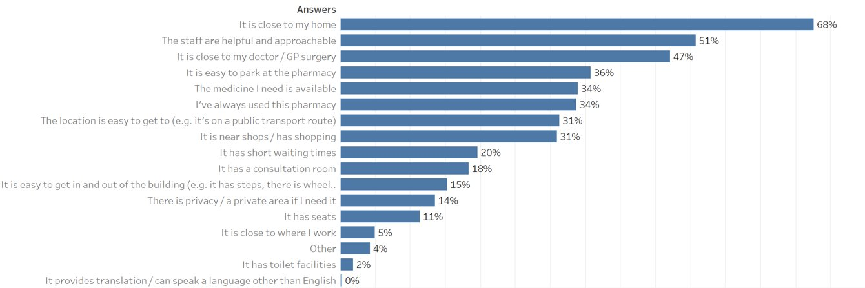

Is there a closer or more convenient pharmacy that you don’t use?
- 25% said that there was a closer/more convenient pharmacy that they don’t use.​
- The main reasons for not using a closer or more convenient pharmacy included
  - Being unhappy with level of customer service received​
  - It’s too busy and/or has a long wait​
  - Had issues with dispensing of prescription, timeliness or having items needed​
  - Not easy to park / no car parking​
  - Prefer to use a pharmacy attached to GP or Prescriptions are automatically sent to another pharmacy through their GP​

If you go to a pharmacy, how do you usually travel there?
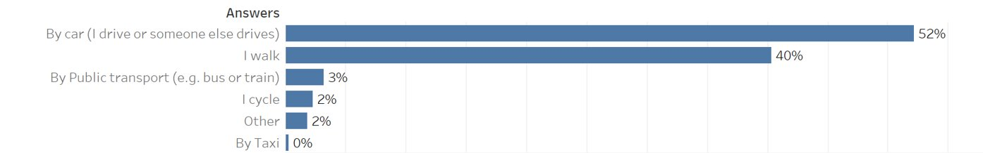

How long does it usually take you to get to a pharmacy?
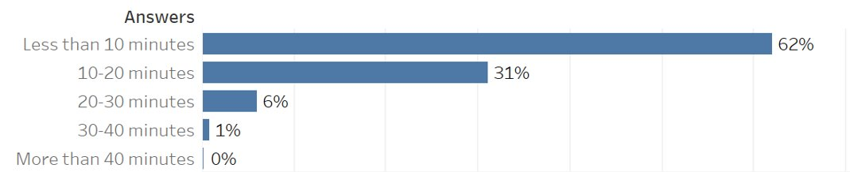

Appendix 6: Consultation report
This report summarises responses to the formal consultation on the draft Pharmaceutical Needs Assessment (PNA) for Dorset. The formal consultation was open from 21st July 2022 to 21st September 2022, following the statutory requirements set out in The National Health Service (Pharmaceutical and Local Pharmaceutical Services) Regulations 2013.

The Steering Group would like to thank all respondents to the consultation for taking the time to review the documentation and share their views.

Consultation Process
The draft PNA and supporting appendices were made publicly available on the Public Health Dorset website from 21st July 2022 to 21st September 2022. Contact details were also provided for any questions, support completing the form or to request alternative formats of the consultation information. Responses to the consultation could be submitted through an online form, linked to on the website, or alternatively through the contact details provided.

The online survey included some set questions around the accuracy of information and views on recommendations and gap analysis, as well as opportunities to submit free text responses.
The consultation information was also sent by email to the following organisations and stakeholders, who were specifically invited to respond and share the consultation with any relevant contacts:

- Dorset Local Pharmaceutical Committee
- Wessex Local Medical Committee
- Healthwatch Dorset
- Dorset Council Hospital NHS Foundation Trust
- University Hospitals Dorset
- Dorset Healthcare University NHS Foundation Trust
- NHS Dorset
- NHS Commissioning Board
- BCP Council Health and Wellbeing Board
- Dorset Council Health and Wellbeing Board
- Devon Health and Wellbeing Board
- Somerset Health and Wellbeing Board
- Wiltshire Health and Wellbeing Board
- Hampshire Health and Wellbeing Board
- Dorset GP Practices
- Dorset Pharmacies

The consultation was also shared on Public Health Dorset social media channels and the Dorset Council consultation portal.

Consultation responses were collated and analysed by the Public Health Dorset team on behalf of the BCP Council and Dorset Council Health and Wellbeing Boards. All consultation responses were considered and reviewed by the steering group, and the PNA document amended as appropriate. A summary of the responses and the related comments and actions are included below.

Consultation Responses
A total of 32 responses were received as part of the formal consultation. 30 were via the online survey and 2 were submitted via email. Responses were received from the following stakeholders:

- Member of the public - 22
- Ward Councillor - 5
- Service Commissioner
- Pharmaceutical service provider
- Employee of the Council - 1
- Representative of a community group, charity or social enterprise
- Business - 1
- Other – 3 (neighbouring health and wellbeing board & 2 representative bodies)

The following sections summarise responses to the online form (30 respondents). Comments from email responses are incorporated into the text analysis – a breakdown can be seen in section 9.

- Purpose and scope of the PNA
28 respondents felt that the purpose and scope of the PNA were clear, 2 did not. An email respondent also commented that they felt the rationale was clearly stated.

- Use of Primary Care Networks (PCNs)
22 respondents felt that Primary Care Network localities are an appropriate division of the area to provide an overview of the need for pharmaceutical services. 3 respondents disagreed and 4 did not know.

One respondent felt that the documentation was difficult to access except for specialists.

Response -- The purpose of the needs assessment is primarily to be used by specialists, NHS England, when considering applications for pharmaceutical services. However, the information could also be used by others to understand community needs, so the language has been reviewed for clarity.

Another respondent felt that PCN boundaries contain both rural areas and towns, which have different needs.

Response – Primary care network boundaries are based on where the patients live that are registered with the GP practices within that PCN. This reflects how people experience and use services. This does mean that some PCNs will have a mix of rural and urban areas within them. Recognising the key challenge in rural areas is around access, we have used driving time as a proxy that can be applied to all areas as this will highlight any particular gaps in rural areas. This rationale has been made clearer in section 3.8 on identifying gaps in the PNA document.

- Information about the currently available pharmaceutical services
18 respondents felt that the information about the currently available pharmaceutical services in Dorset is correct. 11 responded don’t know.

1 responded no, feeling that the crossover between PCN’s, with pharmacies allocated to multiple PCN’s, is confusing. They felt that pharmacies should be allocated to the PCN they have aligned themselves with and will primarily relate to.

Response - Primary care network boundaries are based on where the patients live that are registered with the GP practices within that PCN. This reflects how people experience and use services but does also mean that there are overlaps between the geographical areas that different PCNs cover. Primary Care Networks are beginning to be more integrated and inclusive of specific community pharmacies in their area, although these relationships are still in development, with different PCNs at different levels of maturity. Meanwhile patients may choose to use any community pharmacy within the PCN area or even outside it. The Steering Group felt that the benefit of using PCNs, despite the issue of overlapping boundaries, outweighed the use of exclusive geographical boundaries that are no longer connected to how services work. This rationale has been made clearer in section 3.3 of the PNA document.

The PCN profiles contain a warning that states: the geographies within this PCN area can be in the catchment of multiple PCN boundaries. Therefore, the information contained within these profiles should not be aggregated or compared with other profiles as this could lead to misleading interpretations. The main report summarises information across each health and wellbeing board area.

2 respondents highlighted inaccuracies in pharmaceutical information.

Response - Matters of accuracy highlighted in the responses have been corrected, although we note that as the PNA is a static document published once every 3 years information will always be in the form of a snapshot. Changes to provision, in particular uptake of newer advanced services will only be accurate as at a specific date. As clarified in section 3.11, supplementary statements may be published from time to time to update what the PNA says about availability of pharmaceutical services and once issued become part of the PNA. Supplementary statements cannot provide updates on pharmaceutical need which is only done every three years through a review of the PNA.

- Current or anticipated pharmaceutical service needs
14 respondents felt there were not any currently or anticipated needs that had not been considered in the draft PNA. 7 responded that they don’t know. 9 felt that there were needs that had not been considered.

One email response stated that the conclusions are clearly stated.

Themes from comments are summarised in section 9.

- Gap Identification

Dorset Council
16 respondents agreed with the statement “The Dorset draft PNA does not identify any gaps in the provision of pharmaceutical services in Dorset Council”. Four disagreed with the statement and 10 responded ‘don’t know’.

12 respondents agreed with the statement “The Dorset draft PNA does not identify any future gaps in the provision of pharmaceutical services in Dorset Council if the current services remain open”. 7 disagreed with the statement and 10 stated that they did not know.

Themes from comments are summarised in section 9, with our response.

A few respondents raised points or issues about specific locations within Dorset:

Shaftesbury and Gillingham – comments were made about service levels and waiting times, with staffing and closures mentioned. Increased demand from planned housing expansion was also raised.

Portland – comments about the demand on pharmacy services and waiting times, impact of population and housing increases

Poundbury – planned housing developments and existing pharmacy demand were raised as a concern.

Verwood – a comment raised around pharmacy closures due to staffing pressures
The growing elderly population in the Purbeck area generally was also commented on as a potential consideration point for need.

Response – The Verwood comment related solely to staffing pressures, and was considered alongside other comments about workforce challenges, under general themes that came out of the consultation.

For those comments that expressed concern about population increases or housing developments, the Steering Group reviewed the information again for these specific locations, and again concluded that there were no current or future gaps. The PNA document has been updated with further detail in section 6.3.

The Steering Group did conclude that in one location relocation of one of the existing community pharmacies might lead to improved access, and this has been added into section 7.

Bournemouth, Christchurch and Poole Council
14 respondents agreed with the statement “The Dorset draft PNA does not identify any gaps in the provision of pharmaceutical services in Bournemouth, Christchurch and Poole Council”. Four disagreed and 11 responded ‘don’t know’.

13 respondents agreed with the statement “The Dorset draft PNA does not identify any future gaps in the provision of pharmaceutical services in Bournemouth, Christchurch and Poole Council if the current services remain open”. Seven disagreed and 10 responded ‘don’t know’.

Themes from comments are summarised in section 9, with our response.

One respondent commented on housing development in the Christchurch area, particular the Roeshot Hill development, suggesting that additional facilities may be required.

Response – The Steering Group reviewed the information again for this location, and again concluded that there were no current or future gaps. The PNA document has been updated with further detail in chapter 6 outlining the rationale.

- Aspects of recommendations that may need particular consideration
Respondents were asked if there were any aspects of the recommendations that may need particular consideration to make sure services do not have adverse impacts on any specific groups of people. The following groups and themes were mentioned in responses.

Needs of the elderly population with complex medical issues
There is a growing elderly population in Dorset and Bournemouth, Christchurch and Poole who may have complex medical needs, disabilities and/or issues physically accessing pharmacies. Therefore, delivery and on-line access should be considered.

Physical access
Comments were raised that at some times people need to wait outside a pharmacy, for example if there is a long queue, and that this may impact some people particularly in inclement weather. Access in rural areas was also raised, with limited public transport options in some locations and increasing costs of private transport.

Impact of workforce/staffing pressures
As noted in other responses, the impact of workforce pressures was raised. Examples included pharmacies needing to close where there were staffing issues, or provision of privacy to speak to pharmacists being limited.

Out of hours access
It was commented that more flexibility in opening hours would support working residents to access services, and those who may be without private transport.

Provision for migrants and refugees was noted by one respondent.

Responses – These themes helpfully expand on issues already identified within the PNA and have been incorporated into a first stage Equality Impact Assessment (EQIA) for the PNA. As the PNA has not identified any gaps there is no need for a fuller EQIA.

- Any further comments
Themes from any other comments generally followed or reiterated points from the main questionnaire – they are included in the theme summaries in section 9.
Unique comments to this section included:

- Propose relaxation of pharmacy regulation and making it easier for more pharmacies to operate like other retailers to improve accessibility.
- Pharmaceutical services offer and unplanned closures should be better monitored to maintain service standards and availability
- Somerset PNA identified a gap in Chard on a Sunday. If this gap is filled, then it will have a slight impact in improving access in the Jurassic Coast PCN area.

- Other consultation responses
2 responses were received via email – the comments submitted have been included in the analysis of relevant sections.

- Themes and issues raised from comments
There were several themes that were raised or re-iterated across questions by respondents, therefore all comments have been analysed together and collated into the following points. As a summary, the table below shows the number of responses per question that related to each theme.

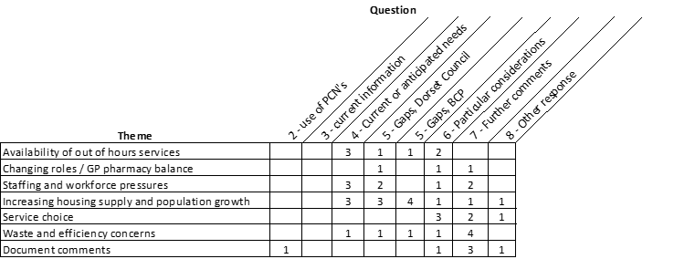

Availability of Out of hours services
Some respondents to the consultation made reference to the lack of 24-hour facilities available and are not considered in the document. It was also mentioned that extended opening hours are useful for shift workers.

Response – Most prescriptions which require dispensing are generated in general practice (over 98.5% by GPs). The core GP contract specifies core hours of 8am to 6:30pm Monday to Friday (excluding Bank Holidays) during which a practice, in discussion with its patients and patient participation group, can determine how services are delivered – there is no requirement to be open this whole time. This year GP practices working together as a PCN may also choose to provide additional opening during identified enhanced or extended access times, between 6.30pm-8pm weekday evenings and 9am-5pm on Saturdays, to be implemented part-way through 22/23. This does not preclude practices from opening outside these hours. Data collated for the PNA have been shared with PCNs to help them in working with their local pharmacies to look at the match between the pharmacy opening hours and their enhanced access plans.

The public engagement survey conducted as part of the PNA development asked about convenient times for people to use a pharmacy. The survey received 1121 responses, with the majority answering between 9 a.m. to 5 p.m. on weekdays and Saturdays as most convenient (note – 80% of survey respondents were aged 60 and over). People under 60 were more likely to select after 5p.m. on weekdays or weekend mornings as the most convenient time for them. Fewer people selected before 9 a.m. as convenient, particularly at weekends.

As prescriptions are not available 24/7, the Steering Group did not feel that 24/7 access to dispensing was one of the ‘necessary services’. Within the PNA we have looked at those pharmacies that are open for 100-hours, and within the specific PCN profiles have looked at earliest and latest opening times for community pharmacies across the whole PCN area for the week. The Steering Group felt that this was currently the best way to look at access outside of usual opening hours.

Section 3.8, relating to the Steering Group’s definition of ‘necessary services’, has been updated to reflect this rationale.

Pharmacy and GP balance / changing of roles
Some referred to their perception of the changing roles of pharmacists and felt this was adding to demand pressures – for example demand for providing over the counter consultations, advice or delivering services such as vaccinations. On the other hand, a couple of respondents felt that there was a need to consider closer working between pharmacies and GP’s or consider providing more services in pharmacies to provide joined-up community services – particularly in rural areas.

Response – There is a national direction of travel to see expanded roles for pharmacists, both within the community pharmacy and within general practice and Primary Care Networks. With the same number of staff delivering against an expanded remit this can reduce capacity in the short-term, however the development of these expanded roles is likely to increase recruitment and retention in the longer term, and other potential benefits include improved patient care, reduction in unwanted medicines and freeing up GP time to enable more time on clinical care. Overall, the balance of positive to negative comments evened out. Further narrative has been added into section 4.3/4.4 NHS Dorset/Our Dorset, section 5.9 Other services and section 6.7 Community pharmacy workforce to reflect this issue.

Staffing and workforce pressures
Several respondents spoke of their perception of workforce pressure and staffing issues affecting services – for example experiencing queues and long waiting times or closures due to staffing availability. There was also mention of waits between GP prescription and pharmacy dispensing, which were attributed to pharmacies seemingly not being able to cope with demand.

Response – Workforce challenges were referenced in the Consultation PNA at section 6.7 as a recognised issue since 2019. The comments coming through in response to the consultation add weight to this issue. The section has been strengthened and in the conclusion section it is recommended that ongoing work to address this should be a high priority for the Dorset Integrated Care system, led by the Medicines Optimisation Transformation Group.

Impact on services from increasing housing development and population growth
References were made to estimated housing and population growth by some respondents, with some feeling that services are overstretched due to growth already seen – this pressure would increase with further growth and interlinks with the workforce pressures described above, and efficiency concerns below. Specific areas of concern have been highlighted in section 5 of this report.

Response – The PNA highlights projected population growth and housing development over the lifetime of the PNA. Overall, there is no indication that this will substantially change the driving time access maps across Dorset.

An increased population is likely to mean increased dispensing activity, although this will be determined by the demographics of people moving into new housing developments. Where comments have highlighted specific locations, we have looked again at the PCN profiles, including pharmacies per 100,000 patients and items dispensed per patient to provide some comparator information. There is no evidence to suggest what level these measures should be, nor what level of population growth or housing completions would provide a specific ‘population trigger point’ to suggest a new pharmaceutical service provider is needed in an area. The most important factor in whether existing pharmacies can meet any increased need is staffing capacity and skill mix within the pharmacy. The pharmacist workforce has been highlighted as the most significant challenge for community pharmacies over the next 3 years and more.

Dispensing and ordering of medication - efficiencies
Some respondents described examples of dispensing inefficiency or issues with the amount of medication ordered. In the dispensing part of the process efficiency concerns included; errors being made in medication dispensed which then cannot be returned, or medication availability difficulties caused by supply and transport issues. However, respondents also described issues in other parts of the process – such as challenges with prescription practices, medication review and automated prescription service timing which can result in over ordering medication, medicine wastage and subsequently additional costs to the NHS.

Response – Issues around over or under ordering and efficiency of the prescribing process are not solely related to the dispensing part of the process but may also relate to prescribing practises, including how patients order repeat medicines, how prescriptions are managed in GP surgeries, how they are transferred between prescriber and dispenser, staffing availability and the supply chain for medications. The Medicines Optimisation Team (MOT) at NHS Dorset aims to enable patients and healthcare professionals to get the best from their medicines by working collaboratively across the system. One area of work is supporting best practise guidance that will help to minimise medicines waste. Information about the team and its role has been added in section 4.3, and the consultation responses have been shared with the group so that these can be considered in rewriting relevant medicines management policies.

One of the essential pharmaceutical services is the promotion of healthy lifestyles, including the pro-active promotion of specific health messages to the public during specific targeted campaign periods in line with national/local campaigns. In the conclusion section it is recommended that at least one of the required health campaigns over the next three years should focus on encouraging patients to only order the medicines they need.

Choice of services
There were some mixed views around service choice. A couple of respondents felt that on-line services, whilst convenient, might not offer the level of advice or services that community pharmacies can – but people might have to resort to using these due to the pressures felt in community services.

Alternatively, a couple of respondents felt that greater choice of services would be beneficial – for example, an on-line dispensary that could offer next day delivery might provide some solution to physical and rural access issues. Alternatively greater local delivery offers would be helpful for the elderly or vulnerable who may not have easy access to private transport.

Response – Nationally we are seeing a shift across many sectors towards digital/online services. Our initial engagement found that most people currently favour attendance at a local service, with only 7% of people currently using an online delivery service. Prescribing data also shows a small proportion of prescriptions (6.2%) dispensed via distance-selling pharmacies. Comments in this section highlight both the benefits and the challenges of delivering services in this way. Online services can provide a valuable alternative for some people but will not be appropriate for everyone.

Comments on the documentation and format
A couple of comments referred to the documents purpose and relevance of information over time. A couple also referred to the technical nature and language in the document. However, a couple of respondents felt the documents were clear in their communication.

Response - The needs assessment is a technical document primarily to be used by specialists, NHS England, when considering applications for pharmaceutical services. However, the information could also be used by others to understand community needs, so the language has been reviewed for clarity.
In relation to the relevance and need to update information, the PNA is required to be a static document published once every 3 years. Therefore, information will always be in the form of a snapshot and service provision will only be accurate as at a specific date. As clarified in section 3.11, supplementary statements may be published from time to time to update what the PNA says about availability of pharmaceutical services and once issued become part of the PNA. Supplementary statements cannot provide updates on pharmaceutical need which is only done every three years through a review of the PNA.

Appendix 7: List of community pharmacies and opening times
ODS CODE | Contractor Name | Postcode | HWB | Opening Hours Monday | Opening Hours Tuesday | Opening Hours Wednesday | Opening Hours Thursday | Opening Hours Friday | Opening Hours Saturday | Opening Hours Sunday
FA612 | Castle Point (UK) Ltd | BH8 9UD | BCP | 07:00-22:00 | 07:00-22:00 | 07:00-22:00 | 07:00-22:00 | 07:00-22:00 | 08:00-22:00 | 09:00-20:00
FAA53 | Jaspers Health Ltd | BH10 4DZ | BCP | 09:00-19:00 | 09:00-19:00 | 09:00-19:00 | 09:00-19:00 | 09:00-19:00 | 09:00-18:00 | Closed
FAR75 | Superdrug Stores Plc | BH9 2AQ | BCP | 08:30-17:30 | 08:30-17:30 | 08:30-17:30 | 08:30-17:30 | 08:30-17:30 | 09:00-17:30 | Closed
FAT46 | Lloyds Pharmacy Ltd | BH14 0DJ | BCP | 09:00-18:00 | 09:00-18:00 | 09:00-18:00 | 09:00-18:00 | 09:00-18:00 | Closed | Closed
FAX44 | Boots UK Ltd | BH12 1DN | BCP | 09:00-17:00 | 09:00-17:00 | 09:00-17:00 | 09:00-17:00 | 09:00-17:00 | 09:00-14:00 | 10:00-16:00
FC009 | Boots UK Ltd | BH15 1SX | BCP | 09:30-17:30 | 09:30-17:30 | 09:30-17:30 | 09:30-17:30 | 09:30-17:30 | 10:00-17:30 | Closed
FCE37 | Shalli Ltd | BH14 0AD | BCP | 09:00-13:00  14:00-17:30 | 09:00-13:00  14:00-17:30 | 09:00-13:00  14:00-17:30 | 09:00-13:00  14:00-17:30 | 09:00-13:00  14:00-17:30 | 09:00-14:00 | Closed
FCG62 | Tesco Stores Ltd | BH12 4NX | BCP | 08:00-22:30 | 06:30-22:30 | 06:30-22:30 | 06:30-22:30 | 06:30-22:30 | 06:30-22:00 | 10:00-16:00
FCM02 | Lloyds Pharmacy Ltd | BH10 5EY | BCP | 08:30-18:30 | 08:30-18:30 | 08:30-18:30 | 08:30-18:30 | 08:30-18:30 | 08:45-12:00 | Closed
FDL19 | Lloyds Pharmacy Ltd | BH8 9UW | BCP | 08:00-13:00  14:00-20:00 | 08:00-13:00  14:00-20:00 | 08:00-13:00  14:00-20:00 | 08:00-13:00  14:00-20:00 | 08:00-13:00  14:00-20:00 | 08:00-13:00  14:00-20:00 | 10:00-16:00
FE379 | Arrowedge Ltd | BH17 9DW | BCP | 09:00-13:00  14:00-17:30 | 09:00-13:00  14:00-17:30 | 09:00-13:00  14:00-17:30 | 09:00-13:00  14:00-17:30 | 09:00-13:00  14:00-17:30 | 09:00-13:00 | Closed
FE691 | Arrowedge Ltd | BH4 9DZ | BCP | 09:00-13:00  14:00-18:00 | 09:00-13:00  14:00-18:00 | 09:00-13:00  14:00-18:00 | 09:00-13:00  14:00-18:00 | 09:00-13:00  14:00-18:00 | 09:00-13:00 | Closed
FE765 | Waremoss Ltd | BH1 4AN | BCP | 08:30-18:00 | 08:30-18:00 | 08:30-18:00 | 08:30-18:00 | 08:30-18:00 | 09:00-13:00 | Closed
FEH72 | L Rowland & Co (Retail) Ltd | BH15 3DH | BCP | 09:00-13:00  13:20-17:30 | 09:00-13:00  13:20-17:30 | 09:00-13:00  13:20-17:30 | 09:00-13:00  13:20-17:30 | 09:00-13:00  13:20-17:30 | 09:00-12:00 | Closed
FT397 | Day Lewis PLC | BH5 1LX | BCP | 09:00-13:00  14:00-17:30 | 09:00-13:00  14:00-17:30 | 09:00-13:00  14:00-17:30 | 09:00-13:00  14:00-17:30 | 09:00-13:00  14:00-17:30 | 09:00-12:00 | Closed
FF719 | L Rowland & Co (Retail) Ltd | BH21 1SQ | BCP | 09:00-13:00  14:00-17:30 | 09:00-13:00  14:00-17:30 | 09:00-13:00  14:00-17:30 | 09:00-13:00  14:00-17:30 | 09:00-13:00  14:00-17:30 | 09:00-12:00 | Closed
FF756 | L Rowland & Co (Retail) Ltd | BH8 9QR | BCP | 09:00-13:00  14:00-17:30 | 09:00-13:00  14:00-17:30 | 09:00-13:00  14:00-17:30 | 09:00-13:00  14:00-17:30 | 09:00-13:00  14:00-17:30 | 09:00-12:00 | Closed
FGC36 | L Rowland & Co (Retail) Ltd | BH15 2PG | BCP | 09:00-13:00  13:20-17:30 | 08:30-13:00  13:20-17:30 | 08:30-13:00  13:20-17:30 | 08:30-13:00  13:20-17:30 | 08:30-13:00  13:20-17:30 | 09:00-12:00 | Closed
FH405 | Boots UK Ltd | BH18 8DP | BCP | 08:45-12:30  13:30-18:00 | 08:45-12:30  13:30-18:00 | 08:45-12:30  13:30-18:00 | 08:45-12:30  13:30-18:00 | 08:45-12:30  13:30-18:00 | 08:45-12:30  13:30-17:30 | Closed
FHC36 | Asda Stores Ltd | BH8 8DL | BCP | 09:00-20:00 | 09:00-20:00 | 09:00-20:00 | 09:00-20:00 | 09:00-20:00 | 09:00-20:00 | 11:00-17:00
FHC79 | FRANSIL Ltd | BH6 3LA | BCP | 09:00-13:00  13:30-17:30 | 09:00-13:00  13:30-17:30 | 09:00-13:00  13:30-17:30 | 09:00-13:00  13:30-17:30 | 09:00-13:00  13:30-17:30 | 09:00-13:00 | Closed
FHE41 | Tesco Stores Ltd | BH12 1AU | BCP | 08:00-22:30 | 06:30-22:30 | 06:30-22:30 | 06:30-22:30 | 06:30-22:30 | 06:30-22:00 | 10:00-16:00
FHK75 | Lloyds Pharmacy Ltd | BH12 3HF | BCP | 08:30-17:30 | 08:30-17:30 | 08:30-17:30 | 08:30-17:30 | 08:30-17:30 | Closed | Closed
FHQ83 | Boots UK Ltd | BH6 5AJ | BCP | 08:30-13:00  13:30-18:00 | 08:30-13:00  13:30-18:00 | 08:30-13:00  13:30-18:00 | 08:30-13:00  13:30-18:00 | 08:30-13:00  13:30-18:00 | Closed | Closed
FJG24 | Arrowedge Ltd | BH18 8DP | BCP | 09:00-13:00  14:00-17:30 | 09:00-13:00  14:00-17:30 | 09:00-13:00  14:00-17:30 | 09:00-13:00  14:00-17:30 | 09:00-13:00  14:00-17:30 | 09:00-13:00 | Closed
FJH73 | Avicenna Retail Ltd | BH11 8DU | BCP | 09:00-17:30 | 09:00-17:30 | 09:00-17:30 | 09:00-17:30 | 09:00-17:30 | 09:00-13:00 | Closed
FKE75 | Lloyds Pharmacy Ltd | BH14 8UB | BCP | 09:00-17:30 | 09:00-17:30 | 09:00-17:30 | 09:00-17:30 | 09:00-17:30 | 09:00-13:00 | Closed
FKH46 | Medi Innovation Ltd | BH8 8BL | BCP | 09:00-17:30 | 09:00-17:30 | 09:00-17:30 | 09:00-17:30 | 09:00-17:30 | 09:00-13:00 | Closed
FKQ52 | Boots UK Ltd | BH15 4JQ | BCP | 09:00-13:00  13:30-18:00 | 09:00-13:00  13:30-18:00 | 09:00-13:00  13:30-18:00 | 09:00-13:00  13:30-18:00 | 09:00-13:00  13:30-18:00 | 09:00-17:00 | Closed
FKT39 | Hillview Pharmacy Ltd | BH9 1SE | BCP | 09:00-17:30 | 09:00-17:30 | 09:00-17:30 | 09:00-17:30 | 09:00-17:30 | Closed | Closed
FL503 | Boots UK Ltd | BH17 8SA | BCP | 09:00-13:00  14:00-18:00 | 09:00-13:00  14:00-18:00 | 09:00-13:00  14:00-18:00 | 09:00-13:00  14:00-18:00 | 09:00-13:00  14:00-18:00 | 09:00-13:00 | Closed
FLG28 | Avicenna Retail Ltd | BH11 9TF | BCP | 08:30-18:30 | 08:30-18:30 | 08:30-18:30 | 08:30-18:30 | 08:30-18:30 | 09:00-12:00 | Closed
FM001 | L Rowland & Co (Retail) Ltd | BH17 7XZ | BCP | 09:00-13:00  13:20-18:00 | 09:00-13:00  13:20-18:00 | 09:00-13:00  13:20-18:00 | 09:00-13:00  13:20-18:00 | 09:00-13:00  13:20-18:00 | 09:00-12:00 | Closed
FM254 | Boots UK Ltd | BH9 2HE | BCP | 09:00-14:00  15:00-17:30 | 09:00-14:00  15:00-17:30 | 09:00-14:00  15:00-17:30 | 09:00-14:00  15:00-17:30 | 09:00-14:00  15:00-17:30 | 10:00-14:00  15:00-17:00 | Closed
FM329 | Asda Stores Ltd | BH15 1JQ | BCP | 08:00-23:00 | 07:00-23:00 | 07:00-23:00 | 07:00-23:00 | 07:00-23:00 | 07:00-22:00 | 10:00-16:00
FM668 | Poole Bay Pharmacy Ltd | BH4 9HJ | BCP | 07:00-23:00 | 07:00-23:00 | 07:00-23:00 | 07:00-23:00 | 07:00-23:00 | 07:00-23:00 | 10:00-14:00
FM738 | L Rowland & Co (Retail) Ltd | BH9 3RE | BCP | 09:00-13:00  13:20:17:30 | 09:00-13:00  13:20:17:30 | 09:00-13:00  13:20:17:30 | 09:00-13:00  13:20:17:30 | 09:00-13:00  13:20:17:30 | 09:00-12:00 | Closed
FMD38 | Day Lewis PLC | BH11 9HS | BCP | 09:00-18:00 | 09:00-18:00 | 09:00-18:00 | 09:00-18:00 | 09:00-18:00 | Closed | Closed
FME91 | Day Lewis PLC | BH14 8EE | BCP | 08:00-13:00  14:00-18:00 | 08:00-13:00  14:00-18:00 | 08:00-13:00  14:00-18:00 | 08:00-13:00  14:00-18:00 | 08:00-13:00  14:00-18:00 | Closed | Closed
FNC32 | Boots UK Ltd | BH14 9DQ | BCP | 09:00-13:00  14:00-17:30 | 09:00-13:00  14:00-17:30 | 09:00-13:00  14:00-17:30 | 09:00-13:00  14:00-17:30 | 09:00-13:00  14:00-17:30 | 09:00-13:00  14:00-17:30 | Closed
FNN12 | Tibbshealthcare Ltd | BH8 8EH | BCP | 08:30-18:00 | 08:30-18:00 | 08:30-18:00 | 08:30-18:00 | 08:30-18:00 | 09:00-13:00 | Closed
FP470 | Avicenna Retail Ltd | BH10 4BX | BCP | 08:00-18:30 | 08:00-20:00 | 08:00-18:30 | 08:00-20:00 | 08:00-18:30 | 08:00-12:00 | Closed
FPK63 | Lloyds Pharmacy Ltd | BH18 8DP | BCP | 08.30-18:00 | 08.30-18:00 | 08.30-18:00 | 08.30-18:00 | 08.30-18:00 | 09:00-17:00 | Closed
FQ299 | Boots UK Ltd | BH2 5NL | BCP | 09:00-13:00  14:00-18:00 | 09:00-13:00  14:00-18:00 | 09:00-13:00  14:00-18:00 | 09:00-13:00  14:00-18:00 | 09:00-13:00  14:00-18:00 | 09:00-13:00  14:00-18:00 | 10:30-16:30
FQ306 | Pharmastar Ltd | BH7 6BW | BCP | 09:00-13:00  14:00-17:30 | 09:00-13:00  14:00-17:30 | 09:00-13:00  14:00-17:30 | 09:00-13:00  14:00-17:30 | 09:00-13:00  14:00-17:30 | 09:00-13:00 | Closed
FQ519 | Boots UK Ltd | BH4 9DZ | BCP | 09:00-13:00  14:00-17:30 | 09:00-13:00  14:00-17:30 | 09:00-13:00  14:00-17:30 | 09:00-13:00  14:00-17:30 | 09:00-13:00  14:00-17:30 | 09:00-13:00  14:00-17:30 | Closed
FQQ97 | L Rowland & Co (Retail) Ltd | BH10 5BG | BCP | 08:30-13:00  13:20-17:30 | 08:30-13:00  13:20-17:30 | 08:30-13:00  13:20-17:30 | 08:30-13:00  13:20-17:30 | 08:30-13:00  13:20-17:30 | 09:00-12:00 | Closed
FR043 | Tuckton Pharmacy Ltd | BH6 3JX | BCP | 09:00-17:30 | 09:00-17:30 | 09:00-17:30 | 09:00-17:30 | 09:00-17:30 | 09:00-13:00 | Closed
FRH25 | Lloyds Pharmacy Ltd | BH12 4BA | BCP | 08:00-13:30  14:00-21:00 | 08:00-13:30  14:00-21:00 | 08:00-13:30  14:00-21:00 | 08:00-13:30  14:00-21:00 | 08:00-13:30  14:00-21:00 | 08:00-13:30  14:00-20:00 | 10:00-16:00
FRK84 | Lawton Pharmacy Consultants Ltd | BH17 8UE | BCP | 07:00-22:00 | 07:00-22:00 | 07:00-22:00 | 07:00-22:00 | 07:00-22:00 | 07:00-22:00 | 09:00-19:00
FRN49 | Day Lewis PLC | BH12 5BF | BCP | 08:30-18:30 | 08:30-18:30 | 08:30-18:30 | 08:30-18:30 | 08:30-18:30 | Closed | Closed
FRW86 | Day Lewis PLC | BH13 7LP | BCP | 09:00-17:30 | 09:00-17:30 | 09:00-17:30 | 09:00-17:30 | 09:00-17:30 | 09:00-13:00 | Closed
FT722 | Pratapsingh Jaysingh Chouhan | BH4 9BB | BCP | 09:00-17:30 | 09:00-17:30 | 09:00-17:30 | 09:00-17:30 | 09:00-17:30 | 09:00-17:30 | Closed
FV796 | Boots UK Ltd | BH1 4BP | BCP | 09:00-13:00  14:00-17:30 | 09:00-13:00  14:00-17:30 | 09:00-13:00  14:00-17:30 | 09:00-13:00  14:00-17:30 | 09:00-13:00  14:00-17:30 | 09:00-13:00  14:00-17:30 | 10:00-16:00
FVA67 | AA & OO Ltd | BH12 5BU | BCP | 07:00-22:00 | 07:00-22:00 | 07:00-22:00 | 07:00-22:00 | 07:00-22:00 | 07:00-22:00 | 09:00-19:00
FVY74 | Superdrug Stores Plc | BH1 4AN | BCP | 08:30-17:30 | 08:30-17:30 | 08:30-17:30 | 08:30-17:30 | 08:30-17:30 | 08:30-17:30 | Closed
FW563 | Premoden Ltd | BH12 4HY | BCP | 09:00-13:00  14:00-18:00 | 09:00-13:00  14:00-18:00 | 09:00-13:00  14:00-18:00 | 09:00-13:00  14:00-18:00 | 09:00-13:00  14:00-18:00 | 09:00-12:00 | Closed
FWH91 | Riverside (Bournemouth) Ltd | BH9 2AB | BCP | 09:00-18:00 | 09:00-18:00 | 09:00-18:00 | 09:00-18:00 | 09:00-18:00 | 09:00-13:00 | Closed
FWN53 | Pharmastar Ltd | BH6 3DB | BCP | 08:45-13:00  14:00-17:45 | 08:45-13:00  14:00-17:45 | 08:45-13:00  14:00-17:45 | 08:45-13:00  14:00-17:45 | 08:45-13:00  14:00-17:45 | Closed | Closed
FWN86 | Boots UK Ltd | BH8 9UY | BCP | 09:00-20:00 | 09:00-20:00 | 09:00-20:00 | 09:00-20:00 | 09:00-20:00 | 09:00-19:00 | 11:00-16:00
FWP45 | Boots UK Ltd | BH9 2DG | BCP | 09:00-13:00  14:00-18:00 | 09:00-13:00  14:00-18:00 | 09:00-13:00  14:00-18:00 | 09:00-13:00  14:00-18:00 | 09:00-13:00  14:00-18:00 | Closed | Closed
FXM71 | Boots UK Ltd | BH6 3RA | BCP | 09:00-13:00  14:00-17:30 | 09:00-13:00  14:00-17:30 | 09:00-13:00  14:00-17:30 | 09:00-13:00  14:00-17:30 | 09:00-13:00  14:00-17:30 | 09:00-13:00  14:00-17:00 | Closed
FXN20 | L Rowland & Co (Retail) Ltd | BH15 2HR | BCP | 09:00-13:00  13:20-18:00 | 09:00-13:00  13:20-18:00 | 09:00-13:00  13:20-18:00 | 09:00-13:00  13:20-18:00 | 09:00-13:00  13:20-18:00 | Closed | Closed
FXP11 | Westcliff Medicines Ltd | BH2 5QR | BCP | 09:00-13:00  14:00-18:30 | 09:00-13:00  14:00-18:30 | 09:00-13:00  14:00-18:30 | 09:00-13:00  14:00-18:30 | 09:00-13:00  14:00-18:30 | Closed | Closed
FAL73 | L Rowland & Co (Retail) Ltd | DT3 6NQ | Dorset | 09:00-13:00  13:20-18:00 | 09:00-13:00  13:20-18:00 | 09:00-13:00  13:20-18:00 | 09:00-13:00  13:20-18:00 | 09:00-13:00  13:20-18:00 | 09:00-12:00 | Closed
FAM12 | Boots UK Ltd | BH21 3LN | Dorset | 09:00-18:00 | 09:00-18:00 | 09:00-18:00 | 09:00-18:00 | 09:00-18:00 | 09:00-13:00 | Closed
FCJ53 | Boots UK Ltd | DT10 1AS | Dorset | 09:00-18:00 | 09:00-18:00 | 09:00-18:00 | 09:00-18:00 | 09:00-18:00 | 09:00-16:00 | Closed
FCM76 | Wessex Pharmacies Ltd | DT4 9DJ | Dorset | 09:00-13:00  14:15-17:30 | 09:00-13:00  14:15-17:30 | 09:00-13:00  14:15-17:30 | 09:00-13:00  14:15-17:30 | 09:00-13:00  14:15-17:30 | 09:00-13:00 | Closed
FCP93 | Aunpharma Ltd | DT1 2LW | Dorset | 09:00-17:30 | 09:00-17:30 | 09:00-17:30 | 09:00-17:30 | 09:00-17:30 | 09:00-13:00 | Closed
FDA03 | Boots UK Ltd | DT1 1BQ | Dorset | 09:00-17:00 | 09:00-17:00 | 09:00-17:00 | 09:00-17:00 | 09:00-17:00 | 10:00-17:00 | Closed
FE320 | Bestway National Chemists Ltd | BH19 1AE | Dorset | 08:30-18:30 | 08:30-18:30 | 08:30-18:30 | 08:30-18:30 | 08:30-18:30 | Closed | Closed
FF509 | Boots UK Ltd | DT4 8PJ | Dorset | 09:00-17:00 | 09:00-17:00 | 09:00-17:00 | 09:00-17:00 | 09:00-17:00 | 09:30-17:00 | Closed
FFA03 | Boots UK Ltd | BH19 1AB | Dorset | 09:00-13:00  14:00-17:30 | 09:00-13:00  14:00-17:30 | 09:00-13:00  14:00-17:30 | 09:00-13:00  14:00-17:30 | 09:00-13:00  14:00-17:30 | 09:00-13:00  14:00-17:30 | 10:00-16:00
FFE58 | Ferndown Pharmacy Ltd | BH22 9AG | Dorset | 07:00-23:00 | 07:00-23:00 | 07:00-23:00 | 07:00-23:00 | 07:00-23:00 | 07:00-23:00 | 10:00-14:00
FFW83 | Flagship (Dorset) Ltd | DT8 3AA | Dorset | 09:00-13:00  14:00-17:30 | 09:00-13:00  14:00-17:30 | 09:00-13:00  14:00-17:30 | 09:00-13:00  14:00-17:30 | 09:00-13:00  14:00-17:30 | 09:00-11:30 | Closed
FFX06 | L Rowland & Co (Retail) Ltd | DT1 2FD | Dorset | 08:30-13:00  13:20-17:30 | 08:30-13:00  13:20-17:30 | 08:30-13:00  13:20-17:30 | 08:30-13:00  13:20-17:30 | 08:30-13:00  13:20-17:30 | 09:00-12:00 | Closed
FGD26 | Bestway National Chemists Ltd | DT4 9PQ | Dorset | 09:00-18:00 | 09:00-18:00 | 09:00-18:00 | 09:00-18:00 | 09:00-18:00 | Closed | Closed
FGD30 | Pope Kyrellos Ltd | BH23 3QG | BCP | 09:00-13:15  14:15-17:30 | 09:00-13:15  14:15-17:30 | 09:00-13:15  14:15-17:30 | 09:00-13:15  14:15-17:30 | 09:00-13:15  14:15-17:30 | 09:00-13:15 | Closed
FGD38 | Boots UK Ltd | BH20 4AF | Dorset | 09:00-13:00  14:00-17:30 | 09:00-13:00  14:00-17:30 | 09:00-13:00  14:00-17:30 | 09:00-13:00  14:00-17:30 | 09:00-13:00  14:00-17:30 | 09:00-13:00  14:00-17:00 | Closed
FGD60 | Bestway National Chemists Ltd | DT4 0LX | Dorset | 09:00-18:00 | 09:00-18:00 | 09:00-18:00 | 09:00-18:00 | 09:00-18:00 | Closed | Closed
FGJ07 | RexPharm Services Ltd | BH20 7AX | Dorset | 09:00-13:00  14:00-18:00 | 09:00-13:00  14:00-18:00 | 09:00-13:00  14:00-18:00 | 09:00-13:00  14:00-18:00 | 09:00-13:00  14:00-18:00 | Closed | Closed
FGM21 | Bestway National Chemists Ltd | DT4 9SS | Dorset | 09:00-13:00  14:00-17:45 | 09:00-13:00  14:00-17:45 | 09:00-13:00  14:00-17:45 | 09:00-13:00  14:00-17:45 | 09:00-13:00  14:00-17:45 | 09:00-12:00 | Closed
FHC47 | Boots UK Ltd | BH23 1QB | BCP | 09:00-17:00 | 09:00-17:00 | 09:00-17:00 | 09:00-17:00 | 09:00-17:00 | 09:00-17:00 | Closed
FHC80 | Avicenna Retail Ltd | SP8 4FA | Dorset | 09:00-13:00  14:00-18:15 | 09:00-13:00  14:00-18:15 | 09:00-13:00  14:00-18:15 | 09:00-13:00  14:00-18:15 | 09:00-13:00  14:00-18:15 | Closed | Closed
FHC86 | Asda Stores Ltd | DT4 8JQ | Dorset | 08:00-23:00 | 07:00-23:00 | 07:00-23:00 | 07:00-23:00 | 07:00-23:00 | 07:00-22:00 | 10:00-16:00
FHE81 | L Rowland & Co (Retail) Ltd | BH23 1EU | BCP | 08:45-13:00  13:20-18:00 | 08:45-13:00  13:20-18:00 | 08:45-13:00  13:20-18:00 | 08:45-13:00  13:20-18:00 | 08:45-13:00  13:20-18:00 | 09:00-12:00 | Closed
FHL51 | Lloyds Pharmacy Ltd | BH23 4RY | BCP | 07:00-23:00 | 07:00-23:00 | 07:00-23:00 | 07:00-23:00 | 07:00-23:00 | 07:00-22:00 | 10:00-16:00
FHV40 | Lloyds Pharmacy Ltd | SP7 8DH | Dorset | 08:30-18:30 | 08:30-18:30 | 08:30-18:30 | 08:30-18:30 | 08:30-18:30 | 09:00-12:00 | Closed
FJV68 | Bestway National Chemists Ltd | DT4 7BX | Dorset | 09:00-18:00 | 09:00-18:00 | 09:00-18:00 | 09:00-18:00 | 09:00-18:00 | Closed | Closed
FK141 | Bestway National Chemists Ltd | DT6 3LF | Dorset | 09:00-17:30 | 09:00-17:30 | 09:00-17:30 | 09:00-17:30 | 09:00-17:30 | 09:00-13:00 | Closed
FKA59 | Sutton Chase Ltd | BH23 5EY | BCP | 08:30-18:00 | 08:30-18:00 | 08:30-18:00 | 08:30-18:00 | 08:30-18:00 | 09:00-17:30 | Closed
FKN07 | Boots UK Ltd | DT11 7AR | Dorset | 09:00-18:00 | 09:00-18:00 | 09:00-18:00 | 09:00-18:00 | 09:00-18:00 | 09:00-17:30 | Closed
FL223 | Flagship (Dorset) Ltd | DT9 3BA | Dorset | 09:00-17:30 | 09:00-17:30 | 09:00-17:30 | 09:00-17:30 | 09:00-17:30 | 09:00-14:00 | Closed
FL781 | Apharm Ltd | BH22 0HX | Dorset | 09:00-13:00  14:00-18:00 | 09:00-13:00  14:00-18:00 | 09:00-13:00  14:00-18:00 | 09:00-13:00  14:00-18:00 | 09:00-13:00  14:00-18:00 | 09:00-13:00 | Closed
FLX51 | Medicine Clinic Ltd | BH21 2SE | Dorset | 09:00-13:00  14:00-18:00 | 09:00-13:00  14:00-18:00 | 09:00-13:00  14:00-18:00 | 09:00-13:00  14:00-18:00 | 09:00-13:00  14:00-18:00 | 09:00-13:00 | Closed
FM887 | Tesco Stores Ltd | BH22 9TH | Dorset | 08:00-19:00 | 08:00-19:00 | 08:00-19:00 | 08:00-19:00 | 08:00-19:00 | 08:00-18:00 | 10:00-16:00
FMA93 | Boots UK Ltd | BH22 9AL | Dorset | 09:00-13:00  14:00-19:00 | 09:00-13:00  14:00-19:00 | 09:00-13:00  14:00-19:00 | 09:00-13:00  14:00-19:00 | 09:00-13:00  14:00-19:00 | 08:30-13:00  14:00-17:30 | 10:00-16:00
FMG47 | Tesco Stores Ltd | DT1 2RY | Dorset | 08:00-22:30 | 06:30-22:30 | 06:30-22:30 | 06:30-22:30 | 06:30-22:30 | 06:30-22:00 | 10:00-16:00
FMK10 | Wm Morrisons Supermarkets Plc | DT3 5AX | Dorset | 09:00-13:00  14:00-19:00 | 09:00-13:00  14:00-19:00 | 09:00-13:00  14:00-19:00 | 09:00-13:00  14:00-19:00 | 09:00-13:00  14:00-19:00 | 09:00-13:00  14:00-19:00 | 10:00-16:00
FMM45 | Lloyds Pharmacy Ltd | DT4 7AW | Dorset | 08:30-17:30 | 08:30-17:30 | 08:30-17:30 | 08:30-17:30 | 08:30-17:30 | 09:00-12:00 | Closed
FMT96 | Boots UK Ltd | DT5 1LZ | Dorset | 09:00-12:30  13:00-17:30 | 09:00-12:30  13:00-17:30 | 09:00-12:30  13:00-17:30 | 09:00-12:30  13:00-17:30 | 09:00-12:30  13:00-17:30 | 09:00-13:00 | Closed
FN247 | Superdrug Stores Plc | DT1 1BS | Dorset | 08:30-14:00  14:30-17:30 | 08:30-17:30 | 08:30-17:30 | 08:30-17:30 | 08:30-17:30 | 09:00-17:30 | Closed
FN499 | RexPharm Services Ltd | BH16 6BQ | Dorset | 09:00-13:00  14:00-18:00 | 09:00-13:00  14:00-18:00 | 09:00-13:00  14:00-18:00 | 09:00-13:00  14:00-18:00 | 09:00-13:00  14:00-18:00 | Closed | Closed
FNC83 | Sutton Chase Ltd | BH23 5ET | BCP | 08:30-18:30 | 08:30-18:30 | 08:30-18:30 | 08:30-18:30 | 08:30-18:30 | Closed | Closed
FND53 | Boots UK Ltd | DT11 7DX | Dorset | 09:00-13:15  14:15-17:30 | 09:00-13:15  14:15-17:30 | 09:00-13:15  14:15-17:30 | 09:00-13:15  14:15-17:30 | 09:00-13:15  14:15-17:30 | 09:00-16:00 | Closed
FP298 | Wessex Pharmacies Ltd | BH23 4AS | BCP | 09:00-13:00  14:00-17:30 | 09:00-13:00  14:00-17:30 | 09:00-13:00  14:00-17:30 | 09:00-13:00  14:00-17:30 | 09:00-13:00  14:00-17:30 | 09:00-13:00 | Closed
FPA91 | Bestway National Chemists Ltd | DT9 3BA | Dorset | 09:00-14:00  14:30-17:30 | 09:00-14:00  14:30-17:30 | 09:00-14:00  14:30-17:30 | 09:00-14:00  14:30-17:30 | 09:00-14:00  14:30-17:30 | 09:00-13:00 | Closed
FPC33 | Boots UK Ltd | SP7 8JE | Dorset | 09:00-13:30  14:30-17:30 | 09:00-13:30  14:30-17:30 | 09:00-13:30  14:30-17:30 | 09:00-13:30  14:30-17:30 | 09:00-13:30  14:30-17:30 | 09:00-13:30  14:30-17:30 | Closed
FPE70 | Medicine Clinic Ltd | BH22 8EB | Dorset | 09:00-18:30 | 09:00-18:30 | 09:00-18:30 | 09:00-18:30 | 09:00-18:30 | 09:00-13:00 | Closed
FPR39 | Lloyds Pharmacy Ltd | DT7 3LS | Dorset | 09:00-18:00 | 09:00-18:00 | 09:00-18:00 | 09:00-18:00 | 09:00-18:00 | 09:00-12:30 | Closed
FPT55 | Wm Morrisons Supermarkets Plc | BH31 6US | Dorset | 09:00-13:00  14:00-20:00 | 09:00-13:00  14:00-20:00 | 09:00-13:00  14:00-20:00 | 09:00-13:00  14:00-20:00 | 09:00-13:00  14:00-20:00 | 09:00-13:00  14:00-18:00 | 10:00-16:00
FPX94 | L Rowland & Co (Retail) Ltd | BH22 9HB | Dorset | 08:45-13:00  13:20-18:00 | 08:45-13:00  13:20-18:00 | 08:45-13:00  13:20-18:00 | 08:45-13:00  13:20-18:00 | 08:45-13:00  13:20-18:00 | 09:00-12:00 | Closed
FQ123 | Bestway National Chemists Ltd | BH19 1AF | Dorset | 09:00-12:30  13:30-18:00 | 09:00-12:30  13:30-18:00 | 09:00-12:30  13:30-18:00 | 09:00-12:30  13:30-18:00 | 09:00-12:30  13:30-18:00 | Closed | Closed
FQA35 | Boots UK Ltd | BH20 6EJ | Dorset | 09:00-18:00 | 09:00-18:00 | 09:00-18:00 | 09:00-18:00 | 09:00-18:00 | 09:00-16:30 | Closed
FQD14 | Day Lewis PLC | BH23 7JN | BCP | 09:00-13:00  14:00-18:00 | 09:00-13:00  14:00-18:00 | 09:00-13:00  14:00-18:00 | 09:00-13:00  14:00-18:00 | 09:00-13:00  14:00-18:00 | Closed | Closed
FQF92 | Boots UK Ltd | DT5 1BX | Dorset | 09:00-18:00 | 09:00-18:00 | 09:00-18:00 | 09:00-18:00 | 09:00-18:00 | 09:00-17:00 | Closed
FQK43 | Boots UK Ltd | DT9 3BA | Dorset | 09:00-13:00  14:00-17:30 | 09:00-13:00  14:00-17:30 | 09:00-13:00  14:00-17:30 | 09:00-13:00  14:00-17:30 | 09:00-13:00  14:00-17:30 | 09:00-13:00  14:00-17:30 | Closed
FQN44 | L Rowland & Co (Retail) Ltd | BH16 5NJ | Dorset | 08:45-13:00  13:20-18:00 | 08:45-13:00  13:20-18:00 | 08:45-13:00  13:20-18:00 | 08:45-13:00  13:20-18:00 | 08:45-13:00  13:20-18:00 | 09:00-12:00 | Closed
FQP89 | Boots UK Ltd | BH21 1AP | Dorset | 09:00-19:00 | 09:00-19:00 | 09:00-19:00 | 09:00-19:00 | 09:00-19:00 | 08:30-17:00 | Closed
FQW31 | Lloyds Pharmacy Ltd | DT6 5BN | Dorset | 08:30-18:30 | 08:30-18:30 | 08:30-18:30 | 08:30-18:30 | 08:30-18:30 | 09:00-12:30 | Closed
FR035 | Medicine Clinic Ltd | BH23 2FQ | BCP | 09:00-13:00  14:00-18:00 | 09:00-13:00  14:00-18:00 | 09:00-13:00  14:00-18:00 | 09:00-13:00  14:00-18:00 | 09:00-13:00  14:00-18:00 | 09:00-13:00 | Closed
FRL80 | Wellbeing (United Kingdom) Ltd | BH21 4AY | Dorset | 09:00-18:00 | 09:00-18:00 | 09:00-13:00 | 09:00-18:00 | 09:00-18:00 | Closed | Closed
FRP28 | Rosepharm Ltd | DT10 1PU | Dorset | 09:00-13:00  14:00-17:30 | 09:00-13:00  14:00-17:30 | 09:00-13:00  14:00-17:30 | 09:00-13:00  14:00-17:30 | 09:00-13:00  14:00-17:30 | 09:00-12:30 | Closed
FTE44 | Avicenna Retail Ltd | SP8 4AG | Dorset | 09:00-12:30  13:30-17:30 | 09:00-12:30  13:30-17:30 | 09:00-12:30  13:30-17:30 | 09:00-12:30  13:30-17:30 | 09:00-12:30  13:30-17:30 | 09:00-12:30  13:30-16:00 | Closed
FTG67 | Pharmland Ltd | BH31 6BY | Dorset | 07:00-23:00 | 06:30-23:30 | 06:30-23:30 | 06:30-23:30 | 06:30-23:30 | 07:00-23:00 | Closed
FTT38 | Tout Ltd | DT1 1QR | Dorset | 08:30-18:30 | 08:30-18:30 | 08:30-18:30 | 08:30-18:30 | 08:30-18:30 | 08:30-15:30 | Closed
FTY01 | Boots UK Ltd | DT7 3QF | Dorset | 09:00-13:00  14:00-17:30 | 09:00-13:00  14:00-17:30 | 09:00-13:00  14:00-17:30 | 09:00-13:00  14:00-17:30 | 09:00-13:00  14:00-17:30 | 09:00-13:00  14:00-17:00 | Closed
FV575 | Lloyds Pharmacy Ltd | BH31 7PY | Dorset | 08:30-18:30 | 08:30-18:30 | 08:30-18:30 | 08:30-18:30 | 08:30-18:30 | Closed | Closed
FV785 | Boots UK Ltd | BH23 1QU | BCP | 09:00-13:00  14:00-18:00 | 09:00-13:00  14:00-18:00 | 09:00-13:00  14:00-18:00 | 09:00-13:00  14:00-18:00 | 09:00-13:00  14:00-18:00 | Closed | Closed
FV817 | Boots UK Ltd | BA21 5BT | Dorset | 08:30-00:00 | 08:30-00:00 | 08:30-00:00 | 08:30-00:00 | 08:00-00:00 | 08:00-00:00 | 10:00-16:00
FVN62 | Boots UK Ltd | DT4 9BG | Dorset | 09:00-18:00 | 09:00-18:00 | 09:00-18:00 | 09:00-18:00 | 09:00-18:00 | Closed | Closed
FVQ27 | Boots UK Ltd | DT4 0AE | Dorset | 09:00-13:00  14:00-18:00 | 09:00-13:00  14:00-18:00 | 09:00-13:00  14:00-18:00 | 09:00-13:00  14:00-18:00 | 09:00-13:00  14:00-18:00 | 09:00-13:00 | Closed
FVR30 | RexPharm Services Ltd | BH21 1NL | Dorset | 09:00-13:00  14:00-18:00 | 09:00-13:00  14:00-18:00 | 09:00-13:00  14:00-18:00 | 09:00-13:00  14:00-18:00 | 09:00-13:00  14:00-18:00 | Closed | Closed
FWE52 | Medicine Clinic Ltd | DT10 2LL | Dorset | 09:00-13:00  14:00-17:30 | 09:00-13:00  14:00-17:30 | 09:00-13:00  14:00-17:30 | 09:00-13:00  14:00-17:30 | 09:00-13:00  14:00-17:30 | 09:00-13:00 | Closed
FWH67 | Super Happy Wing Ltd | BH24 2HP | Dorset | 09:00-13:00  14:00-17:30 | 09:00-13:00  14:00-17:30 | 09:00-13:00  14:00-17:30 | 09:00-13:00  14:00-17:30 | 09:00-13:00  14:00-17:30 | 09:00-13:00 | Closed
FWL38 | Avicenna Retail Ltd | SP8 4XS | Dorset | 09:00-13:30  14:30-18:30 | 09:00-13:30  14:30-18:30 | 09:00-13:30  14:30-18:30 | 09:00-13:30  14:30-18:30 | 09:00-13:30  14:30-18:30 | Closed | Closed
FWV19 | L Rowland & Co (Retail) Ltd | DT3 6LD | Dorset | 09:00-13:00  14:00-18:00 | 09:00-13:00  14:00-18:00 | 09:00-13:00  14:00-18:00 | 09:00-13:00  14:00-18:00 | 09:00-13:00  14:00-18:00 | Closed | Closed
FX758 | Day Lewis PLC | DT3 4DT | Dorset | 08:30-13:00  14:00-17:30 | 08:30-13:00  14:00-17:30 | 08:30-13:00  14:00-17:30 | 08:30-13:00  14:00-17:30 | 08:30-13:00  14:00-17:30 | Closed | Closed
FXF11 | Wessex Pharmacies Ltd | DT4 7JJ | Dorset | 09:00-13:00  14:15-17:30 | 09:00-13:00  14:15-17:30 | 09:00-13:00  14:15-17:30 | 09:00-13:00  14:15-17:30 | 09:00-13:00  14:15-17:30 | 09:00-13:00 | Closed
FXH34 | Boots UK Ltd | DT6 3QJ | Dorset | 09:00-16:30 | 09:00-16:30 | 09:00-16:30 | 09:00-16:30 | 09:00-16:30 | 09:00-17:30 | Closed
FYM76 | FG Lock Ltd | DT6 6PX | Dorset | 09:00-13:00  14:00-17:30 | 09:00-13:00  14:00-17:30 | 09:00-13:00  14:00-17:30 | 09:00-13:00  14:00-17:30 | 09:00-13:00  14:00-17:30 | 09:00-13:00 | Closed

Appendix 8: List of distance selling pharmacies and opening times
ODS CODE | Contractor Name | Postcode | HWB | Opening Hours Monday | Opening Hours Tuesday | Opening Hours Wednesday | Opening Hours Thursday | Opening Hours Friday | Opening Hours Saturday | Opening Hours Sunday
FAE92 | Automeds Pharmacy Ltd | BH12 3PG | BCP | 09:00-13:00  14:00-18:00 | 09:00-13:00  14:00-18:00 | 09:00-13:00  14:00-18:00 | 09:00-13:00  14:00-18:00 | 09:00-13:00  14:00-18:00 | Closed | Closed
FXL70 | P & D Cards Ltd | BH22 9HU | Dorset | 09:00-13:00  14:00-18:00 | 09:00-13:00  14:00-18:00 | 09:00-13:00  14:00-18:00 | 09:00-13:00  14:00-18:00 | 09:00-13:00  14:00-18:00 | Closed | Closed

Appendix 9: List of dispensing appliance contractors and opening times
ODS CODE | Contractor Name | Postcode | HWB | Opening Hours Monday | Opening Hours Tuesday | Opening Hours Wednesday | Opening Hours Thursday | Opening Hours Friday | Opening Hours Saturday | Opening Hours Sunday
FCY62 | Fittleworth Medical Ltd | BH9 2RE | BCP | 09:00-17:00 | 09:00-17:00 | 09:00-17:00 | 09:00-17:00 | 09:00-17:00 | Closed | Closed
FWP06 | Salts Healthcare Ltd | BH1 1HF | BCP | 09:00-17:00 | 09:00-17:00 | 09:00-17:00 | 09:00-17:00 | 09:00-17:00 | 09:00-17:00 | Closed
FMK11 | Respond Healthcare Ltd | BH22 9NG | Dorset | 09:00-17:00 | 09:00-17:00 | 09:00-17:00 | 09:00-17:00 | 09:00-17:00 | Closed | Closed

Kulakiewicz A and Macdonald M, ‘Pharmacy and the impact of Covid-19’, House of Commons Library Debate Pack Number CDP-0028, 10 March 2021.
Dorset Council's Plan - Dorset Council
Corporate Strategy - April 2022 (BCP COUNCIL Councilcouncil.gov.uk)
NHS Dorset – Integrated Care Board
Medicines Optimisation – NHS Dorset
Our Dorset – Your local NHS and councils working together
Sub-National Population Projections (2018) | Tableau Public
Population Topic Data - Dorset Council
2011 Census - Office for National Statistics (ons.gov.uk)
Joint Strategic Needs Assessment (JSNA) - Public Health Dorset - Dorset Council
Asylum and refugee resettlement in the UK - Migration Observatory - The Migration Observatory (ox.ac.uk)
Unique health challenges for refugees and asylum seekers - Refugee and asylum seeker patient health toolkit - BMA
ONS Census 2011
Prostitution (parliament.uk)
COVID-19: Health needs of sex workers are being sidelined, warn agencies The BMJ
Statutory homelessness in England: October to December 2021 - GOV.UK (www.gov.uk)
22.7 HEALTH AND HOMELESSNESS_v08_WEB_0.PDF (local.gov.uk)
Local discussions with Universities
Destination-specific research | VisitBritain
Travel Time Map | Drive Time Radius & Other Modes
Purbeck Local Plan - Dorset Council

